ValuWaste 4 Final Phase

**Requirements & Functional Specifications**

***v0.96***

|  |  |  |
| --- | --- | --- |
| Revision History | | |
|  |  |  |
|  |  |  |

Prepared by: Stephen Rogers

CTO

LeanPath, Inc.

503.381-8288

[sarogers@leanpath.com](mailto:sarogers@leanpath.com)

Contents

1 Document Overview 6

1.1 Related Documents 6

1.2 ValuWaste Product Road Map 6

2 Glossary 6

3 VWA4 Requirements Outline 10

4 VWA Versions Requirements 13

4.1 Data Modification/Deletion Strategy Error! Bookmark not defined.

4.2 Presentation of Unavailable Functionality (TBD) Error! Bookmark not defined.

5 UI Design 23

6 UI Configurability 23

6.1 Task Explorer – Task Groups and Tasks 23

6.1.1 UI for Configuring Task Explorer (stretch goal) 24

6.2 Shortcuts/Settings 24

6.2.1 UI for Configuring Shortcuts/Settings (stretch goal) 24

7 Task Requirements Detail 24

7.1 Commonalities Between Tasks 24

7.2 Task: Import Waste Data 25

7.3 Task: Print Weekly Reports 26

7.4 Task: Upload Data 27

7.5 Task: Import Production Data 28

7.6 Task: Review Reports 29

7.7 Task: View Transactions (was View Waste Data) 30

7.7.1 View Transactions Popup 30

7.7.2 Individual Record Editing of Waste Data 31

7.7.3 Batch Editing of Waste Data 31

7.7.4 Remap Waste Data Types 31

7.8 Task: Enter Weekly Financials 32

7.9 Task: Print SWAT Form 33

7.10 Task: Enter SWAT Minutes 34

7.11 Task: Set or Modify Goals 36

7.12 Task: Employee Recognition 36

7.13 Task: Print Meeting Script 37

7.14 Reports: Report Series 38

7.15 Reports: Stored Reports 39

7.16 Reports: Custom Reports 40

8 VWA4 Reporting Framework 40

8.1 Types of Reports 40

8.2 Requirements Overview 41

8.3 Report Properties 42

8.4 Report Parameters 42

8.4.1 Constants 42

8.4.2 Built-in Global Variables (BGV) 42

8.4.3 Dynamic Global Variables (DGV) 43

8.4.4 Notes on Global Variables 43

8.5 Report Series 43

9 VWA4 Report Classes (ActiveReports/Print-Optimized0 43

9.1 Report Class Feature Requirements Overview 43

9.2 Report Class Architecture (ActiveReports) 45

9.2.1 Report Class Basic Structure 45

9.2.2 Property Sheet 45

9.2.3 Input and Output Parameters 45

9.2.4 Report Series 45

9.3 Report Class: Transactions Report (from View Transactions) 45

9.3.1 Historical Requirements 45

9.4 Report Class: Trend Report 46

9.4.1 Historical Requirements 46

9.5 Report Class: Weekly Comparison Report 47

9.5.1 Historical Requirements 47

9.6 Report Class: Ranked Item/Cross Tab Report 47

9.6.1 Historical Requirements 47

9.7 Report Class: Detail Reports 48

9.7.1 Historical Requirements 48

9.8 Report Class: Employee Report 49

9.8.1 Historical Requirements 49

9.9 Report Class: Low Participation Report 49

9.9.1 Historical Requirements 49

9.10 Report Class: Production Report 49

9.10.1 Historical Requirements 49

9.11 Report Class: Yield Report 49

9.11.1 Historical Requirements 49

9.12 Report Class: Goals Report 49

9.12.1 Historical Requirements 49

9.13 Report Class: Financial Report 50

9.13.1 Historical Requirements 50

9.14 Report Class: Interstitial Report 50

9.14.1 Requirements 50

9.14.2 Historical Requirements 50

9.15 Report Class: Transfers History Report 50

9.15.1 Historical Requirements 50

9.16 Report Class: Database Report 50

9.16.1 Requirements 50

9.16.2 Historical Requirements 51

9.17 Report Class: Configuration Report 51

9.17.1 Historical Requirements 51

10 VWA4 & Future Report Class Ideas (TBD) 52

10.1 Report Series – Enhancement Ideas 54

10.1.1 Historical Requirements 54

11 VWA4 Dashboards 56

11.1 Dashboards Feature Requirements Overview 56

11.2 Main Screen Dashboard 56

11.2.1 Main Screen Dashboard - Detailed Requirements 61

12 ValuWaste Configurator 62

12.1 Overview 62

12.2 Type Manager 62

12.2.1 Overview 62

12.2.2 Upgrading from VWA 3.1 63

12.3 Tracker Manager 63

12.4 Site Manager 65

12.5 Paper UI Manager (memorized transactions) 65

13 VWA4 Upgrade Mechanism 67

14 VWT4 Upgrade Mechanism 67

15 VWA4 Menus (UI) 67

15.1 File Menu 67

15.2 Tasks Menu 67

15.3 Reports Menu 67

15.3.1 Transfer History Report Item 67

15.4 Settings Menu 67

15.5 Tools Menu 67

15.6 Help Menu 67

16 Database Recording of Weekly Task Data 68

17 68

18 VWT4 UI Design 69

18.1 Standard Waste Loop - Revised 69

18.1.1 Overview – Main Loop 69

18.1.2 Start screen - Revised 69

18.1.3 Select your name screen 69

18.1.4 Main Menu - Revised 70

~~18.1.5~~ ~~Free-form Notes -~~ Dropped 71

18.1.6 Event Order Number Data Entry 71

18.1.7 Questions 72

18.1.8 Pre-Main Menu Questions - New 73

18.1.9 Post-Main Menu Questions – New 73

18.2 Paper Tracking Waste Loop – New 74

18.2.1 Overview – Paper Tracking Loop 74

18.2.2 Paper Tracking UI 75

18.3 Control Panel 76

19 VWT4 Utilities 77

19.1 Common Tasks that Require Exiting to Windows (Dave B.) 77

20 VWT4 Data Protocol Specs 79

20.1 File System Rules and Conventions 79

20.2 File Formats – Overview 79

20.3 Configuration Files 79

20.3.1 Configuration File Handling 79

20.3.2 Configuration Transfer File Format 79

20.3.3 Notes on Configuration Transfer File Format 88

20.3.4 Units of Measure Notes Error! Bookmark not defined.

20.4 Waste Log Files 88

20.4.1 Waste Log Transfer File Handling 88

20.4.2 Waste Log Transfer Process 88

20.4.3 Waste Log File Format 89

21 VWT4 Local Data Formats 95

21.1 Factory Setup File 95

21.2 Scale Calibration File 95

21.3 AV Settings File 96

22 Technical Design/Implementation 98

22.1 Database Modifications 98

22.2 UI State Management 99

23 Architecture/design Sessions 100

23.1 Notes from Nathan Conf Call 6/11/08 100

23.2 100

23.3 Notes from Steve Severance onsite session 7/19/08 100

23.3.1 Questions/Plan for Mtg 100

23.4 Notes for/from Steve Severance Meeting #2 102

23.4.1 Agenda/Prep 102

23.5 Research – Infragistics 103

24 Appendix 1 – New/Modified Requirements Mop-up 104

24.1 Food Value Discount (Based on Loss Reason) 107

24.1.1 Original Concept Discussion 107

24.1.2 Solution Description 108

25 Appendix 2 – Parked Requirements 110

# Document Overview

This is an omnibus specification for ValuWaste 4, providing cleansed and updated foundational documentation to support the final phase of ValuWaste 4 project, through beta and into production release.

## Related Documents

* “ValuWaste 4 Product Enhancement Specs”, v0.92, by S.A.Rogers  
  This is the prior omnibus document that includes the historical spec evolution, including ideas that both were and were not implemented.
* “ValuWaste Advantage 4.0 UI Design”, S.A.Rogers (PPT)  
  Comps and explanations of UI design

In general, this document will derive heavily from the above documents, seeking primarily to refine the specs and requirements therein into final form, both to guide and document what will become the beta and then production deliverables.

## ValuWaste Product Road Map

* ValuWaste 2.0
  + Beta version, rolled out to ARAMARK Feb 2005
* ValuWaste 3.0
  + First production version, rolled out to ARAMARK Sept 2005-Feb 2006
* ValuWaste 3.1 (v3.1.3.4)
  + Major Production upgrade rolled out to existing customers + part of initial market launch June 2006
* ValuWaste 4.2
  + Documented herein – first version of the new generation ValuWaste.
* ValuWaste 4.n
  + Incremental list of functionality enhancements that are stretch/cut from 4.0, particularly new reports.
* ValuWaste 5.n possible enhancements:
  + Networking/real-time support (e.g. linking dashboards with Tracker data collection)
  + New data tracking markets.

# Glossary

|  |  |  |
| --- | --- | --- |
|  | **Terms** | **Definition** |
|  | Button  aka - Alias | Each Button added to a VWA Tracker configuration creates a button in a corresponding menu on the Tracker. Each Button corresponds to an individual Type, i.e. when a Tracker Button is selected, the current waste record is “typed” according to the selection (e.g. a Food Type of “Deli Meat” might be linked to a button that is labeled “Sliced Turkey” under a menu of “Lunch / Sandwiches”). |
|  | Designated order | This is an order that the user supplies in the ValuWaste Advantage configuration UI that determines the order in which the Tracker displays food, loss, container and other type dimension buttons in the waste loop UI.  The order shown in VWA is the same order that menus and buttons will be shown on the Tracker. |
|  | Menu | A Menu is a particular screen on the Tracker that has a collection of Buttons on it, for selecting the Type of the current waste transaction (or a sub-menu).  Further, Food Menus can be associated with implicit data entry as well, specifically:   * Daypart * Source/Station   What this means is that a particular menu can be specified as implying a Daypart or Station, simply by selecting a type that is subordinate to that menu.  Note: the implied Daypart or Station will be overridden if there is a Question that explicitly asks for the user to choose from a list of possible Dayparts or Stations. |
|  | Off Stage (UI) | Refers to software UIs that customer users ordinarily don’t experience in the course of normal operational usage of ValuWaste. Examples:   * Manage Types * Manage Trackers * Manage Sites |
|  | On Stage (UI) | Refers to the primary software UIs that customer users experience in the course of normal operational usage of ValuWaste. Examples:   * Print Weekly Reports * Import Waste Data * Upload Waste Data * Print SWAT form |
|  | Site | Sites provide a way to organize Trackers by physical location and ownership. Each Tracker must be a member of a single Site. Each Site also is associated with a single Type Catalog (Master or Sub-Type Catalog), and can have the CRM properties of Customer, Business Unit, Region, and District.  The concept of Sites is intended to parallel the ValuWaste concept of a Site, which is a physical location licensed for a specific number of Trackers. As such, VWA has the ability to restrict functionality based on the number of Sites a particular installation is licensed for. |
|  | Tracker Manager  a.k.a. Tracker UI Manager, Tracker [Button | UI] Designer. | This is the VWA UI form that is used to define and manage the Tracker’s hierarchical UI and link the individual buttons to specific reporting types (food, loss, container). This form also includes the management interface for global Tracker settings (e.g. timeouts, defaults). |
|  | Type | A data dimension used in waste reporting. Types include:   * Food Type * Loss Reason * Container Type * Team Members * Stations * Dispositions * Dayparts * BEOs * User Defined (not managed by Type Manager – originates from the Tracker Manager) |
|  | Type, Registered | A “registered type” is a Type that is in the Type Catalog. |
|  | Type, Unregistered | An “unregistered type” is a Type that is encountered in the waste data stream, but is not in the Type Catalog. This can be due to expected reasons or exceptions. The primary example of the former:   * An EO (Event Order) that is not yet in the Type Catalog * (are there any other examples?)   There are various possible reasons for encountering exceptional unregistered types. A few examples:   * Tracker waste data is imported into the wrong database. * Types are deleted from a Type Catalog without updating the Tracker configuration. |
|  | Type Catalog, Master  Type Catalog, Site (a.k.a. “Sub-Type Catalog”) | The Master Type Catalog is the source of all Types except the Answers to User Defined Questions (which are similar to types but are created in the Tracker Manager) and the Pre/Post Consumer Waste Type (which is fixed to a choice between Pre or Post). Master Types are “parents” in that all Site Type Catalogs inherit their sub-types from the Master Types.  Except for a few fields (Food Type Cost, Container Tare Weight and Container Cost), all fields for each sub-type are defined/edited in the Master Type Catalog. The excepted fields above allow a Site Type Catalog to allow site-specific cost and container parameters. This, along with the ability to exclude types from being made available in Site Type Catalogs (see below) are the primary reasons for having sub-types. It is expected that Sites in different areas will likely have different costs, and different container sets.  Another benefit of separating Site Type Catalogs from a Master is in anticipation of creating a set of standardized Master Types. With Site Type Catalogs, the ability to exclude any types from the Master allows easier management of a Site level type catalog by revealing only that subset of types that are actually used in a specific site.  This is important in that the Tracker Manager must load the current set of Types for that site into its list of available types, which are in turn associated with buttons and menus. |
|  | Tasks (VWA) | VWA functions that support regular – mostly weekly – responsibilities of the ValuWaste manager. These tasks include (for example):   * Import waste data from Trackers * Enter Waste Data Manually * Print Weekly Reports * Upload Database Files (via FTP) * Upload Database Files (via Web) * Enter SWAT Meeting Data * Set Waste Reduction Goals * Enter Financial Operating Data |
|  | Task State (VWA) | VWA UI layout that occurs when a particular Task is clicked. |
|  | Tracker Manager | This is the VWA UI form that is used to define and manage a Tracker’s configuration, which includes its UI (which allows user specification of all available type dimensions for a waste transaction), default settings, name, serial number, Site/Type Catalog association, and other critical settings. |
|  | Type Manager | This is the VWA UI form that is used to define and manage a customer’s hierarchical set of Types. For a single database, there is a single Master Type Catalog and any number of Site Type Catalogs. |
|  |  |  |

# VWA4 Requirements Outline

|  |  |
| --- | --- |
| **Requirements** | **Notes / Implications** |
| 1. Main Screen – new design |  |
| * 1. SAR interpretation #1 of Hot Pepper design is visual starting point | * See UI Design section below for an overview of the layout. * It is expected that much revision will be done to colors, fonts, proportions, white space etc. |
| 1. VWA Versions |  |
| * 1. Version of VWA filters functionality down from the most powerful features | * See VWA Versions Requirements section below for an overview of the versions. * It is expected that much revision will be done to colors, fonts, proportions, white space etc. |
| 1. UI Model | * See UI Design for an overview of the main screen. |
| * 1. Task-based | * The overarching design motif of the VWA4.NET UI is based on “tasks.” Each task has a specific main screen state/layout, or popup window, associated with it. * From a technical perspective, a “task state” is a specific functional UI state consisting of:   + A single highlighted task in the Task Explorer.   + A specific arrangement of controls in the workspace.   + An optional popup window (or, possibly, windows), for more complex tasks. |
| * 1. Week-based | * The overarching design motif also organizes around a selected week. Most task states depend on this date, which is selected from within the Header Bar. * All data in the UI is persisted forever as part of the permanent program history for the site. * Exceptions (**TODO: what happens when the current task is not dependent on the selected week?) |
| * 1. Site-based | * All “on stage” tasks occur within the context of a site. * Filtering down from a site to specific trackers, or any other type of filter criteria, is done within the workspace or popup window (see below). * Multi-site reporting functionality (i.e. consolidated data reports) is beyond the scope of this first VWA4.NET release. * (**TODO: need to add a “default site” concept so that a non-multi-site version of VWA has a definite site to go to, regardless of the database that is opened.) |
| * 1. Single “main screen” is used for the primary “on stage”, fundamental tasks (those that don’t require too much workspace) | * Main screen layout is designed to accommodate different tasks within the same general layout. * Uses the Explorer concept to select the task, the workspace to contain the UI for the current task. * Embedded controls other than those in the workspace generally stay constant across main screen functions. |
| * 1. Popup windows (other than simple dialogs) are used sparingly, specifically to provide access to deeper, more complex functionality. | * Popup windows are used when there is a lot more complex functionality that must be present at the same time, and (usually) arranged tightly (due to the number of controls that are needed at the same time). |
| 1. Task Explorer UI Behavior - | * Task Explorer is always shown in its designated screen position. Not resizable or movable. * Future potential: use std Windows UI techniques to allow hide/show, pinning/unpinning etc. |
| * 1. Click on Task Icon in Task bar to change to new Task State | * Task icon states are checked and unchecked, signifying done and not done. * User can change these anytime by double clicking on the icon. |
| * 1. At the conclusion of some tasks, the task state will automatically be set to checked. | * Specifically:   + After a successful Import Waste Data   + After a Print Weekly Reports   + After Upload Data   + After Import Production Data   + After a View Transactions interaction   + After financials are entered in Enter Weekly Financials   + After Print SWAT Form is printed   + After Enter SWAT minutes   + After Print Meeting Script |
| * 1. Some tasks require the user to manually set to checked/unchecked. | * Specifically:   + Review Reports   + Set or Modify Goals   + Employee Recognition |
| 1. UI Behavior – Resizing |  |
| * 1. Resize entire application window | Some UI elements are fixed; others grow/shrink with the resizing.   * Fixed horiz and vertical:   + Task Explorer * Fixed vertical / float right   + Menu Bar   + Header Bar   + Shortcut Bar * Floating vertical + horizontal   + Workspace |
| 1. UI Behavior – Hiding/Showing UI Elements |  |
| * 1. Hiding options | Some UI elements cannot be hidden:   * Menu Bar * Header Bar * Task Explorer (until we add advanced pinning features) * Workspace   Others can be hidden:   * Shortcuts/Settings Bar * Status Bar |
| * + 1. Hiding UI elements | * Menu item toggles for Shortcuts Bar and Status Bar (View>Show / Hide Shortcuts Bar; View>Show / Hide Status Bar) |
| 1. Task: Import Waste Data |  |
| * 1. Handle new data dimensions |  |
| * 1. Sync dimension type keys up to type catalog |  |
| * 1. Error checking | * Data format correct * Keys exist in Type Catalog * Out of range (over-limit) * Duplicate time stamps * Check transfer timestamp and date stamp against PC clock to identify potential time and date setting |
| * 1. Event Orders (EO’s) | * Dynamic EO creation/mapping based on unique numbers encountered in the waste stream (originate from VWT). |
| * 1. Import Waste data archives | * same functionality; mainly is the ability to specify a particular file rather than the standard VWTWasteTransfer.dat. * Waste data archive files are the same format as standard transfer files. |
| 1. Task: Print Weekly Reports |  |
|  |  |
| 1. Task: Upload Data |  |
|  |  |
| 1. Task: Import Production Data |  |
|  |  |
| 1. Task: Review Reports |  |
|  |  |
| 1. Task: View Transactions |  |
| * 1. Handle new data dimensions | * Columns |
| * 1. Embedded version (Task) | * Main screen workspace, accessed from Task Explorer * Cut down functionality for quick viewing. * Button allows easy launching of Popup version. |
| * 1. Popup version | * Popup window contains the full-featured View Transactions UI. * Full access to all filter functions * Transaction editing   + Batch editing   + Remap Waste Transaction Types |
| * 1. Sorting defaults | * Default sort order is greatest to last on first click |
|  |  |
|  |  |
|  |  |
| 1. Task: Enter Weekly Financials |  |
|  |  |
| 1. Task: Print SWAT Form |  |
|  |  |
| 1. Task: Enter SWAT Minutes |  |
|  |  |
| 1. Task: Set or Modify Goals |  |
|  |  |
| 1. Task: Employee Recognition |  |
|  |  |
| 1. Task: Print Meeting Script |  |
|  |  |
| 1. Reports: Report Series |  |
|  |  |
| 1. Reports: Stored Reports |  |
|  |  |
| 1. Reports: Custom Reports |  |
|  |  |
| 1. Data Uploading |  |
| * 1. FTP | * Uploads entire database * Admin screen similar to VWA 3 |
| * 1. Web Uploader | * Launch Browser with URL to Uploader + parameters that specify the right file automatically. * Web page handles the rest (similar to current ValuWaste uploader). * Uploads entire database * Admin screen similar to VWA 3, i.e. web URL, any (TBD) options that are needed |
| * 1. Web service (later) | * Uploads only changed data from baseline * Uploads to a consolidated ValuWaste database (server) |
| 1. Security model | * User types/levels |
|  |  |
|  |  |

# VWA Versions Requirements

## Version and Configuration Management for ValuWaste Advantage 4.0

(ARS provided this Discussion Draft – March 4, 2009)

1. **Purpose**

This document outlines requirements for ValuWaste 4 version and configuration management in response to emerging product marketing requirements.

There are three overall objectives for version management within VWA4.0.

1. **User Differentiation**. The application will offer more or less functionality based on the User Type (see Section 2)
2. **License Compliance**. Future sales agreements will require an annual payment to continue using the software. We need to be able to turn off an application if support is not renewed.
3. **Matching Features to Customer Segments**. Different types of customers (contract managers, hotels, etc.) require different things from the software. We need to be able to turn on certain functionality for certain customers and disable it for others.
4. **User Differentiation**

There are four user types:

1. **Primary User**. This individual, typically a chef or production manager, is the owner and champion for the waste tracking effort. He or she imports data, prints reports, coordinates SWAT team meetings, and review financial performance. He or she must produce some reports for use by subordinates and posting and other reports for management review by his or her boss.
2. **Reviewer**. These individuals do not contribute data to the database. They only review reports. They may be subordinates to the Primary User located at a remote site or superiors to the Primary User.
3. **Contributor**. This individual collects data from Trackers at a remote or “little brother” site and imports this data into Advantage via a network interface. He or she may also need to print reports at the local site.
4. **Super-User**. This is a LeanPath technician armed with access to specialized, backstage interfaces that provide powerful data manipulation capabilities.

For purposes of VW4, we will not attempt to implement role-based security. As such, we will make the same features and functionality available to Primary Users and Contributors. This is a simplification of the use model which may be modified in a future product release.

1. **License Compliance**

This is a feature which entirely disables the VWA4 application without an active license. The user receives a notice that their license is not valid and they need to contact LeanPath for support.

The system should validate the license each time the application is launched and check the system time against the expiration date in a secure license file. As the license renewal approaches, the system should generate warning messages that the license will expire.

The user should have a license interface that allows them to enter a new license key which renews the license.

Due to the low-volume of ValuWaste users and the general lack of technical acumen among our user base, this system does not need to be secure at a world-class level. Perhaps a simple algorithm could be developed to allow LeanPath to generate authorized license keys that could be delivered by e-mail or telephone to the end user. The end user would enter the license key into the installed software to activate use for a given period of time (with the time length somehow embedded in the license key, from 1-24 months). This approach might allow us to avoid integrating a formal product such as Software Key.

1. **Customer Segmentation**

There are four customer segments:

1. **Foodservice Core**. This is our core customer in foodservice, including healthcare, college, K12, B&I and military.
2. **Contract Management**. This is the same as our core foodservice segment except the customer is a contract management company.
3. **Hotel/Conference Center**. This group is very different than foodservice and represents a high-volume catering (banquet and buffet) operation and potential on-site restaurants. Also includes stadiums and arenas.
4. **Restaurant**. This is an independent restaurant with limited capital and tracking needs.
5. **Feature Options**

The following features are designed to be turned on/off based either customer segment or user type:

1. **Import Data**. Ability to import data from a thumb drive or file
2. **Enter Waste Data**. Ability to manually enter waste data.
3. **Report Views**. (Stretch/Defer) Certain reports should be limited to viewing/printing by specific customer segments and user types.
4. **Catering Module**. Ability to track event orders
5. **Database Utilities**. Ability to access super-user features (database transformation utilities, etc. Perhaps certain features currently on the type and tracker manager would be masked to be usable only by the super user. Delete types being one such example.)
6. **Type Limits**. Number of distinct food and loss types that can be created
7. **Tracker Limit**. Number of unique Trackers that can import data to the software. This number can be increased with a special payment/license modification.

**Feature Access Permissions by Customer Segment**

|  |  |  |  |  |
| --- | --- | --- | --- | --- |
|  | **F/S Core** | **Contract Mgmt** | **Hotel/CC** | **Restaurant** |
| **Import Data** | Yes | Yes | Yes | No |
| **Enter Waste Data** | Yes | Yes | Yes | Yes |
| **Report Views** | Custom | Custom | Custom | Custom |
| **Catering Module** | No | Yes | Yes | No |
| **Database Utilities** | N/A | N/A | N/A | N/A |
| **Type Limit** | 75 | 150 | Unlimited | 30 |
| **Tracker Limit** | 2 | 3 | Unlimited | 0 |

**Feature Access Permissions by User Type**

|  |  |  |  |  |
| --- | --- | --- | --- | --- |
|  | **Primary** | **Contributor** | **Reviewer** | **Super-User** |
| **Import Data** | Yes | Yes | No | Yes |
| **Enter Waste Data** | Yes | Yes | No | Yes |
| **Report Views** | Custom | Custom | Custom | Custom |
| **Catering Module** | Based on segment | Based on segment | Based on segment | Yes |
| **Database Utilities** | No | No | No | Yes |
| **Type Limit** | Based on segment | Based on segment | Based on segment | No |
| **Tracker Limit** | Based on segment | Based on segment | Based on segment | Unlimited |

**Logic at Launch**

The software would need to confirm the following on launch:

1. Is the license valid (checking dates of license against system time)
2. What is the user type for this license (primary, contributor, reviewer, super-user)?
3. What is the customer segment for this license (f/s, contract, hotel, restaurant)?
4. What is the base Tracker limit and have any incremental Trackers been added?

Based on these four data points, the system would evaluate a permissions matrix (akin to the above) and enable/disable options based on the matrix settings and the license attributes.

## Requirements Analysis (SAR)

### License File

VWA4.NET will use a text license file, which must be present in the application directory to achieve a full launch of the software. This file will simply contain the license code.

### License Code

There is a single license code per installation. It contains information that allows control of the following features:

* **Import Data**. Block/allow ability to import data from a thumb drive or file
* **Enter Waste Data**. Block/allow ability to manually enter waste data.
* **Add/Remove Users**. Block/allow ability to the simple Add and Remove Users (onstage) functions.
* **Catering Module**. Block/allow ability to track event orders
  + **Ability to enable Event Orders on Tracker configuration**
  + **Ability to create an Event Order Question for a Tracker configuration**
  + **Ability to view/add Event Order types in Manage Types**
  + **Disable Manual Data Entry ability to specify an Event Order in a Transaction.**
* **Manage Configuration**. Block/allow access to features that alter database configuration info.
  + **Manage Types**
  + **Manage Trackers**
  + **Manage Sites**
  + **Manage Recurring Transactions**
* **Process Tracking Data**. Block/allow access to features that alter tracking data.
  + Ability to change task status (checkmarks)
  + **Enter Monthly Financials**
  + **Enter SWAT Notes**
* **Type Limit**. Number of distinct food types that can be created
* **Tracker Limit**. Number of unique Trackers that can simultaneously exist in a database that is opened by that VWA4.NET instance.
* **Database Manager PIN**. Enables access to manager features.
  + If not null… enables manager access
  + Access to Manage Types, Manage Trackers, Manage Sites
* **Database SuperUser PIN**. Enable access to super-user features
  + If not null… enables superuser access
  + **“Nuclear Features” such as Initialize Database, import v3 database etc. (TBD)**

The license code also contains:

* a date that the license expires
* a serial number (range of 100,000 units) that is used to track customer data

### Version Management

As described in the initial March 4 requirements discussion document (see above), the mapping of a specific licensed Version (as installed on a PC) is a complex function that depends on an interwoven and overlapping set of relationships between the values of a specific “Customer Segment” and a current “User Type.” The following sections describe how this will be addressed in the product.

#### Customer Segment

As described, Customer Segment is an abstract marketing concept that could change over time, and thus this data will not be coded into VWA4.NET; instead, Customer Segment will be managed offline, e.g. in an Excel spreadsheet that analyzes the relationships and outputs values derived from that, which are used to generate the features portion of a License Code.

#### User Type

There will be 3 user types in VWA4.NET. (TBD – finish and clean this up)

Primary User (Reporting, Importing Data, Entering Data, Add User, Delete User from main screen..) – no PIN required.

Manager User (Type Manager, Tracker Manager, Site Manager, etc.) - Manager PIN

SuperUser (Nuclear, delete types, …) – Superuser PIN

User Type will be implemented in the software. Notes:

* When the product first boots, the user level is Primary User, which inherently limits VWA4.NET functionality regardless of license level, routine functions.
* To access higher levels of functionality, the user must log in as Manager or Superuser, which (if available – see license code details above) requires a PIN. The session will remain at the logged in level until the user exits the program (maybe there will also be a signout).
* Manager User level cannot supercede the maximum capabilities of the licensed product. The specific program instance’s maximum capabilities are limited by the license.
* SuperUser level can supercede the maximum capabilities of the installed product (and is not generally given out to customers).

### Behavior – Opening Databases

Databases are checked to ascertain that their characteristics are acceptable to license level of the VWA4.NET version that is attempting to open them. If not, the program will not allow the database to be opened. Examples: Tracker and Type limits (see below) are exceeded in a database that a VWA4.NET instance is trying to open.

### Startup Process

The following describes the processing of VWA4.NET startup relative to licensing.

1. Is there a license file?
   1. If so, then read the license code and use it to enable/disable features and start up in the correct mode.
   2. If not, then prompt the user for a license code.
   3. If the user-supplied license code is valid, then write out the license file and use it for subsequent startups.
   4. If the user-supplied license code is invalid, re-prompt until the user either supplies a correct code or cancels.
2. Use the license code to finish starting up VWA4.NET.
   1. Check license compliance – Date.
      1. If current system date is past the time that the license code is good for, then notify the user and prompt for a new key. If key is invalid, reprompt until the user either supplies a correct code or cancels.
      2. If current system date is within 1 month of the license expiration, notify the user during startup. User has the ability to enter a new code at this time that will extend the license.
   2. Set the feature access permissions according to the license. Internally, this is a set of variables that must be checked each time a controlled feature is presented (e.g. enable/disable/make not visible) or attempted to be launched (e.g. click on a link/button and receive a warning/notification that the requested feature is not available).
   3. Modify the feature access permissions according to the user type (TBD)
   4. Enable/disable access to specific features by enabling/disabling (graying out) controls, making them invisible, or enabling warning dialogs that occur when non-accessible buttons are clicked. This occurs during initialization of each task sheet and the main page. There also must be provision for transferring the feature variables to VWA.Delphi (Manage Types, Manage Trackers, Manage Sites). This needs to be discussed in greater depth.
3. Analyze the current database file and take appropriate actions based on whether it is in compliance with the limitations of the license.
   1. If the current database is not in compliance, then prompt the user to open another database.

At this point, VWA4.NET is started and will function normally, within the constraints of the Feature Implementation constraints below.

## Feature Implementation

|  |  |
| --- | --- |
| **Features** | **Implementation Notes** |
| 1. Import Waste Data |  |
| * 1. Presentation | * Configured from Database * No difference based on version |
| * 1. Behavior when disabled | * Dialog warns that this VWA4.NET version cannot be used to import waste data. * Task is not launched. |
| 1. Enter Waste Data |  |
| * 1. Presentation | * Configured from Database * No difference based on version |
| * 1. Behavior when disabled | * Dialog warns that this VWA4.NET version cannot be used to enter waste data. * Task is not launched. |
| 1. ~~Reporting~~ |  |
| * 1. ~~Presentation~~ | * ~~Configured from Database~~ * ~~TBD~~ |
| * 1. ~~Behavior when disabled~~ | * ~~TBD~~ |
| 1. Event Orders – View Transactions | Catering “Module” |
| * 1. Presentation | * Event Order column cannot be shown (TBD depending on how hard this is to do) |
| * 1. Behavior when disabled | * User cannot see Event Order data and cannot modify it. |
| 1. Event Orders – Enter Waste Data | Catering “Module” |
| * 1. Presentation | * Event Order button is disabled. |
| * 1. Behavior when disabled | * User cannot enter an Event Order. |
| 1. Event Orders – Manage Types | Catering “Module” |
| * 1. Presentation | * Event Order tab is disabled. |
| * 1. Behavior when disabled | * User cannot view or edit Event Order types. * Types actually present depend on the database. |
| 1. Event Orders – Manage Trackers | Catering “Module” |
| * 1. Presentation | * Show Event Order (EO) Buttons checkbox is disabled. * Event Order questions choice cannot be selected. |
| * 1. Behavior when disabled | * User cannot control Event Order configuration, other than to delete an EO question if one happens to be in the database. * Actual Tracker configuration present depends on the database. |
| 1. Add/Remove Users (onstage) |  |
| * 1. Presentation | * Links are shown/not shown depending on whether the database utilities are enabled. |
| * 1. Behavior when disabled | * User cannot use the Add User or Remove User functions. |
| 1. Transfer Configuration |  |
| * 1. Presentation | * Links are shown/not shown depending on whether the database utilities are enabled. |
| * 1. Behavior when disabled | * User cannot use the Transfer Configuration function. |
| 1. Manage Baselines | “Database Utilities” |
| * 1. Presentation | * Link is shown/not shown depending on whether the database utilities are enabled. |
| * 1. Behavior when disabled | * User cannot use the Transfer Configuration function. |
| 1. Manage Preferences | “Database Utilities” |
| * 1. Presentation | * Menu item is grayed out depending on whether the database utilities are enabled. |
| * 1. Behavior when disabled | * User cannot use the Transfer Configuration function. |
| 1. Transfer Configuration | “Database Utilities” |
| * 1. Presentation | * Link is shown/not shown depending on whether the database utilities are enabled. |
| * 1. Behavior when disabled | * User cannot use the Manage Baselines function. |
| 1. Manage Recurring Transactions | “Database Utilities” |
| * 1. Presentation | * Link is shown/not shown depending on whether the database utilities are enabled. |
| * 1. Behavior when disabled | * User cannot use the Manage Recurring Transactions function. |
| 1. Manage Types | “Database Utilities” |
| * 1. Presentation | * Menu item is grayed out depending on whether the database utilities are enabled. |
| * 1. Behavior when disabled | * User cannot use the Manage Types function. |
| 1. Manage Trackers | “Database Utilities” |
| * 1. Presentation | * Menu item is grayed out depending on whether the database utilities are enabled. |
| * 1. Behavior when disabled | * User cannot use the Manage Trackers function. |
| 1. Manage Sites | “Database Utilities” |
| * 1. Presentation | * Menu item is grayed out depending on whether the database utilities are enabled. |
| * 1. Behavior when disabled | * User cannot use the Manage Sites function. |

### Food Type Limit Implementation

Food Type Limits refers to the number of types that can coexist in a database. This will be implemented by disabling ability to create new food types when a user attempts to do so, if the new type would put the databased beyond the limit.

### Tracker Limit Implementation

Tracker limits apply to the ability to open and use a database. If a database has more Trackers than the license allows, it cannot be opened.

If a user attempts to add a Tracker that would exceed the allowed limit, an error message dialog would be presented, disallowing the user from doing so.

## Implementation Notes

### As Built Notes on Specific License Controls

The following shows (bullets) the on/off control of specific features:

Basic Process (All Users):

* Import Data
* Enter Waste Data
* Quick Add/Remove Users

Advanced Process (All Users):

* Change Task Status
* Enter Monthly Financials
* Enter SWAT Notes

Catering Module (All Users):

* Manage Event Orders
* Enter Event Orders Manually

Reporting and Preferences (All Users):

* Manage Baselines
* Manage Preferences

Configuration (DB Manager Users + Super Users only):

* Manage Types
* Manage Trackers
* Manage Sites
* Manage Recurring Transactions
* Manage Food Cost Adjustments
* Manage Event Clients

“All user” functions, if enabled, do not require DB Manager or Super User login to access them. “DB Manager + Super Users only” functions are only available to users who have logged in as either Manager or Super User. But in order for a DB Manager User to use the functions, the functions must be specifically enabled via the license code. In contrast, a Super User can always see all functions regardless of the license code.

### Passing Values to Delphi

* Values are passed to Delphi via the GlobalVars table of the database. Specifically:
  + Food type limit number
  + Tracker limit number
* VWA4.NET initializes the GlobalVars table each time it opens a database.
  + Values are set according to the license code level for that installed version.
* VWA.Delphi reads the GlobalVars table to find out the values from the license code.
  + This is not a bulletproof method but it will work almost all the time.

# UI Design

The following is a schematic view of the Main Screen, which is the basis and “home” for VWA4.NET:

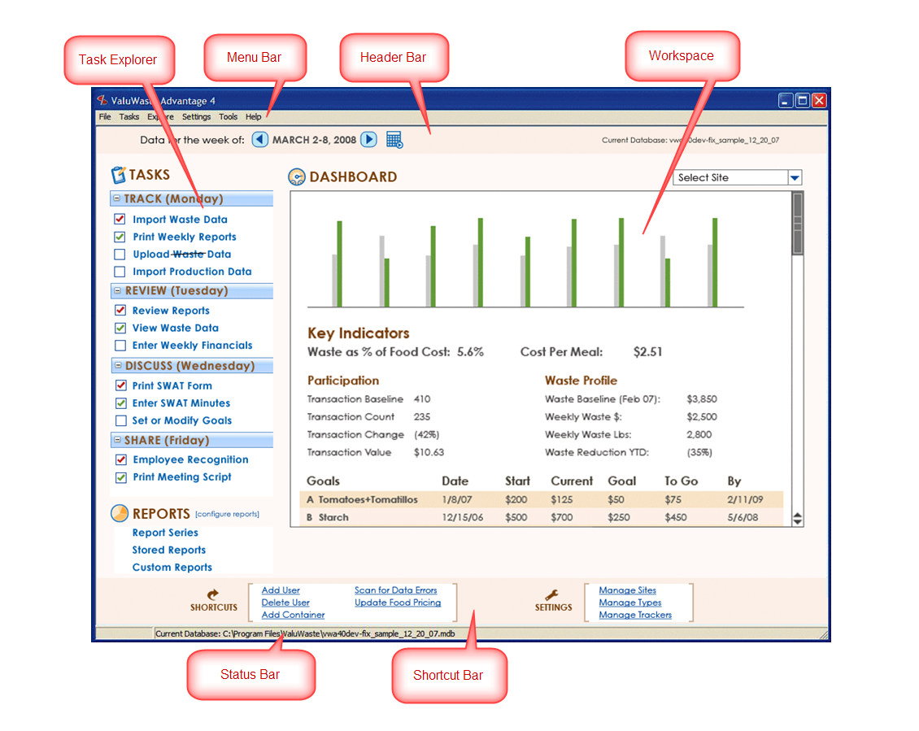

# UI Configurability

Several aspects of the VWA4.NET UI are configurable. This configurability is all persisted in, and driven from, the database. UI Configurability includes:

* Task Explorer
* Shortcuts/Settings
* Status bar
* NOTE: the Menu Bar is fixed both in being always present, and always the same structure (i.e. all items are always present – depending on the mode of operation and SW version).

## Task Explorer – Task Groups and Tasks

The Task Explorer contents are driven from a database table. As such, it can be modified in certain ways:

* Task Groups can be added/removed/renamed
  + There must be at least 1 Task Group; all tasks must fall into a Task Group.
* Individual Tasks can be turned on/off and renamed to suit.
* Tasks can be placed under any Task Group.

### UI for Configuring Task Explorer (stretch goal)

From within Tools>Options on the Menu Bar, a simple configurator tree control will be available, with columns that expose the settings. Structure will be controlled by drag/drop within the tree. Task Group Adds/Deletes will be done via simple buttons.

## Shortcuts/Settings

* Entire Shortcut/Settings window can be shown/hidden (shown is default)
* Individual Shortcuts and Settings links can be turned on/off and reassigned to the specific functions that are available.

### UI for Configuring Shortcuts/Settings (stretch goal)

From within Tools>Options on the Menu Bar, a simple configurator tree/grid control arrangement will be available.

* Fixed list for Shortcuts, another for Settings
* Fixed list for linkable functions.
* Drag/drop functions to Shortcuts and/or Settings slots. Visibility of entire Shortcuts or Settings array is determined by whether there are any links configured under it.

# Task Requirements Detail

## Commonalities Between Tasks

* “Instant Help” is instructional for how to do   
   the task
* Question mark icon invokes popup help?

## Task: Import Waste Data

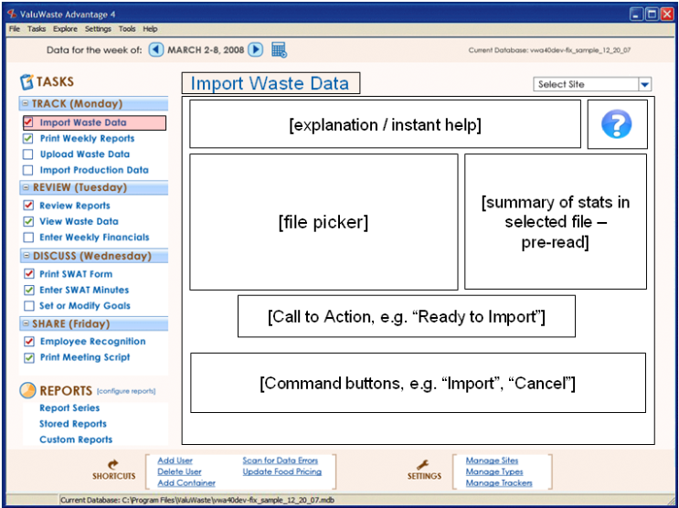

**Specific Behavior Notes:**

* When VWA4 detects a USB drive labeled “VALUWASTE” it interrogates the file and provides a summary of the data in the stats summary window, e.g. # of transactions, Tracker names, date ranges.
* “Call to Action” prompts the user for next step, “Ready to Import”
* Command buttons are clicked by user to initiate / cancel the actions.

**TBD:**

* how to display the importing in progress
* Extent of ability to correct errors/exceptions found in the waste stream
* REFER TO the prior spec ValuWaste 4 Product Enhancement specs v0.92, Import Waste Data UI section (6.8)

## Task: Print Weekly Reports

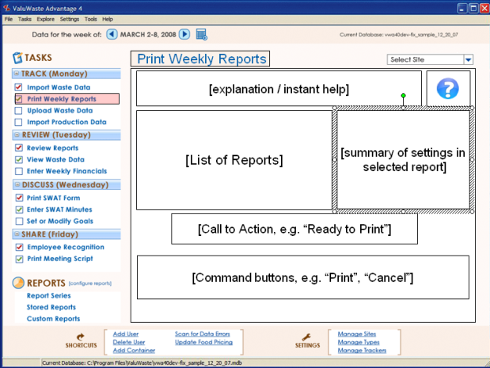

**Specific Behavior Notes:**

* User can change the week (top of screen) to determine which week to print reports for.
* List of reports is a data grid that lists which reports will be printed in order. It includes checkboxes to allow easy reprinting of specific reports (e.g. because printer ran out of paper, changed settings, etc.)
* User can click on an item in the list – when s/he does so, the Summary of settings pane will contain a textual list of the settings for that report, allowing user to quickly ascertain that the reports are set up correctly.
* Double-clicking on an item takes the user to a popup screen that has the detailed setup for that particular report. (also there will be a button in Summary of settings that user can click to change settings).
* A checked combobox placed somewhere in the Workspace will be used to select which Trackers will be printed.
* When no report is selected (initially when this screen is shown, for example) the Summary of settings shows how many reports will be printed, which Trackers will be printed, and other useful info regarding this print script.

**TBD:**

* Where/how to report status of printing. Something simple like highlighting the item in the report script?

## Task: Upload Data

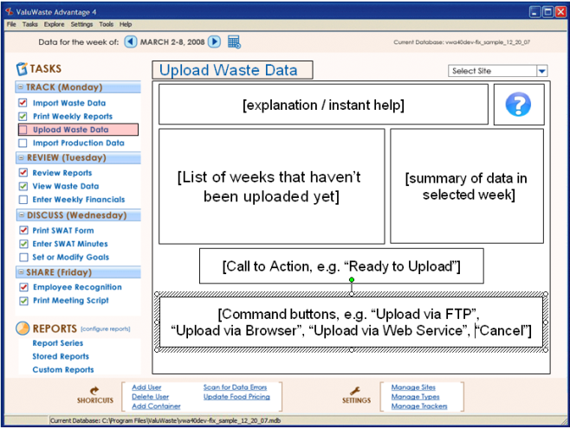

**Specific Behavior Notes:**

* When you enter the form, List of Weeks shows which weeks have data that has not been uploaded yet.
* Click on a particular week, and the summary of data in selected week shows how many records are available for transfer from that week, and [TBD] summary data for that week such as how much $ it represents.
* Multiple options for uploading are offered [TBD how this is configured. Goal is to persist the option selected]:
* FTP uploads the whole database
* Web browser transfers user to a web browser that loads the LeanPath uploader page.
* Web service transfers just the records that haven’t been transferred yet, to a [TBD] Leanpath server.

**TBD:**

* how to display the uploading in progress

## Task: Import Production Data

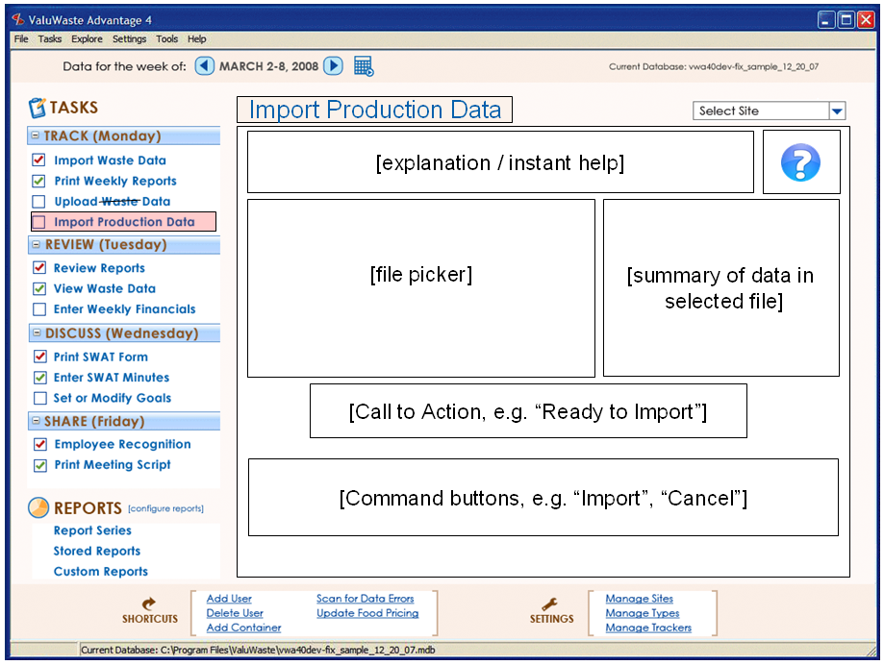

**Specific Behavior Notes:**

* File picker allows user to select the file containing production data to import.
* Data summary pane summarizes the records in the selected file.

**TBD:**

* Data format, e.g. XML or CSV?
* How to map Food Production System data types into ValuWaste 4 data types.
* How configured?

## Task: Review Reports

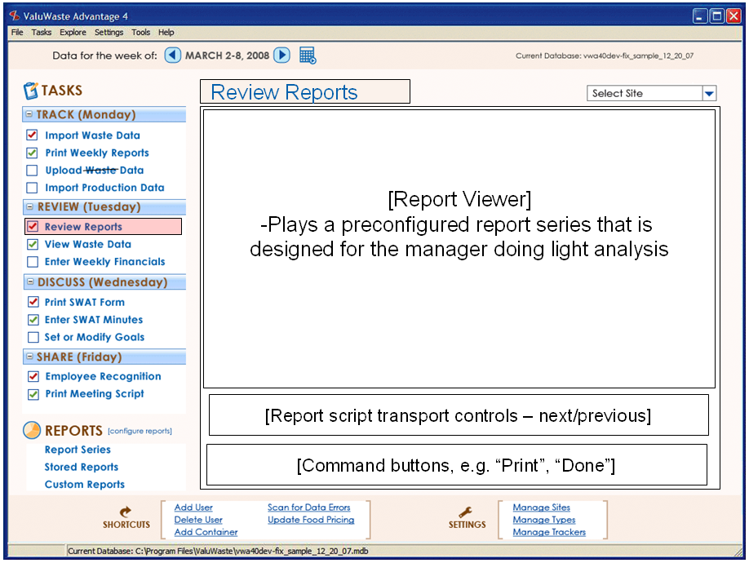

**Specific Behavior Notes:**

* The Report Viewer control plays a single preconfigured report series.
* The transport controls allow user to page forward and backward through the report.
* Conversely to Print Weekly Reports, Review Reports is optimized for on screen viewing rather than routine printing, and thus features the viewer rather than the report list and settings. (Print Weekly displays reports in a popup, Print Preview fashion)
* The Review Reports report series, or the currently show report, can easily be printed, however, from Command buttons below the transport pane.
* Command buttons will also be provided to allow the user to show a popup window that provides access to the report list and the individual report settings, displayed in a manner similar to the Print Weekly Reports embedded report list and settings pane.

**TBD:**

## Task: View Transactions (was View Waste Data)

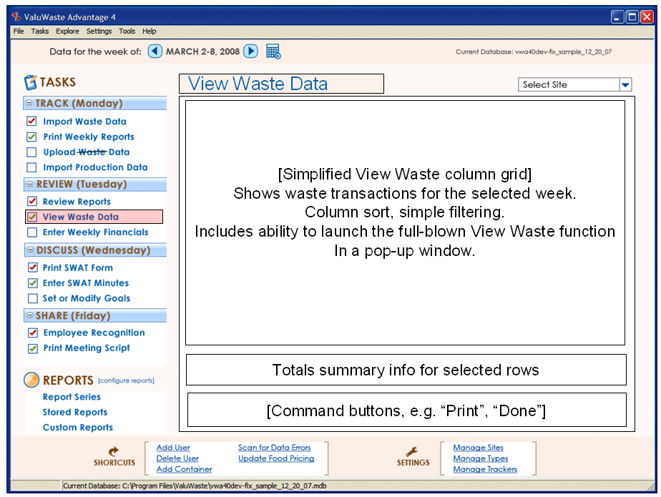

**(View Waste Data will be renamed to View Transactions)**

**Specific Behavior Notes:**

* Shows waste transactions for the selected week.
* Simplified grid from the full View Transactions popup (see below). More limited ability to configure the view. View configuration is done right in the window using the grid control itself.
* Command button shows popup version of the View Transactions control; this is expanded and allows setting any date range, plus contains a full range of features to filter and configure the view in any way available.
  + Popup version includes additional control pane for showing/hiding any waste data column/dimension.

**TBD:**

* Columns shown in the cut-down View Transactions may need to be fixed (TBD).

### View Transactions Popup

The View Transactions embedded (Task) view is a subset of the popup, which has an additional control panel attached to it, which allows more advanced features.

* All features from VWA 3.1.
* Full set of filters
* Full set of parameters
* Waste Data editing and transformation
  + Requires super-user access (“Manager”/”Administrator” level?)

**TBD:**

* Exact balance of functionality between the embedded (Task) view and the popup.

### Individual Record Editing of Waste Data

Waste data can be edited by SMV on a record-by-record basis from within View Transactions.

### Batch Editing of Waste Data

Waste data can be batch edited by SUV from within the View Transactions popup.

Batch editing is needed primarily to transform existing data from one type catalog (set of types) to another when big changes (such as upgrading from v3.1 to 4) are needed to conform existing data to a new shape. This function operates as follows:

* The current View Transactions dataset (which can be filtered according to a large variety of criteria – types, properties, date ranges, and many other waste data attributes) defines the edit scope.
* Within the edit scope, any dimension can be revised to any different (legal) value. Example: 1) filter a set of records so that only records with a loss reason of “Patient Overproduction” remain; 2) batch edit the Station attribute to contain “Patient”; 3) batch edit the “Patient Overproduction” loss reason to “Overproduction”. Result is that each “Patient Overproduction” record is changed to “Overproduction” arising from the “Patient” station.
* No new records are generated through the process of batch editing.

### Remap Waste Data Types

Waste data can be remapped by SUV from within the View Transactions popup.

“Remapping” is a process of transforming parts of the existing waste data from one type to another. Remapping is needed primarily to “unload” v3.1 types that were overloaded due to lack of adequate type dimensions; in v4 a number of additional type dimensions are available, so this overloading is no longer necessary. This is generally done when upgrading from v3.1 to v4, but could also be useful for achieving other goals regarding the reconfiguring of type catalogs.

* Remap Waste Data function operates on the current View Transactions dataset (which can be filtered according to a large variety of criteria – types, properties, date ranges, and many other waste data attributes).
* Within the context of the current filtered dataset, Remap Waste Data can map waste data from one “source” type into a set of other “target” types, based on percentages against the weight of each transaction affected. Examples:
  + “remap (food type) ‘Chili/Soup/Sauce’ transactions from Jan 1, 2008 to July 1, 2008 into ‘Chile’ (35%), ‘Soup’ (25%), and ‘Sauce’ (40%) transactions”.
* For the waste transactions affected, no new waste data records are generated. Instead, each existing transaction is remapped to a different type. Thus:
  + Weekly (any period, actually) transaction counts will be the same as before the remapping.
  + The remap function will attempt to smoothly spread the new types over time, and do its best to hit the desired percentages. However, it will be an approximation (which is more accurate/smooth the more transactions there are – with only a few transactions the remapping would probably be “lumpy”).
* Unloading Food Types: e.g. “Chili/Sp/Sce” will be become three separate types: “chili”, “soup”, and “sauce”
* The waste transactions for these will need to be split at the time of conversion from the single overloaded source type into “percentage allocations” for each of the target types.
* During this transition, we need to find a way to maintain accurate historical transaction counts.
* Unloading Loss Reasons:
  + This is referring to an ability to populate new dimensions that previously didn’t exist. Accomplish this through a batch edit of a filtered set of records.

## Task: Enter Weekly Financials

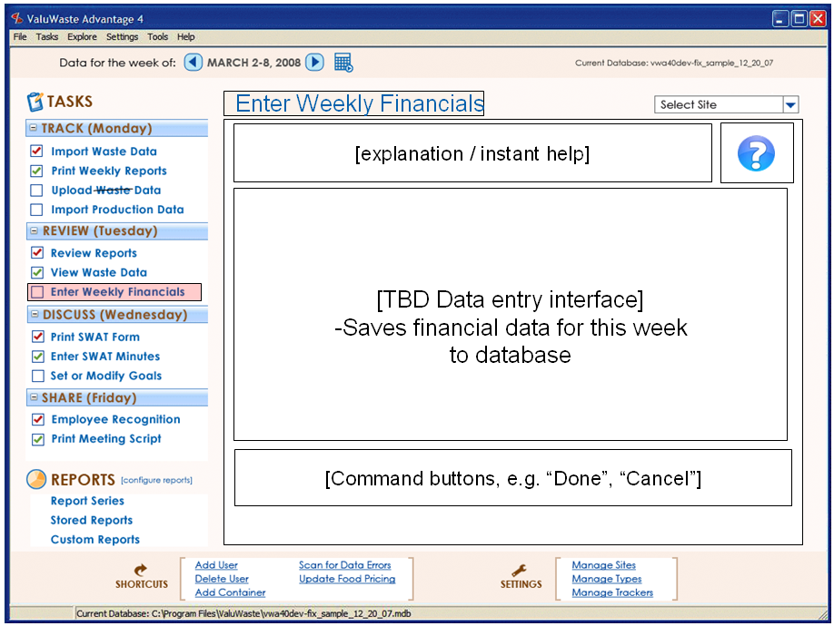

**Specific Behavior Notes:**

* Data entry interface of some kind…

**TBD:**

* Design of the financial subsystem and data entry requirements.

## Task: Print SWAT Form

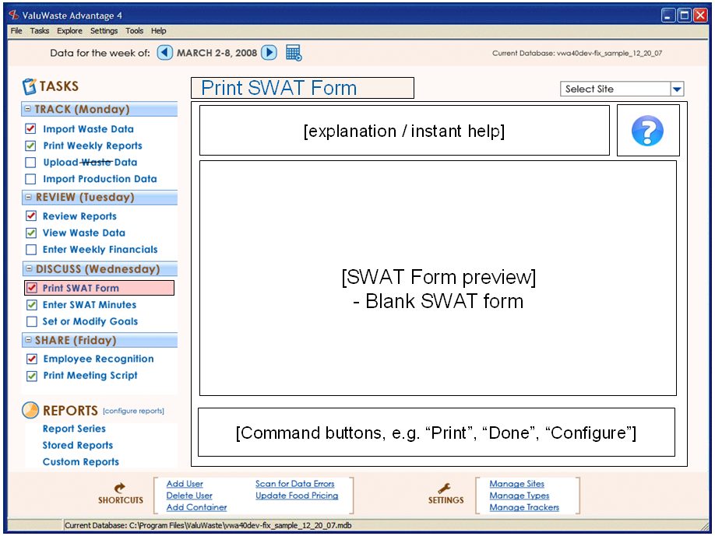

**Specific Behavior Notes:**

* SWAT Form is previewed
* It is an Active Report that is populated with current week’s key data points (including goal metrics) that can serve as a discussion guide for the SWAT meeting AND as a note-taking vehicle for written notes that will later be typed back into VWA4.

**TBD:**

## Task: Enter SWAT Minutes

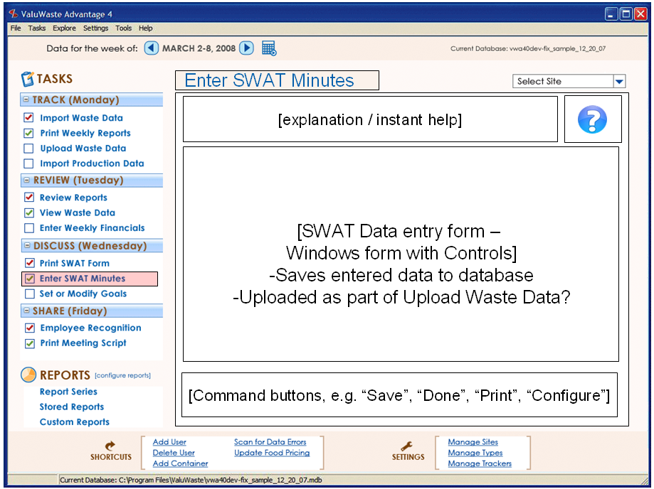

**Specific Behavior Notes:**

* SWAT data is associated with the selected week.
* SWAT data entry form is a simple Windows panel with embedded controls arrayed in a convenient manner for entering the SWAT data.
* Command buttons allow saving, printing the SWAT data
  + Printing the SWAT data is an Active Reports printed report.
* Configuration of the SWAT Data entry form (see below)

**TBD:**

**SWAT Form:**

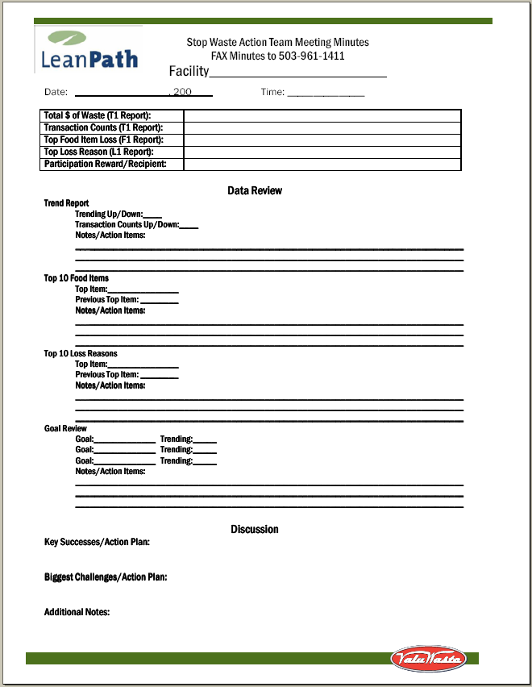

## Task: Set or Modify Goals

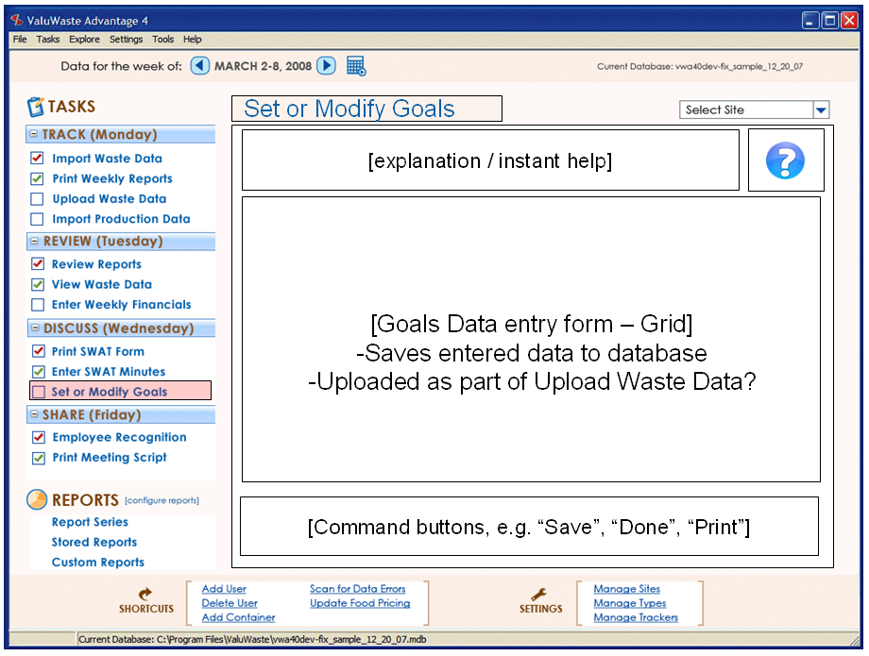

**Specific Behavior Notes:**

* x

**TBD:**

## Task: Employee Recognition

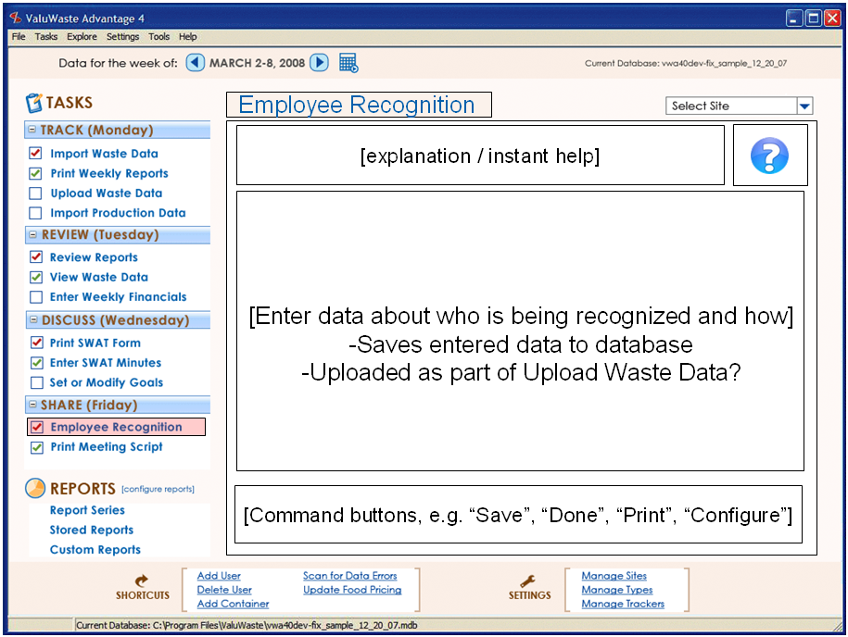

**Specific Behavior Notes:**

* Enter a date that recognition occurred using a date picker
* Select an employee name from the list of employees (tree or drop down concept)
* Enter free text to describe award given
* Enter free text to describe why this staff member won.

**TBD:**

* Develop a matching a tabular active report to show a list of prior winners

## Task: Print Meeting Script

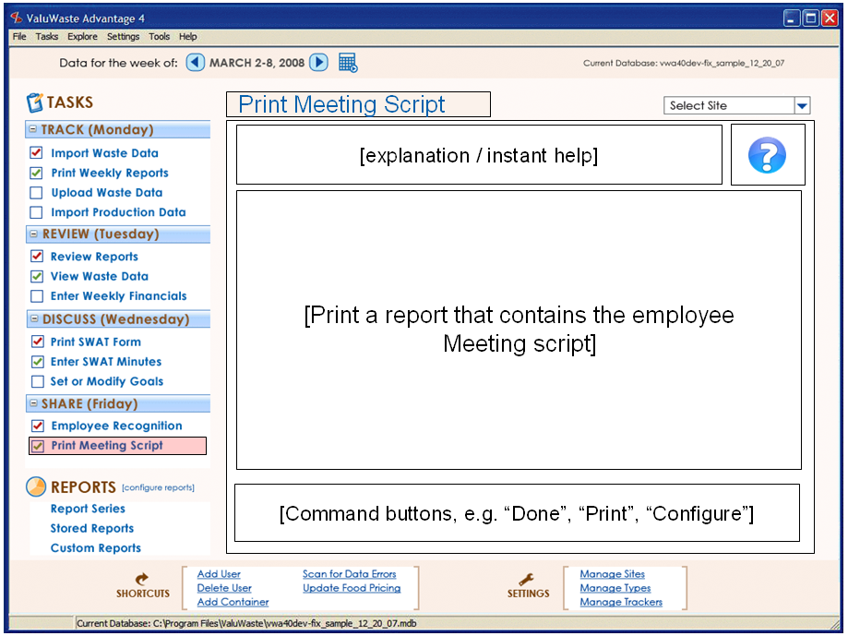

**Specific Behavior Notes:**

* x

**TBD:**

* x

## Reports: Report Series

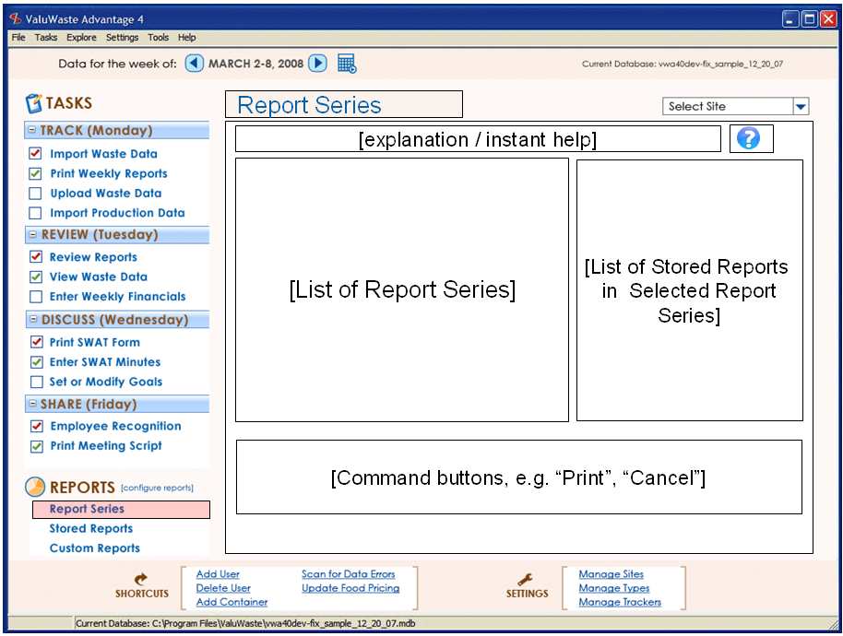

Provides ability to view, create, edit report series.

**Specific Behavior Notes:**

* Report Series list is a hierarchical picker, showing all saved report series.
* Click on a report series to select it.
* List of Stored Reports shows the stored reports in the selected report series.
* List of Stored Reports allows adding/deleting/reordering the reports in the report series.
* Checkboxes allow enabling or disabling of reports individually.
* Double click on a report to launch its popup viewer/editor (report class UI).
* Print command allows printing of enabled reports in order.

**TBD:**

* x

## Reports: Stored Reports

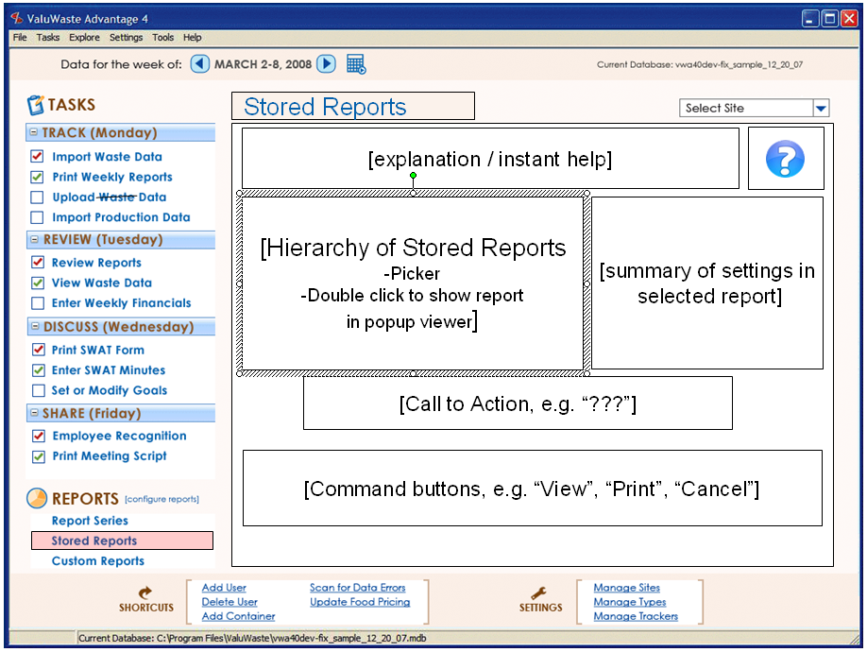

This task provides ability to view or print individual stored reports interactively.

**Specific Behavior Notes:**

* User selects individual stored reports using hierarchical viewer
* Settings for selected report are shown in the summary of settings
* double click on report (or click “View” while a report is selected) to launch that report in its viewer.
* UI will allow viewing report with or without parameter editing UI.
* Can print the selected report by clicking Print button.

**TBD:**

* x

## Reports: Custom Reports

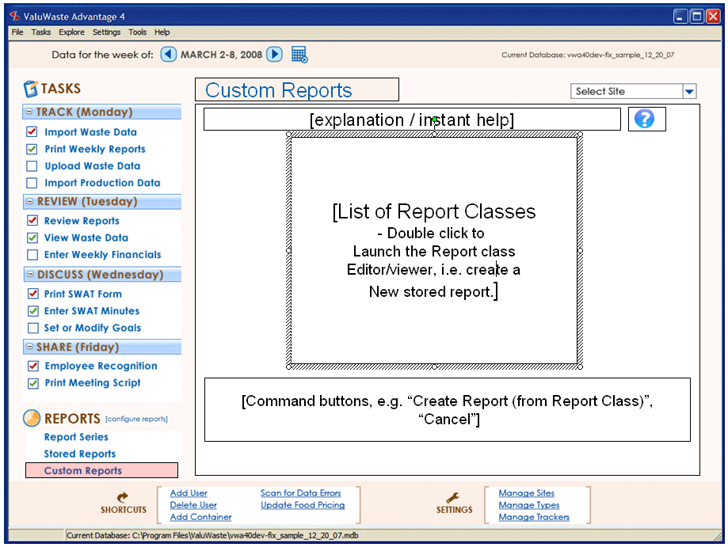

This task provides the ability to launch any report class UI for purposes of creating a new Stored Report based on that report class.

**Specific Behavior Notes:**

* Simple list shows all available report classes.
* Double click or click on command button to launch the editor/viewer for the selected report class.
* Saving is done from within the report class UI.

**TBD:**

* x

pload Datacument, e.g. how to display printing progress (if possible)..Concerts are fun but they'gured under it. present - not

# VWA4 Reporting Framework

## Types of Reports

|  |  |
| --- | --- |
| **Report Types** | **Notes** |
| 1. Dashboards |  |
| * 1. Optimized for onscreen | * Built using Infragistics controls. * See UI Design section for an example dashboard – the main home screen. |
| * 1. Printing is TBD | * What are the options for printing a set of controls on a form? This may be possible… * Printing could also be done by creating an ActiveReport that matches the dashboard, but this is a lot of work and it won’t be the same anyway since ActiveReports and Infragistics have different features. |
| 1. ActiveReports |  |
| * 1. Optimized for printing | * Built using ActiveReports (Data Dynamics) * Combined charts and tabular/banded reports. |
| 1. Report Series |  |
| * 1. Sequence of ActiveReports |  |

## Requirements Overview

VWA4.NET has the ability to memorize reports with user-defined names and settings, and combine multiple reports into sequences (“report series”).

The VWA “reporting framework” supports a standardized method for how VWA reports are created and run. The basic goals of the framework are:

* Support creation of data-driven reports for use in VWA by LeanPath product developers as well-defined, reusable classes (in the object sense), that can have both input and output parameters.
* Support “memorization” of specific report class instances, which in effect is saving a set of input parameter values (or sources) and output parameter assignments under a unique name by which the “memorized report” is accessed. Memorized reports can be executed either standalone or in the context of a “report series” (see below).
* Support ability to define and memorize “report series”, which define report order, parameter sources, and (at some point) conditional execution of reports based on expressions containing variables. Variables can be assigned the value of output parameters from reports or predefined global values (e.g. current date/time), and can also be used to pass values to the input parameters of report classes.
* Support creation of an easy-to-use UI that enables a user to 1) create memorized reports from a set of report classes provided by LeanPath, and 2) to create memorized report scripts from the memorized reports.
* The VWA database is used as the primary data source, and to store all data associated with memorized reports, memorized report scripts, and the reporting framework.
* The reporting framework can access all of the data dimensions saved in the ValuWaste v4 waste data stream, and use these dimensions to filter/shape the content and presentation of reports.

The reporting framework is built on a **reporting engine** that provides the base functionality for reporting, including (for example):

* Charts – vertical and horizontal bar, pie, area, line
* Banded reports (which can also contain charts and images)
* A variety of output formats: screen, print (including print preview), PDF, HTML.
* Ability to access all major functions (creation, printing, etc.) from code, in order to allow creation of the reporting framework.
* Nice to have: report scripting with variables, built in; end-user report designer.

Examples of candidate reporting engines include Data Dynamics ActiveReports and Microsoft Reporting Services.

## Report Properties

Examples:

* Report name
* Report key
* (more…)

## Report Parameters

Report parameters drive how reports are created, and contain essential information such as report start date, end date, presentation selections (e.g. colors, titling choices), filter criteria (e.g. types to show), sorting, and more.

When a VWA4 report class is created by a software engineer, the input and output parameters for that report class are fixed in the following ways:

* parameter name (this is the parameter key also)
* parameter data type
* input or output parameter
* data source/destination (“linkage”)

All parameters are “linked” to one of the following data sources/destinations:

* A Constant (source only)
* A Built-in global variable (read-only; can only be used as a source for input parameters)
* A Dynamic global variable (read/write; can be used both as a source for input parameters and a destination for output parameters)

### Constants

Report parameters can be stored and retrieved as constants. This is the standard way to save report parameters. Storing constant parameters is done through the report’s property sheet by directly typing in the values desired. Parameters specified as constants are directly loaded from the saved constant values when the report initializes.

### Built-in Global Variables (BGV)

Report parameters can be retrieved by name from built-in global variables. Global variables will contain different values based on the following:

* An automatic update process (e.g., current date, current time, current Tracker, current Site, etc.).

BGVs are as follows:

|  |  |
| --- | --- |
| **Built-in Global Variable Name** | **Notes / Implications** |
| 1. WeekStartDay | * Starting day of fiscal/reporting week |
| 1. CurrentWeekStart | * Starting date of current week |
| 1. CurrentWeekEnd | * Ending date of current week |
| 1. CycleTimeWeeks | * Cycle time in weeks |
|  |  |

### Dynamic Global Variables (DGV)

Report parameters can be stored and retrieved by name to/from dynamic global variables. Dynamic global variables will contain different values based on the following:

* An update that occurs from the output parameters of a report (e.g. top food type waste for the current week).

### Notes on Global Variables

* All global report parameters have names.
* All read-only global parameters have predefined, reserved names.
* All read/write global parameters are dynamically created as they are encountered in a report series. For a report to access a read/write global input parameter, it must be specified as an output parameter from a prior report in the series.
* A report that specifies an output parameter (dynamic global variable) with the same name as one that was created via a prior report will be overwritten with no errors produced. This re-use of common names is defined to be normal practice in creating report series.
* All read/write global parameters are dynamically discarded at the end of a report series.

## Report Series

Report series are simply named sequences of reports that can be printed or displayed in order, by a single command.

**Notes:**

* Standard practice: input parameters are used in conjunction with designed report behavior to enhance the effectiveness and usefulness of report series:
  + Example: A report can be designed to be skipped or rendered based on a report parameter.
  + Example: A report can be designed to be used in conjunction with another report, by linking their behavior to dynamic global variables, via input and output parameters.

# VWA4 Report Classes (ActiveReports/Print-Optimized0

VWA4.NET report classes define a new standard for how reports are built and used. Refer to the framework aspects discussed above for an introduction.

This section describes report classes from the standpoint of the classes themselves, i.e. what is required when a report class is built? Some of this is in the category of defined best practices, and some of it is required for a report class to actually function properly in VWA4.NET.

## Report Class Feature Requirements Overview

|  |  |
| --- | --- |
| **Requirements** | **Notes / Implications** |
| 1. Property sheet UI | Each report class has a UI that is used to manage the properties of report instances (memorized reports). |
| * 1. All parameters are shown | * Input parameters shown on main sheet * Link to separate property sheet for specifying output parameters. |
| * 1. Report title | * User-definable report title, specified as a saved constant parameter. |
| * 1. Report subtitle | * User-definable report title, specified as a saved constant parameter. |
| * 1. Presentation | * Background color   + Defaults are keyed to the VWA4.NET color scheme. |
| * 1. Conditional formatting | * ??? TBD |
|  |  |
|  |  |
| * 1. Report PK | * Primary key of a memorized report is shown on the property sheet (and the report list/tree). |
|  |  |
|  |  |
| 1. Filtering |  |
| * 1. Start/end date | * Set to a constant * Select a built-in BGV to use (e.g. “beginning date of the prior week”) |
| * 1. Starting day of week | * Set to a constant * Select the built-in BGV to use – “starting day of week for the site”) * Monday is default. |
| * 1. Presentation | * Depends on report class – typically:   + Horizontal or Vertical bars   + Value reported in lbs or $   + Value bar color   + Background color   + 3D/2D style   + Show/hide waste transaction count   + Waste transaction bar color   + Waste transaction bar height   + Sorting options   + Threshold options (limit display to |
| * 1. Filter by all applicable types and properties | * New filter mechanism (UI), allowing ability to filter by all waste transaction dimensions.   + Food type, loss reason type, station type, user type, daypart type, EO type, disposition type, pre/post consumer, … |
| 1. Output options |  |
| * 1. Print to printer |  |
| * 1. Print to PDF |  |
| * 1. Print to HTML (?) | * TBD |
| 1. Titling (on report output) |  |
| * 1. Report title | * From saved input parameter |
| * 1. Report subtitle | * From saved input parameter |
| * 1. Site | * The name of the Site a report is based on is automatically included on each report. |
| * 1. Filter summary | * Auto-generated filter summary in small type that uses “Multiple” as descriptor if multiple types within a dimension filter are selected. |
| * 1. Report PK | * Primary key of a memorized report is shown on the report output, as part of the footer. |
| 1. Types |  |
| * 1. Report Type names | * Report Type names are used for labeling types in reports (not type names). |
| 1. Misc Stretch Goals (nice to have) |  |
| * 1. Customer logo | * Option for including customer logo on reports. |
| * 1. Error message based on thresholds | * It would be helpful to have a space on some reports (maybe all?) where an error message can be displayed.  For example, on a trend report if the count falls below a certain level it would be nice to be able to publish a warning message such as:  “Warning:  Low Transactions” |

## Report Class Architecture (ActiveReports)

Report classes optimized for printing via Print Weekly Reports and other report series are built using ActiveReports. There is a standard structure for building these, so that they operate similarly and smoothly in the context of the reporting framework.

### Report Class Basic Structure

### Property Sheet

* UI for setting report properties and saving memorized reports

### Input and Output Parameters

* Input parameters are specified on the main property sheet, along with report name.
* Output parameters are specified on a separate “output parameters” property sheet.

### Report Series

## Report Class: Transactions Report (from View Transactions)

### Historical Requirements

|  |  |
| --- | --- |
| **Requirements** | **Notes / Implications** |
| Report Class - View Transactions | * Same design as current report for View Transactions * Add dimensions for Station, Daypart, Disposition, EO, and Pre/Post, and user-defined (if present) * Remove Gross Weight and leave Net Weight of Transaction. * (Optional) Remove Container name if there isn’t enough room for one more column * Report may require 2-line style of presentation. Aim for keeping it as crisp and simple as possible. * Based on query defined in “Transaction Viewer” interactive tool * May be printed live from within the Transaction Viewer or saved as a Memorized Report * Do not show hierarchy (just type report names) |

## Report Class: Trend Report

### Historical Requirements

|  |  |
| --- | --- |
| **Requirements** | **Notes / Implications** |
| Report Class - Trend Report Chart  (Based on VWA 3.1 Trend Reports) | * Report that returns the total amount in dollars or lbs * Broken out by periods (user variable such as day, week, month, quarter and year) over a specified date range. * Report should also optionally return total transaction count for the same set of properties (date, filters, etc.). * Allow for offset so that labels on transaction count do not collide with totals printed on chart. * Includes a report label at the top (user-defined) * Input parameters:   + Start Date   + End Date   + Interval of Reporting     - Weekly, Monthly, Quarterly, Yearly   + Starting day of week (global setting)   + Combination Filters   + Trendlines (optional)   + Visual elements   + Show in Lbs   + Show Waste Transactions   + Threshold value(s) for amount of Change (used in Output parameter) * Output parameters:   + Total Waste Dollars   + Total Waste Lbs   + Total Transactions   + Direction of change (increase/decrease)   + Amount of change from prior [interval]   + (TBD) |

## Report Class: Weekly Comparison Report

### Historical Requirements

|  |  |
| --- | --- |
| **Requirements** | **Notes / Implications** |
| Report Class - Weekly Comparison Report Chart  (Based on VWA 3.1 Trend Reports) | Same as VWA3.1 except   * Remove check box for days of the week included in the report (Check with Dave to confirm no one is using this feature). * Add filters for new data dimensions. * In addition to the existing choices to compare this week’s data to add the following choices   + Compare to Previous Cycle Week (Go back X weeks based on a user variable specified as a global variable   + Compare to same week, Previous Year * Eliminate ranking alphabetically; default to Max to Min * Eliminate “Don’t show values below a certain amount.” We can accomplish this by limiting just the number of items. * Make the default slide item count 10 items |

## Report Class: Rankings Report

### Historical Requirements

|  |  |
| --- | --- |
| **Requirements** | **Notes / Implications** |
| Report Class - Rankings Report Chart  (Based on VWA 3.1 Detail Reports) | Report that breaks down a particular chosen type (the “Reporting Dimension”) broken by the top N types from another dimension (the Ranking Dimension), with the ability to filter by all other dimensions. Returns the top N types for a given time period. Reporting Dimension is one of the following: food types, loss types, station types, disposition types, Daypart types, BEO types. Within the selected Reporting Dimension, the user may multi-select which types are included at both the Category and/or individual type level. The Report should be sorted Max to Min. UNKNOWN: Categories? Consider changing labels so that the “food” and “loss” tabs are now reversed in order to present the information in a clearer way to customers. |

## Report Class: Snapshot Reports

### Historical Requirements

|  |  |
| --- | --- |
| **Requirements** | **Notes / Implications** |
| Station Snapshot Report | Shows a mash-up of top-line stats for a specific station:   * Top 10 foods * Top 10 loss reasons * Top 10 people weighing * Waste by Day of Week for this Station * Top 5 Dispositions * Top 3 dayparts |
| Food Snapshot Report | Shows a mash-up of top-line stats for a specific food type:   * Top 10 stations where this food is wasted * Top 10 loss reasons for this food * Top 10 people throwing this item away * Waste by Day of Week for this Food Type * Top 5 Dispositions * Top 3 dayparts |
| Loss Snapshot Report | Shows a mash-up of top-line stats for a specific loss type:   * Top 10 stations where this loss type is wasted * Top 10 food types reasons for this loss reason * Top 10 people throwing this item away * Waste by Day of Week for this loss Type * Top 5 Dispositions * Top 3 dayparts |
| Disposition Snapshot Report | Shows a mash-up of top-line stats for a specific Disposition type:   * Top 10 stations where this Disposition type is wasted * Top 10 food types for this Disposition * Top 10 loss reasons for this Disposition * Top 10 people throwing this item away * Waste by Day of Week for this Disposition Type * Top 3 dayparts |
| Daypart Snapshot Report | Shows a mash-up of top-line stats for a specific Disposition type:   * Top 10 stations where this Daypart type is wasted * Top 10 food types for this Daypart * Top 10 loss reasons for this Daypart * Top 10 people throwing this item away * Waste by Day of Week for this Daypart Type * Top 5 Dispositions |

## Report Class: Employee Report

### Historical Requirements

|  |  |
| --- | --- |
| **Requirements** | **Notes / Implications** |
| Report Class – Employee Reports | * Waste data by employee. * Exceptions (employees with no waste) - optional |

## Report Class: Low Participation Report

### Historical Requirements

|  |  |
| --- | --- |
| **Requirements** | **Notes / Implications** |
| Report Class – Low Participation Reports | Users that don’t have transactions. |

## Report Class: Production Report

### Historical Requirements

|  |  |
| --- | --- |
| **Requirements** | **Notes / Implications** |
| Report Class – Production Reports | Need to define this  (Andrew)  these are reports that print production data, or comparisons or production data with waste data |

## Report Class: Yield Report

### Historical Requirements

|  |  |  |  |
| --- | --- | --- | --- |
| **Requirements** | | **Notes / Implications** | |
| Report Class – Yield Report Class | Needs to be defined  (Andrew) | |

## Report Class: Goals Report

### Historical Requirements

|  |  |  |  |
| --- | --- | --- | --- |
| **Requirements** | | **Notes / Implications** | |
| Report Class – Goal Report | Needs to be defined  (Andrew) | |

## Report Class: Financial Report

### Historical Requirements

|  |  |  |  |
| --- | --- | --- | --- |
| **Requirements** | | **Notes / Implications** | |
| Report Class – Financial Report Class | Tabular report showing sales, food cost, meal count and food waste (broken down by month) on the same grid for a specified period of time.  Three reports – see separate spreadsheet mockups. | |

## Report Class: Interstitial Report

### Requirements

|  |  |
| --- | --- |
| **Requirements** | **Notes / Implications** |
| Report Class – Interstitial Report | Need to define this  (Andrew/SAR)  Simple text report that prints a list of messages based on input parameters, to alert the user to issues/opportunities in prior reports. |

### Historical Requirements

None – this is a new report class.

## Report Class: Transfers History Report

### Historical Requirements

|  |  |
| --- | --- |
| **Requirements** | **Notes / Implications** |
| Report Class – Transfer History | Needs to be designed  (SAR)  Report that summarizes the dates of prior waste transfers and # of records and Tracker serial numbers |

## Report Class: Database Report

### Requirements

|  |  |
| --- | --- |
| **Requirements** | **Notes / Implications** |
| Report Class – Database Report | Needs to be designed  (SAR)  This report provides a number of useful statistics regarding the current database, including:   * Database size * Number of sites, and number of Trackers for each site * Number of waste records * Number of waste transfers that have taken place * Number of Types broken down into all the dimensions) * Number of Menus, Buttons broken down by Tracker and each type of menu/button * [more TBD] |

### Historical Requirements

None – this is a new report class.

## Report Class: Configuration Report

### Historical Requirements

|  |  |
| --- | --- |
| **Requirements** | **Notes / Implications** |
| Report Class - Print Configuration Report  (Based on VWA 3.1 Detail Reports) | Needs to be designed  (SAR/Andrew)  Updated report that reflects the total configuration of Trackers, Types, etc. , and hierarchy. |

Report Orientation: Landscape

Header: Database filename, Date

Footer:

Outline:

# VWA4 & Future Report Class Ideas (TBD)

This chapter documents ideas for reports that have been introduced into the VWA4 requirements, but either have not been adequately defined to proceed into implementation, or are not projected for near-term development. These ideas need to be defined and designed prior to implementation. When they are defined enough at a requirements level, individual report class ideas will be place in the previous chapter on VWA4 Report Classes, from where design and implementation can commence.

|  |  |  |
| --- | --- | --- |
|  | **Requirements** | **Notes / Implications** |
|  | Report Class – Production Reports | Needs to be defined  (Andrew/Dave/Stephen)  Report that uses data from paper tracking, traditional scale entry, or volume data entry in comparison with production levels. Goal is to illustrate variances between produced and waste amounts and to identify the # of guests per pan of an item consumed (see report from Jennifer Bargisen). |
|  | Report Class – Velocity HTML/RTF Report w/ Chart | Needs to be defined  (Andrew)  Show annualized figures. |
|  | Averages | Needs to be defined  (Andrew)  Discuss with Dave. Comparisons versus whole date range in program |
|  | Waste Reduction v. Baseline | Needs to be defined  (Andrew) |
|  | Confirm Data Quality | Needs to be defined  (Andrew)  One page summary of transaction counts, nights, weekends, missing items, missing people |
|  | Report Class – SWAT Minutes - RBuilder | Needs to be defined  (Andrew)  A banded report that lists the responses to specific SWAT questions for a meeting of a specific date. |
|  | Report Class – SWAT Script - RBuilder | Needs to be defined  (Andrew)  A banded report that lists the agenda/questions to be used in a SWAT meeting scheduled for a specific week. Stretch to dynamically include some summary data (in text form) on this sheet. |
|  | Report Class – Employee Meeting Script - RBuilder | Needs to be defined  (Andrew)  A banded report that lists the agenda/questions to be used in an employee meeting scheduled for a specific week. Stretch to dynamically include some summary data (in text form) on this sheet. |
|  | Pie Charts | Needs to be defined  (Andrew)  This class would take waste data and use it in an algorithm to convert greenhouse gas implications (CO2, Methane, etc.).   This report could show the environmental profile for waste, or the inverse which would be the environmental savings based on waste reduction thus far.  You’ll recall I brought this up originally with the idea of partnering with Good Company in Eugene.  I haven’t heard from them in awhile, but I think we may be able to build these algorithms on  our own with a little Googling. |
|  | Sustainability Report Class | Needs to be defined  (Andrew)  Allowing the user to present waste data in context by calculating the equivalencies of the waste.  For example, during the last month we weighed the equivalent of 1.5 whales.   We would need a table of items and their weight equivalencies.  The report could them express the equivalency of this waste in other terms.  I would not see this as a complex report.  It would accept a date range, produce a total waste dollars and lbs figure for the date range, and then print out a sheet of equivalencies.  We could prepopulate the table with various equivalent items or allow customers to add items to the table.  Would be printed as a banded report. |
|  | Congratulations Report | Needs to be defined  (Andrew)  If a goal is achieved, we would have a simple report in large type stating “ Congratulations, we met our goal to reduce _____” and we did it.  Perhaps it shows the initial soup numbers, and the current numbers, and the amount of change |
|  | Employee Report – Personal Best | Needs to be defined  (Andrew)  If an employee hits a personal best for waste transactions, provided it exceeds a certain threshold, they get an autogenerated certificate. |
|  | Employee Participation by Week | Needs to be defined  (Andrew)  Grid showing employee names down left side, and last 12 weeks across the top.  Each box on the grid includes the transaction counts, with highlights for low figures (below a defined threshold – TBD) |
|  | “Fun” Report Class | Needs to be defined  (Andrew)  Allowing the user to present waste data in context by calculating the equivalencies of the waste.  For example, during the last month we weighed the equivalent of 1.5 whales.   We would need a table of items and their weight equivalencies.  The report could them express the equivalency of this waste in other terms.  I would not see this as a complex report.  It would accept a date range, produce a total waste dollars and lbs figure for the date range, and then print out a sheet of equivalencies.  We could prepopulate the table with various equivalent items or allow customers to add items to the table.  Would be printed as a banded report. |
|  | Tracker Comparison Report | Needs to be designed  (SAR/Andrew)  Compares Total Waste among several Trackers within the same database |
|  | Site Comparison Report | Needs to be designed  (SAR/Andrew)  EMV Only. Compares total waste by site. |

## Report Series – Enhancement Ideas

Report Series have been simplified for VWA4.NET, specifically in the fact that report series are initially limited to ActiveReports

### Historical Requirements

|  |  |
| --- | --- |
| **Manage Analysis Scripts** | This feature allows the user to build and set the properties of Analysis Scripts. This involves selecting Memorized Script Objects, and placing them in a tree structure that determines script order, and how they are displayed when activated. |
| **Manage Analysis Script Objects**  **(a.k.a. “Memorized Script Objects”)** | This feature allows the user to build and set the properties of Analysis Script Objects, which in “memorized” form are used to form Analysis Scripts. Each object is based on an available object type, which has certain properties that can be set. After setting the properties, the user names and saves the object for later use.  Anticipated object types include:   * Reports * Scorecards * Dashboards * Analytic Views * Plans * Specialized forms/controls * Other objects TBD (expandable over time)   Note that ReportBuilder banded reports cannot be displayed in the same window as other reports, since these reports are only viewable online in a Print Preview manner. All other object types will be “played back” in a single window (or what will appear to be a single window). The desired effect is that each object looks like it is being played back in a single wizard-style window. |

# VWA4 Dashboards

VWA4 dashboards are different from ActiveReports in several ways:

* Dashboards are optimized for viewing onscreen.
* Dashboards are dynamically controlled – not memorized under unique names with different sets of parameters. Only the most current parameter settings are saved.
* Dashboards can be printed in a limited way (TBD – probably printing a form with controls on it)
* Dashboards cannot be part of a Report Series.

## Dashboards Feature Requirements Overview

|  |  |
| --- | --- |
| **Requirements** | **Notes / Implications** |
|  |  |
|  |  |

## Main Screen Dashboard

General Principles

* Data takes place at a point in time defined at least in part related to a given week
* Designed to engage chef and cause them to want to know more
* Designed to immediately showcase success and reinforce their confidence based on past achievements
* Designed to be as simple as possible
* Can include alerts to problem areas (i.e. missing food cost data, low transaction levels)

Scope at this point

* Uses baselines
* Does not use goals at this time

Variations to comp (subject to SAR discretion)

* Less visual emphasis on trends or complete removal of trend report
* Removal of goals
* Highlighting **less** data **more** effectively
* Showcase changes in both food cost (optional based on customer data entry) and waste levels
* Try to keep some content related to participation levels

References

* Content from January discussions (e-mailed)

Additional Design:

* Add two main graphs to the dashboard
  + Waste Reduction
    - Baseline waste versus current period (current period would be a calculated figure for the last N weeks of waste data reaching back from the current date), label shows % reduction prominently.
      * Potential stretch goal with drilldown: A line chart showing food waste weekly (by either dollar or lb based on global user preference) total by month for the last 12 months.
    - Baseline financial starting point versus current period (current period would be a calculated figure for the last N months of financial data reaching back from the current date), label shows % reduction prominently
      * Potential stretch goal with drilldown: A line chart showing food cost (either points or FCPM, based on the user’s global preference) total by month for the last 12 months.
* Add a text-based section below the graphs with the following information on Weekly Participation:
  + Label it as “Weekly Participation”
  + Transaction Baseline (calculated the same as the waste cost baseline)
  + Current Week Transactions
  + Variance to Baseline in Percentage (amount this week’s data is under or over the baseline)
* Add a text-based section below the graphs with the following information on Weekly Waste Profile:
  + Label as “Weekly Waste Profile”
  + Total Waste Dollars
  + Total Waste Pounds
  + Annual Waste at this Rate (52 week extension of this value)

### Data Model Notes

* Stored Financial Elements (one set of data per month):
  + Actual food cost (total purchases)
  + Budgeted food cost
  + Actual Food revenue (total sales)
  + Budgeted food revenue
  + Budgeted Meal count
  + Actual Meal Count
  + Preference setting needs to be saved for each customer: show report either based on “Food Cost Points” OR “Food Cost Per Meal”
* Baseline data consists of:
  + financial elements – **on a monthly basis**
  + transaction data summaries (e.g. waste cost) – **on a weekly basis**
* Baseline modes (select one at any given time)
  + Mode: Average of n weeks
    - Starting date and number of weeks
    - n = 1 to specify a single week (identify a maximum via a trend chart if needed)
  + Mode: Stipulated baseline
    - Values are supplied explicitly as configuration variables
    - Note: financial baselines are only available as stipulations

### Example Financial / WasteReduction Reports

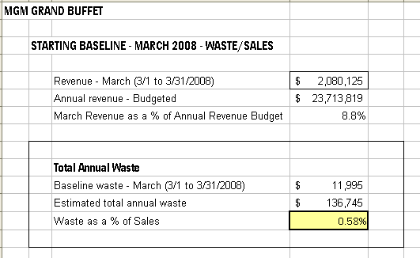

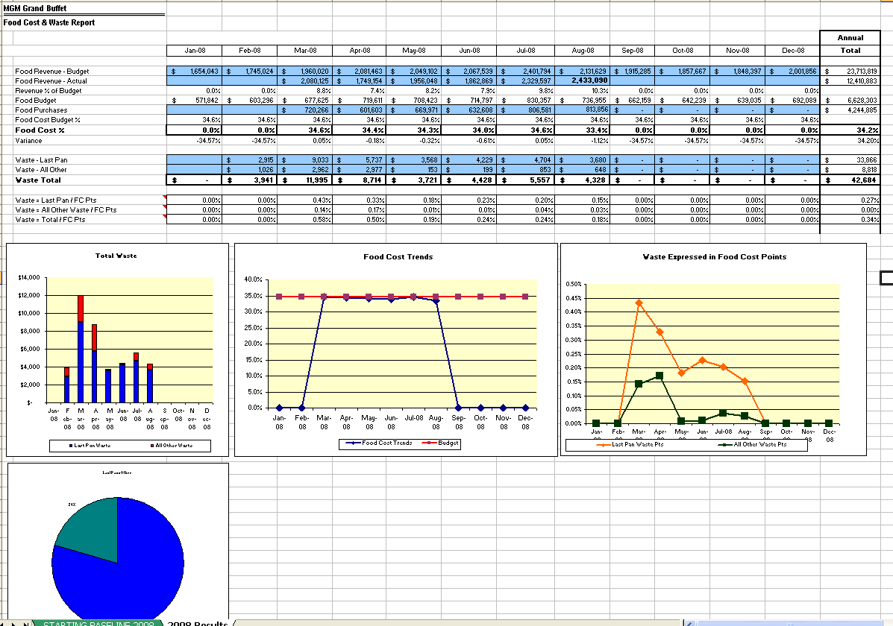

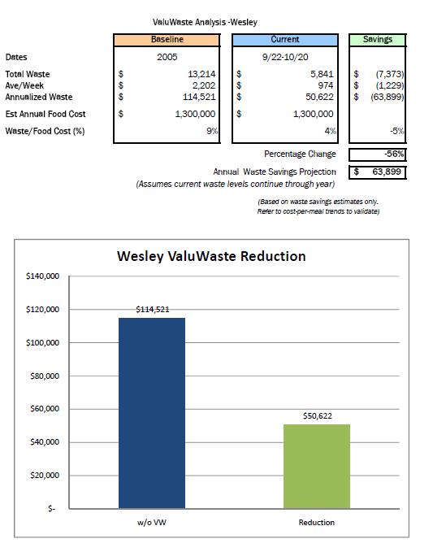

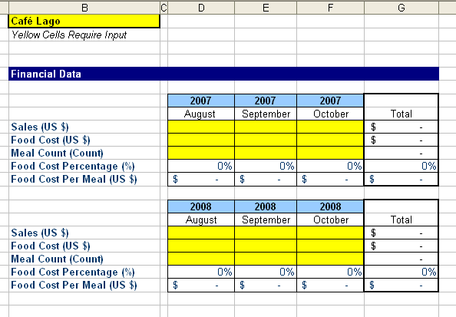

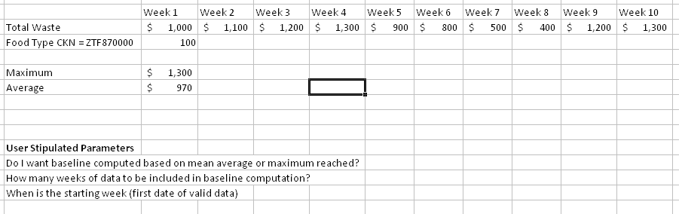

## Main Screen Dashboard (Original concept)

The main screen dashboard gives high-level summary information about the current site. Example depiction:

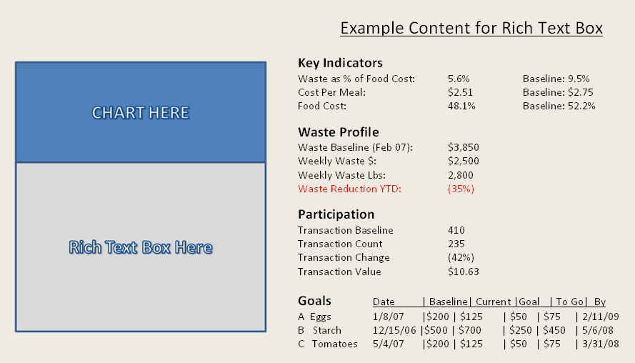

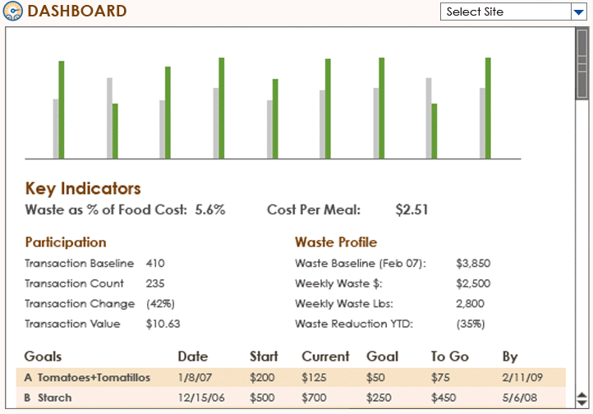

### Main Screen Dashboard - Detailed Requirements

|  |  |
| --- | --- |
| **Requirements** | **Notes / Implications** |
|  |  |
|  |  |

# ValuWaste Configurator

## Overview

The ValuWaste Configurator consists primarily of:

* Site Manager
* Type Manager
* Tracker Manager
* Paper UI Manager
* Optional Properties
* Transfer Utility Functions

## Type Manager

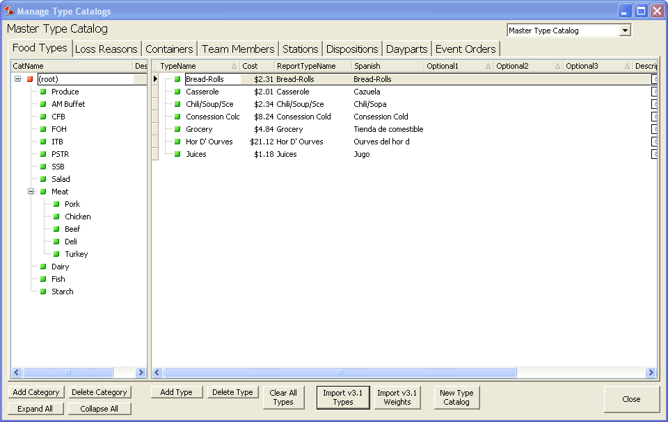

### Overview

* Refer to the completed product!
* Written in Delphi 2006; invoked through VWA4.NET

### Upgrading from VWA 3.1

* Import v3.1 Types
* Import v3.1 Weights

## Tracker Manager

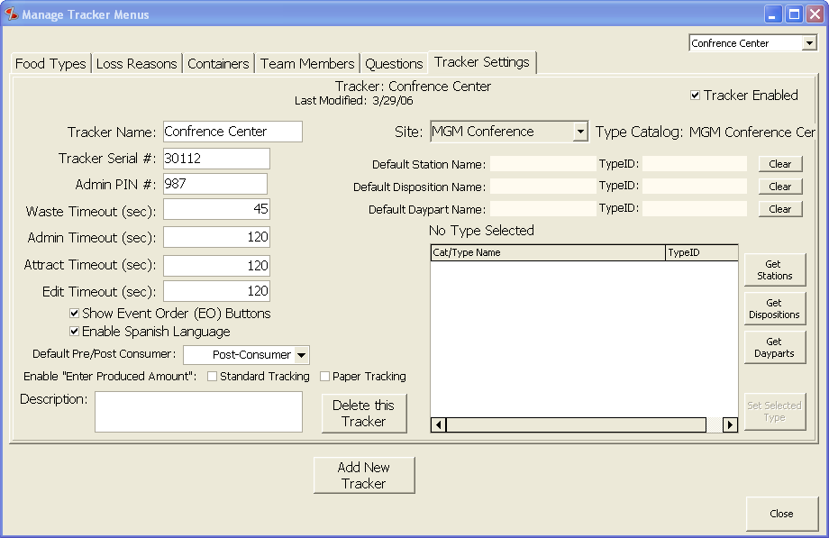

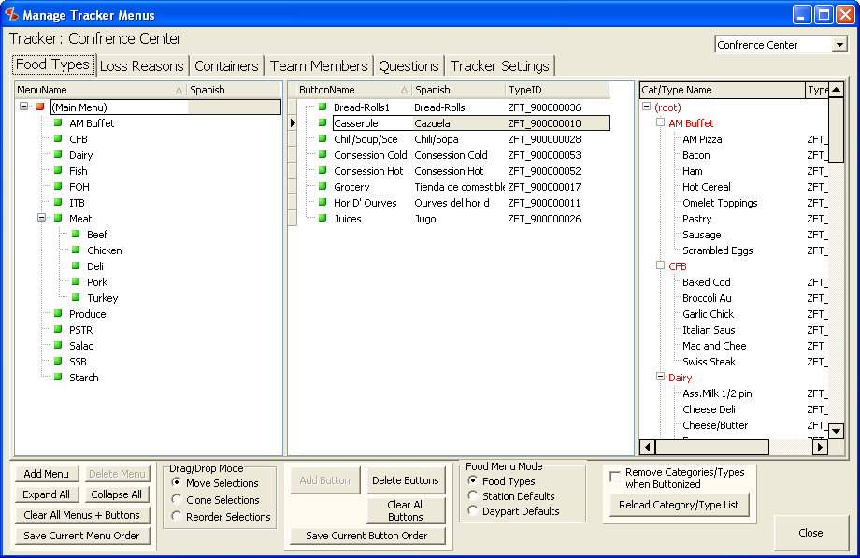

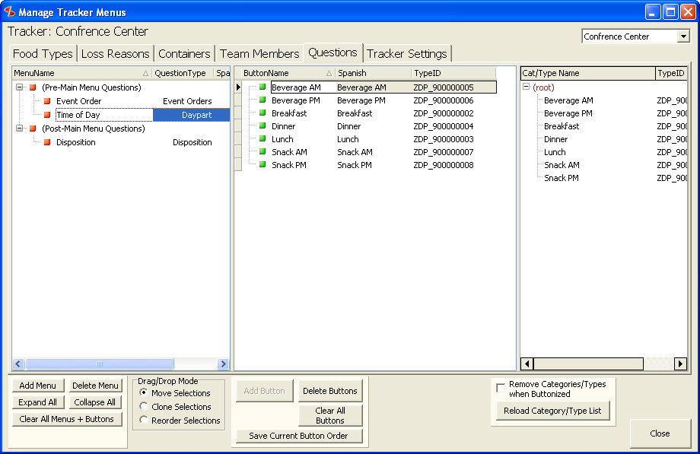

## Site Manager

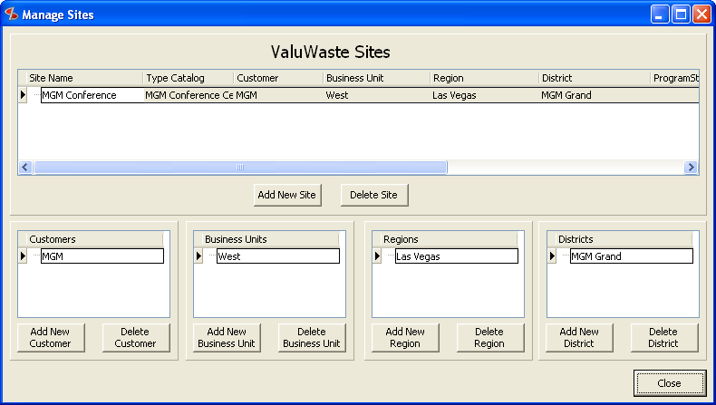

## Paper UI Manager (memorized transactions)

* Primary interface for user manual data entry is on VWT. User selects “Paper UI” from home screen, proceeds into a UI that allows selection of a MT from a hierarchy menus and buttons. Selecting a button selects a MT, which brings up the data entry screen.
* VWA4 Tracker Manager contains the Paper UI Memorized Transaction (MT) Builder, which enables:
  + Creation/deletion/editing of MT’s.
  + Hierarchical menu/button building like standard dimensions allow, with ability to name a transaction (button name).
  + Two modes of MT data entry are provided;
    - **Item Mode:** Unit of measure is specified via a text name plus an associated conversion factor that will convert the user-entered number of units into lbs.
    - **Weight Mode:** Unit of measure is selected from a list of possible weight units of measure (lb, kg, grams, oz). User-specified number is converted into lb automatically.
  + A complete group of food, loss, container, station, disposition, daypart dimensions are hardwired for each memorized transaction.
* UI general design for Paper UI Manager:

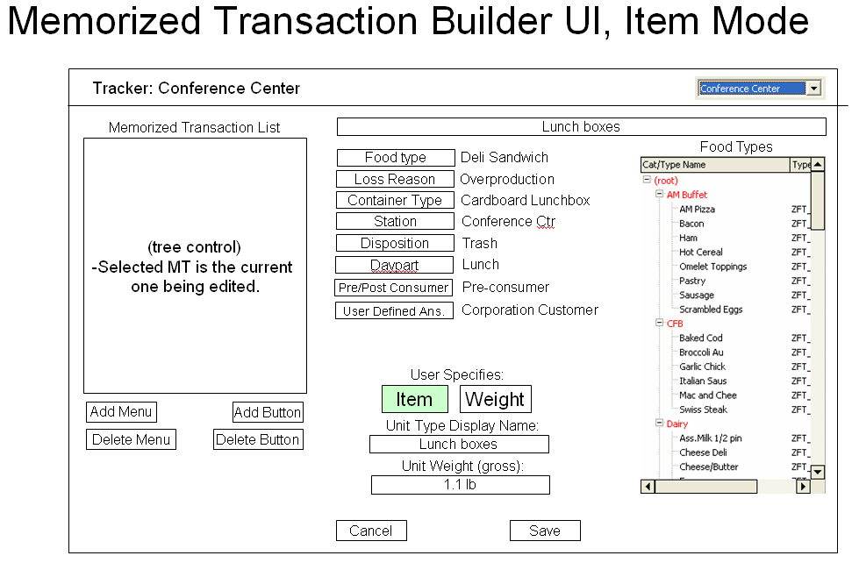

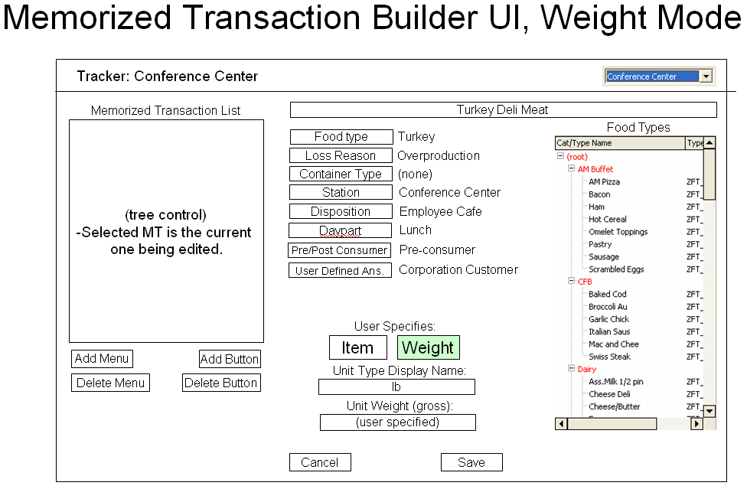

**UI Notes:**

* Grid/tree of memorized transactions for each Type Catalog
* UI to select and display every data dimension as part of crafting a memorized transaction.
  + Tree control displays the available types (select which type via button)
  + Buttons allow user to select which type hierarchy is shown
  + Double click on types to choose them.
  + Label controls hold the selections
  + When all info is provided, “Save” button is enabled, which will save the current MT (cancel deletes it)

# VWA4 Upgrade Mechanism

This chapter will describe how upgrades will be performed on VWA going forward beyond version 4.

# VWT4 Upgrade Mechanism

This chapter will describe how upgrades will be performed on VWT going forward beyond version 4.

# VWA4 Menus (UI)

This chapter will describe the structure of the VWA4 menus.

## File Menu

## Tasks Menu

## Reports Menu

### Transfer History Report Item

* Shows Transfer History Report in a popup window.

## Settings Menu

## Tools Menu

## Help Menu

# Database Recording of Weekly Task Data

In accordance with the week-based UI model for VWA4.NET, much data is saved for each week in the database.

Generally, the data required to re-create all UI screens and reports associated with the selected must be saved. In addition to the waste data itself, this includes:

|  |  |
| --- | --- |
| **Saved data** | **Notes / Implications** |
| 1. Checked/unchecked state of each task. |  |
| 1. Goals |  |

# VWT4 UI Design

## Standard Waste Loop - Revised

### Overview – Main Loop

1.0 Home screen

1.1 User Clicks Start or Comienzo button

2.0 User screen (if users are present)

3.0 Pre-Main Questions (if present, in order)

3.1 Optional Event Order entry (interactive button)

4.0 Main Menu

4.1 Optional Event Order entry (interactive button)

5.0 Post-Main Questions (if present, in order)

5.1 Optional Event Order entry (interactive button)

4.2 or 5.2 Save or Cancel and return to 1.0 Home Screen

Notes:

* Cancel can occur at any point.

### Start screen - Revised

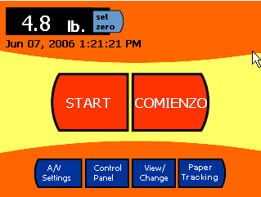

* Change “Help” button to “Paper Tracking” button (Manual Data Entry)
* Paper Tracking works the same as “Start/Comienzo” buttons in that the User login is retained in between transactions. The “Weigh More” screen variation is not shown after a Paper Tracking cycle, however, since it would incorrectly imply that a weighing had been done.

### Select your name screen

* No change

### Main Menu - Revised

* New design incorporating:
  + Hierarchy, via folders and buttons
  + hierarchical breadcrumbs
  + Title, derived from the type dimension currently selected: [ Foods | Reasons | Containers ]
  + EO – Event Order interactive entry button (optional based on Tracker configuration setting)
  + Handles ability to have Post-Main menu questions.

**Mock-ups:**

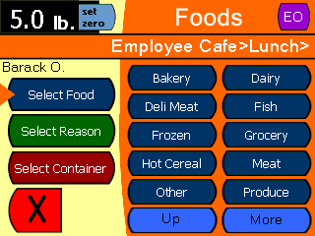 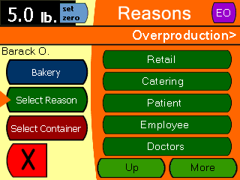

*Containers Screen, where there are NO Post-Main Menu Questions:*

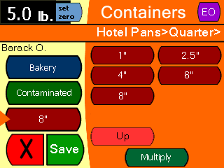

*Containers Screen, where there are Post-Main Menu Questions:*

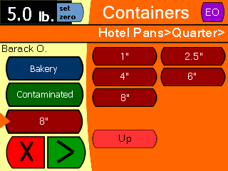

Design Notes re above mock-ups:

* TBD – design of the folder button look. It will be the same color regardless of data dimension, so that it is easily distinguished from a Type selection button.
* Multiply button will appear as now, on the containers screen when all choices are made.
* We want to optimize for the case where the user goes back to select a different food or reason after all 3 have been already selected. As shown above, reserve room for the Multiply button just on Containers, and make the user go back to Containers to access the Multiply button in this particular use case.

### ~~Free-form Notes -~~ Dropped

* ~~[Insert Mock-up here]~~
* ~~This is an option that allows the user to enter notes via a virtual keyboard.~~

### Event Order Number Data Entry

* EO # entry screen is shown 1) if there is an EO question configured or 2) if the interactive EO option is enabled (which shows a button on the main screen for entering EO).
* User provides a EO # via PIN. Previous EO # is pre-filled. Pre-filled EO # is cleared when user clicks the first number.
* Cancel, Enter buttons to cancel or save the EO# as part of the current transaction. If the transaction is cancelled, the EO# is discarded.

EO # entry screen mock-up:

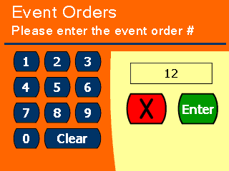

### Questions

* Questions resolve the value of the following type dimensions by asking a question and offering the user a hierarchical set of items to choose from:
  + Station
  + Disposition
  + Daypart
  + Pre/post consumer
  + User-defined
* EO (formerly BEO) – Note that EO can be specified either by configuring an EO type Question or manually by using the EO button on the Main Menu. If the former is chosen, then the EO # entry screen will appear in the order configured in the VWA Tracker Manager. If the latter is chosen, then the user has to click the EO button (see Main Menu mock-up) to access this screen.

### Pre-Main Menu Questions - New

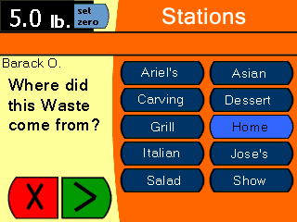

* Pre-Main Menu Questions are optionally configurable data entry screens that present hiearchical sets of buttons (except for EO and Pre/Post Consumer types – EO shows the EO# entry screen, and Pre/Post Consumer shows just the 3 choices that can occur). The hierarchical buttons work essentially the same as the main menu design, which allow user to select the new data dimensions available for ValuWaste 4. The difference is that there is only one type dimension per screen, and the selected item is highlighted instead of being placed in the type selector buttons – which don’t exist here.
* The configurable Question is on the left, taking the place of the type selector buttons.
* All data dimensions use the double button row design (shown).
* Title (above breadcrumbs, like in Main Menu) is automatic based on the type dimension: [ Stations | Dispositions | Dayparts | Waste Type (i.e. Pre/Post Cosumer, with two buttons only) | Question (i.e. User-Defined Question with user specified answer buttons) ]
* There will be a “Next” button (using an image rather than the word) that appears after the button selection is made.

### Post-Main Menu Questions – New

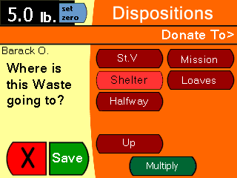

* Post-Main Menu Questions are the same as Pre-Main Menu Questions except:
  + They occur after the Main Menu.
  + The last Question screen will contain the Save button rather than the “Next” button.
  + The last Question screen will contain the Multiply button, to allow multiplying the number of items

## Volume Entry Option

If the following conditions are all met when the user hits “Save”, the Enter by Volume screen is invoked.

* Volume entry option is enabled (see VWA Tracker Manager, exported as part of the config file transfer).
* The user-selected food type includes a nonzero weight-per-volume.
* The user-selected container type includes a nonzero volume-per-container

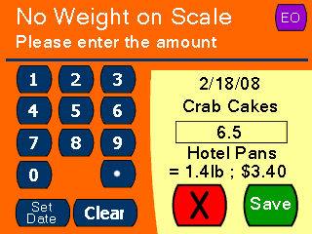

This allows the user to enter the number of containers of the food type that is being wasted, which is converted to weight and $.

## Paper Tracking Waste Loop – New

Paper tracking (a.k.a. “manual data entry”) is a new data entry mode for VWT that allows the use of “memorized transactions” that have all the data dimensions specified in advance, and a number is manually entered by the user that allows computation of the weight (using a unit of measure).

### Overview – Paper Tracking Loop

1.0 Home screen

1.1 User Clicks Paper Tracking button

2.0 User screen (if users are present)

3.0 Paper Entry – Step 1 – Select Memorized Transaction

3.1 Optional Event Order entry (interactive button)

4.0 Paper Entry – Step 2 – Select Amount

4.1 Optional Event Order entry (interactive button)

4.2 Optional Set Date entry (interactive button)

4.3 Save or Cancel and return to 1.0 Home Screen

Notes:

* Cancel can occur at any point.

### Paper Tracking UI

* Main Menu – the Help button is reprovisioned to use as the invocation of a Paper Tracking waste transaction (see Main Menu mockup above).
* User is entered per a normal transaction, including remembering the previous user for the duration of the user timeout period.
* Transaction picker screen – a screen similar to the Questions data entry screens is used.

*before item is selected:*

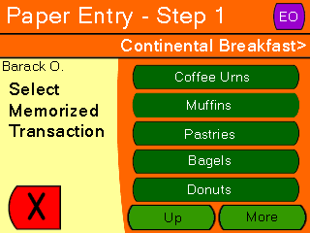

*after item is selected:*

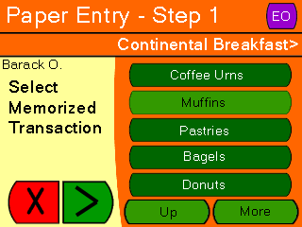

* + Menus can be used to represent “paper forms”, with subordinate menus/buttons used to find the desired memorized transaction.
  + When a button is clicked, that memorized transaction is selected, and the UI presents the “next” button to proceed to the data entry screen.
  + EO button allows entry of an Event Order #.
* Data entry screen:

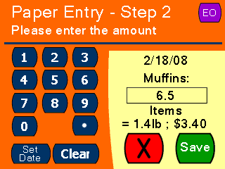

* + Numeric pad for entering QTY
  + Decimal point button for entering a fractional amount
  + Button allowing entering a specific date applicable to the transaction
  + EO button allows entry of an Event Order #.
  + Label revealing the units of measure (UOM) for the memorized transaction.
  + Label revealing the computed weight based on the QTY entered.
  + Label revealing the computed value based on the QTY entered.
  + All type dimensions are specified for every memorized transaction, so that the Tracker user only needs to enter the QTY (and if necessary the Date if it is not the current Date).
* Transaction structure

|  |  |  |  |  |  |
| --- | --- | --- | --- | --- | --- |
|  |  |  | **Conversion** | | computed |
| **Name** | **QTY** | **UOM** | **TO LBS** | **DATE** | **Weight** |
| Patient Tray | 11 | Trays | 2.30 | 2/11/2008 | 25.30 |
| Coffee Gallons | 4 | Gallons | 7.00 | 2/12/2008 | 28.00 |
| H'or Deuvres Expired | 25 | Pieces | 0.05 | 2/15/2008 | 1.25 |

## Control Panel

Generally, there are few changes to the VWT Control Panel. The following is a list as of this writing (2/7/08):

* Add Time Zone Setting to Date/Time interface.
  + Research whether there is a way to integrate new DST into the code.
  + Make Time Zone setting persistent, since Windows doesn’t accomplish this? (Mantis 600, 602)
* Improve exception handling related to bad USB media, if possible. See Mantis 593.

# VWT4 Utilities

The desire is to add new utilities for reducing the need to exit VWT application during troubleshooting, reconfiguration and customer support.

## Common Tasks that Require Exiting to Windows (Dave B.)

DB would like to avoid (ordered by importance):

1. Export Flash FX Copy to the Thumb drive.
2. Import Flash FX from Thumb drive.
3. Stylus: Screen Re-Calibration, Launches the Screen recalibration utility and then exits back to Advantage once they are done.
4. Launching Internet Explorer/Explorer and Viewing Flask FX contents.
5. Notepad/Keyboard utility so changes to Flash FX .dat files VWTConfig.dat and VWTSetup.dat could be done on the Tracker.
6. Ability to update the Tracker Serial # without having to export flash FX, make all the changes and the re-import.
7. Attact file in VWT folder:  Ability to access this folder and make changes to the logos within.  Mainly removal if they are no longer an ARAMARK acct. and need to input their new logo.  This could be more difficult and could use the Export/Import Flash FX above to accomplish this task.  This would be beneficial of a loaner is sent to an account (Bon Appetit, but has an ARAMARK Logo still in it)
8. Print Screen Option—a button that will capture an image of the current screen (Maybe only show’s up on Errors) and saves that image into FlashFX so the it could be exported to the thumb drive and sent to me.  Or would the error recording we’ve been talking about cover this?
9. Changing Time Zone (but we’ve given up on that one right?)
10. Advantage/Tracker note—
    1. On upload via FTP, could we put some directional items in there so this uploader capability could also be used to upload from the thumb drive?
    2. Make it secret so they couldn’t make a mistake of switching to it but would only know about it if I directed them to “flip the switch” so I could get the Flash FX etc. sent directly to me.
    3. While we’re at it, could I reverse download?  Example they send me the Flash FX, I make changes and can send it back through Advantage?
    4. Most time consuming thing I do with a customer:
       1. Walk them through the Exiting to Windows.
       2. Finding what I want on Windows.
       3. Collecting what I need off the Tracker.
       4. Walking them through the uploader (www.lrssolutions.com/Uploader) at the PC.
       5. Making the changes once I get the file.
       6. Posting the changed (file, .dat, etc.) to a website.
       7. Walking them through finding that site.
       8. Downloading the changes via their PC.
       9. Unzipping the changes on their PC.
       10. Putting them onto their thumb drive.
       11. Moving the changes to the Tracker.

# VWT4 Data Protocol Specs

Standard text files are used for transferring data between VWT and VWA. Initially, these files are transferred via USB memory but other types of media will be used in the future, e.g. network.

There are currently three types of transfer files:

* Configuration file
  + Created by VWA
  + Targets one or more VWT stations
  + VWT reads the file and configures itself according to the instructions in it
* Waste records file
  + Created by VWT stations
  + Read by a VWA instance, the data is converted and inserted into the currently open Jet database.

## File System Rules and Conventions

Multiple configurations, waste record sets, and application updates can be written to a single USB memory device.

The file structure of the device containing VW data transfer files is as follows

[root directory designation]\VWT4\[filenames] contains VW data transfer files

The root directory designation is standard hard disk, e.g. “F:\”.

The Volume Label is named “VALUWASTE”

## File Formats – Overview

* All file formats are text, using CSV (comma separated values) with one record per line. EOL (end of line) denotes the end of a record.
* For purposes of matching keywords, text formats are not case sensitive. Case is preserved in data records.
* [v3.1] The order of records determines the order that items will appear in the VWT UI. This applies to food, loss, tare, and user elements.

## Configuration Files

### Configuration File Handling

The configuration filename for data transfer is:

VWT4ConfigTransfer.dat

This text file contains all configurations for a single ValuWaste database, which normally includes all Trackers in the management scope of a particular Host PC.

### Configuration Transfer File Format

The format is as follows (order is important unless otherwise noted):

* Transfer record is the first record of the file, which records date+time that the file was written by VWA.
* A set of sections, one per Tracker, containing complete and separate configurations for each Tracker.

A Tracker will search through VWT4ConfigTransfer.dat until it finds a Tracker record that matches its unique serial # (TermID). That configuration will then be loaded. Subsequent operation and food waste logging will be done according to the new configuration.

| **Configuration Data Record Structure** | | |
| --- | --- | --- |
| **Record type 0 – Transfer (one only per file)** | | |
|  | Record Type ID | * “TransferConfig” |
|  | Transfer File Written by VWA (Date + Time) | * The date + time that this file was written by VWA. |
|  | Transfer Written Locally by VWT (Date + Time) | * The date + time that this file was written to the Tracker by VWT, which represents the “update” date+time. * NOTE: this is only written by VWT as part of the Transfer Config process, and thus only is seen on the Tracker itself. |
|  | Product Version of VWA4.NET that wrote this config file.  (String) | * Provided by VWA4.NET in standard .exe version format. |
|  | Assembly Version of VWA4.NET that wrote this config file.  (String) | * Provided by VWA4.NET in standard .exe version format. |
| **Record type 1 – Volume Units of Measure (one set of records per file)** | | |
|  | Record Type ID | “VolumeUnit” |
|  | Unique Name  (string / 20) | * Key of this unit type – maintained specifically to be invariant across versions and instances of the database |
|  | Display Full Name  (string / 50) | * Display name, non-abbreviated |
|  | Display Abbreviated Name  (string / 20) | * Display abbreviation |
|  | Conversion Factor  (decimal) | * Factor to convert any number of these units to cups |
| **Record type 2 – Weight Units of Measure (one set of records per file)** | | |
|  | Record Type ID | “WeightUnit” |
|  | Unique Name  (string / 20) | * Key of this unit type – maintained specifically to be invariant across versions and instances of the database |
|  | Display Full Name  (string / 50) | * Display name, non-abbreviated |
|  | Display Abbreviated Name  (string / 20) | * Display abbreviation |
|  | Conversion Factor  (decimal) | * Factor to convert any number of these units to pounds |
| **Record type 3 – Food Cost Discounts (one set of records per file)** | | |
|  | Record Type ID | “FCDiscount” |
|  | Food Type ID  (string) | ID (Primary key) for the food type that qualifies for this discount, assuming the loss reason also matches. |
|  | Loss Type ID  (string) | ID (Primary key) for the loss reason that qualifies for this discount, assuming the food type also matches. |
|  | Discount factor  (Decimal) | Decimal value of 0 or greater, which provides a multiplier that is applied against computed food cost in the event that a transaction’s food type and loss reason match those in this record.  Waste Cost = (Food cost * (Weight – Container Weight) * Food Cost Discount) + (Container Cost * Container Weight) |
| **Record type 4 – Tracker Info (one only per Tracker section – must be first)** | | |
|  | Record Type ID | * “Tracker” |
|  | Tracker ID  (integer – in DB as text) | * The unique serial number of the target VWT station for this record. (TermID in the DB) |
|  | Tracker Name  (string / 20) | * Text string designating the assigned name of the Tracker associated with Tracker ID. (TermName in the DB) |
|  | Admin PIN  (string / 6 – numerics only) | * PIN for gaining Admin access (0-6 digits)   + 0 digits (null) => no PIN required |
|  | Waste Loop Timeout value  (integer) | * Number of seconds of inactivity, during a waste log reading, before the current user is logged out and the station is returned to the Stage 1 menu. |
|  | Admin Timeout value  (integer) | * Number of seconds of inactivity, during an Admin session, before the current user is logged out and the station is returned to the Stage 1 menu. |
|  | Attract Loop Timeout value  (integer) | * Number of seconds of inactivity, while at the Stage 1 menu, before the attract loop starts. |
|  | Delete Record Reachback Timeout value (see View/Change funct in VWT)  (integer) | * Number of seconds that can elapse before a waste record can no longer be edited or deleted on the Tracker. 0 means that records cannot be edited or deleted. |
|  | Default Waste Class  (integer) | * Standard Waste Class # that is used to configure the UI. Standard values thus far:   + -1 = All Waste Classes (most generic)   + 0 = Food_General – (standard, generic Food mode)   + 100000 = Non-food_General (standard, generic Non-food mode) |
| **Record type 5 – Site Info (one only per Tracker section)** | | |
|  | Record Type ID | * “Site” |
|  | Site ID  (integer) | * ID (Primary key) of this site in the database |
|  | Site Name  (string) | * Text name of this site |
|  | Type Catalog ID  (integer) | * ID (Primary key) of this Type Catalog in the database * 0 => Master Type Catalog |
|  | Type Catalog Name  (string / 50) | * Text name of this Type Catalog |
| **Record type 6 – Languages (one only per Tracker section)** | | |
|  | Record Type ID | * “Lang” |
|  | Languages  (string) | * Sequence of 1-2 Language Names, using Microsoft globalization nomenclature, in order of priority. * If English + Spanish:   + Must be “en,es” * If English only:   + Must be “en” |
| **Record type 7 – Units of Weight Measure (one only per Tracker section)** | | |
|  | Record Type ID | * “Units” |
|  | Display weight units of measure  (string) | * Specifier of what the weight of the transactions are displayed in, i.e. can be either: ‘lb’ or ‘kg’. * Note: internally all weights are tracked as lbs. * Note: for 4.2 – VWT expects lb only (kg display is not yet implemented) |
| **Record type 8 – Operation Mode (one only per Tracker section)** | | |
|  | Record Type ID | * “Mode” |
|  | User Login Mode  (string) | * “Login-On” indicates login is required * “Login-Off” indicates login is not required |
|  | Food Mode  (string) | * “Food-On” indicates loss code entry is required * “Food-Off” indicates loss code entry is not required |
|  | Loss Mode  (string) | * “Loss-On” indicates loss code entry is required * “Loss-Off” indicates loss code entry is not required |
|  | Tare Mode  (string) | * “Tare-On” indicates tare code entry is required * “Tare-Off” indicates tare code entry is not required |
|  | EO Mode  (string) | * “EO-On” indicates EO button should be displayed on Tracker for user-optional EO number entry. * “EO-Off” indicates EO button should be displayed.   Note on operation – if an EO Question is encountered, the EO button is turned off automatically, since the EO number entry screen will occur on every transaction in that event. |
|  | Pre/Post Default  (string) | Tracker-level default waste type (will be overridden if a Pre/Post Question is configured).   * “Pre” indicates pre-consumer waste is the default * “Post” indicates post-consumer waste is the default * “Int” indicates intermediate waste is the default |
|  | Produced Amount – Paper UI  (string) | Indicates whether or not the option to specify Produced Amount is enabled on the Tracker’s Paper UI loop:   * “ProdAmtPaper-On” indicates Produced Amount button is enabled * “ProdAmtPaper-Off” indicates Produced Amount button is disabled |
|  | Produced Amount – Main UI  (string) | Indicates whether or not the option to specify Produced Amount is enabled on the Tracker’s Main UI loop:   * “ProdAmtMain-On” indicates Produced Amount button is enabled * “ProdAmtMain-Off” indicates Produced Amount button is disabled |
|  | Volume Based Data Entry – Main UI  (string) | Indicates whether or not the option to enable Volume Based Data Entry is enabled on the Tracker’s Main UI loop:   * “VolumeEntryMain-On” indicates enabled * “VolumeEntryMain-Off” indicates disabled |
|  | Use Admin PIN for Paper UI  (string) | Indicates whether or not the option to enable the Admin PIN is enabled for the Tracker’s Paper UI loop:   * “PaperUIPIN-On” indicates enabled * “PaperUIPIN-Off” indicates disabled |
| **Record type 9 – Default Station (one only per Tracker section)** | | |
|  | Record Type ID | * “DefStation” |
|  | Type ID  (string / 20) | * Primary key of the default Station type |
|  | Type Name  (string / 64) | * Name of the default Station type |
|  | Type Spanish Name  (string / 64) | * Spanish name of the default Station type |
| **Record type 10 – Default Disposition (one only per Tracker section)** | | |
|  | Record Type ID | * “DefDisposition” |
|  | Type ID  (string / 20) | * Primary key of the default Disposition type |
|  | Type Name  (string / 64) | * Name of the default Disposition type |
|  | Type Spanish Name  (string / 64) | * Spanish name of the default Disposition type |
| **Record type 11 – Default Daypart (one only per Tracker section)** | | |
|  | Record Type ID | * “DefDaypart” |
|  | Type ID  (string / 20) | * Primary key of the default Daypart type |
|  | Type Name  (string / 64) | * Name of the default Daypart type |
|  | Type Spanish Name  (string / 64) | * Spanish name of the default Daypart type |
| **Record type 12 – User Buttons** | | |
|  | Record Type ID | * “User” |
|  | Type ID  (string / 20) | * Primary key of the default User type – str(20) |
|  | Button Name  (string / 25) | * Name of this User Button – str(TBD) |
|  | Button Spanish Name  (string / 25) | * Spanish name of this User Button – str(64) |
|  | PIN  (string / 6 – numerics only) | * FOR FUTURE EXPANSION – Not currently used. Must be blank. * PIN for this user (0-6 digits)   + 0 digits (null) => no PIN required |
|  | Language  (string / 2) | * FOR FUTURE EXPANSION – Not currently used. Must be blank. * Concept/architecture:   + If/when used, contains the standard language identifier (“en” for English, “es” for Spanish, etc.). |
| **Record type 13 - Food Menus/Buttons** | | |
|  | Record Type ID | * “Food” |
|  | Type ID  (string / 20) | * Primary key of this Food type |
|  | Button Name  (string) | * Fully qualified name of this Food Button in the form:   + \Menu\submenu\...\name |
|  | Button Spanish Name  (string) | * Spanish name of this Food Button in the form:   + \Menu\submenu\...\name |
|  | Cost  (currency) | * Cost of this Food type in currency format, per unit of weight (see Food Type Units of measure record) |
|  | Implied Station TypeID  (string / 20) | * This Station TypeID will be used if this food item is selected, unless explicitly overridden by a Question. |
|  | Implied Daypart TypeID  (string / 20) | * This Daypart TypeID will be used if this food item is selected, unless explicitly overridden by a Question. |
|  | Volume Weight  (decimal) | * Weight in lbs per Specified number of "VolumeUnits" per "VolumeUnitType" |
|  | Volume Units  (decimal) | * Number of "VolumeUnitType" volume units a lb of this food occupies |
|  | ~~Volume Unit Type ID~~  ~~(long integer)~~ | * ~~Volume unit type ID used to convert weight <-> volume for this food type~~ * ~~References UnitsVolume table, which contains the conversion factors~~ |
|  | Volume Unit Unique Name  (string / 20) | * The key of this unit type, referencing into the list of volume units built by VolumeUnit records (see above). |
| **Record type 14 – Loss Menus/Buttons** | | |
|  | Record Type ID | * “Loss” |
|  | Type ID  (string / 20) | * Primary key of this Loss type |
|  | Button Name  (string) | * Fully qualified name of this Loss Button in the form:   + \Menu\submenu\...\name |
|  | Button Spanish Name  (string) | * Spanish name of this Loss Button in the form:   + \Menu\submenu\...\name |
|  | Type Overproduction Flag  (boolean) | * Flag designating whether this is an Overproduction item. * 0 => false; -1 => true |
|  | Type Trim Waste Flag  (boolean) | * Flag designating whether this is a Trim Waste item. * 0 => false; -1 => true |
|  | Type Handling Flag  (boolean) | * Flag designating whether this is a Handling item. * 0 => false; -1 => true |
| **Record type 15 – Container Menus/Buttons** | | |
|  | Record Type ID | * “Cont” |
|  | Type ID  (string / 20) | * Primary key of this Container type – str(20) |
|  | Button Name  (string) | * Fully qualified name of this Container Button in the form:   + \Menu\submenu\...\name |
|  | Button Spanish Name  (string) | * Spanish name of this Container Button in the form:   + \Menu\submenu\...\name |
|  | Tare Weight  (decimal) | * Weight in pounds for this tare weight entry. |
|  | Cost  (currency) | * Cost of this Container type in currency format, per container |
|  | Volume Units  (decimal) | * Number of "VolumeUnitType" units that this container contains |
|  | ~~Volume Unit Type ID~~  ~~(long integer)~~ | * ~~Volume unit type ID used to convert weight <-> volume for this food type~~ * ~~References UnitsVolume table, which contains the conversion factors~~ |
|  | Volume Unit Unique Name  (string / 20) | * The key of this unit type, referencing into the list of volume units built by VolumeUnit records (see above). |
| **Record type 16 – Pre Main Menu Question Menus/Buttons** | | |
|  | Record Type ID | * “PreQ” |
|  | Question Type ID  (integer) | * 1 => Station * 2 => Disposition * 3 => Daypart * 4 => BEO * 5 => Pre/post consumer * 6 => User Defined |
|  | Button Name  (string) | * Fully qualified name of this Button in the form:   + \Menu\submenu\...\name |
|  | Button Spanish Name  (string) | * Spanish name of this Button in the form:   + \Menu\submenu\...\name |
|  | Data Type ID  (string / 20) | * Question type 1-3: contains PK of the data type (string) * Question type 4 (BEO) = null * Question type 5 (Pre/Post) = ‘Pre’,’Post’, or ‘Int’ * Question type 6 (User Defined) = null |
| **Record type 17 – Post Main Menu Question Menus/Buttons** | | |
|  | Record Type ID | * “PostQ” |
|  | Question Type ID  (integer) | * 1 => Station * 2 => Disposition * 3 => Daypart * 4 => BEO * 5 => Pre/post consumer * 6 => User Defined |
|  | Button Name  (string) | * Fully qualified name of this Button in the form:   + \Menu\submenu\...\name |
|  | Button Spanish Name  (string) | * Spanish name of this Button in the form:   + \Menu\submenu\...\name |
|  | Data Type ID  (string / 20) | * Question type 1-3: contains PK of the data type (string) * Question type 4 (BEO) = null * Question type 5 (Pre/Post) = ‘Pre’,’Post’, or ‘Int’ * Question type 6 (User Defined) = null |
| **Record type 17 – Memorized Transaction Menus/Buttons** | | |
|  | Record Type ID | “MemTrans” |
|  | Button Name  (string) | Fully qualified name of this Button in the form:   * \Menu\submenu\...\name |
|  | Button Spanish Name  (string) | Spanish name of this Button in the form:   * \Menu\submenu\...\name |
|  | Unit type key  (string) | Units of measure for the numeric entry that the user will make on the VWT Paper Tracking UI screen. The quoted string will appear on the VWT UI to indicate to the user the appropriate units to enter.   * “” = no entry * “Item” = “Items” (all item types use this code – which can refer to pans, cans, plates, trays, etc. Use Unit type Display name below to specify the name to use). * ”Pound” = “lb” (weight) * “Kilogram” = “kg” (weight) * ”Gram” = “grams” (weight) * “Milligram” = “Milligrams” (weight) * ”Ounce” = “oz” (weight) |
|  | Unit type Display name (string) | Name to display on PaperTrackingUI for this memorized transaction.  Comes from the UnitsWeight configuration table. |
|  | Unitary Item Weight  (decimal) | Food Weight in lbs that corresponds with 1.0 being typed by the user as the numeric entry. VWA supplies unitary weight here as a conversion constant, by which the numeric entry is multiplied.   * Accuracy to 4 decimal points. * Not Tare adjusted! |
|  | Pre/post consumer flag  (integer) | * 0 => Intermediate waste * 1 => Pre-consumer waste * 2 => Post-consumer waste |
|  | Food type Name  (string) | Food type name for this transaction. |
|  | Food type ID  (string / 20) | ID (Primary key) for the food type for this transaction. |
|  | Food type cost  (currency) | Cost for this food type from current Tracker configuration.   * Can be zero |
|  | Loss type Name  (string) | Loss type name for this transaction. |
|  | Loss type ID  (string / 20) | ID (Primary key) for the loss reason for this transaction. |
|  | Container type Name  (string) | Container type name for this transaction. |
|  | Container type ID  (string / 20) | ID (Primary key) for the loss reason for this transaction. |
|  | Container weight  (Decimal) | Weight in pounds for the container type selected by the user.   * Accuracy to 4 decimal points. |
|  | Container Cost  (Currency) | Cost per weight unit for this type of container.   * Can be zero |
|  | Station type ID  (string / 20) | ID (Primary key) for the station type for this transaction.   * Can be blank |
|  | Disposition type ID  (string / 20) | ID (Primary key) for the disposition type for this transaction.   * Can be blank |
|  | Daypart type ID  (string / 20) | ID (Primary key) for the daypart for this transaction.   * Can be blank |
|  | User-Defined Question - Button Name  (string) | Fully qualified name of a Button that indicates the selection of a User-Defined Question, in the form:   * \Menu\submenu\...\name |

### Notes on Configuration Transfer File Format

* All type menus and buttons are displayed in VWT in the order received via this file.
* Pre and Post Main Menu Questions – are asked in the order received via this file.
* /* denotes a comment
* The number and order of languages in the Profile record determines the number and order, left to right, of the language variation Start buttons on the Stage 1 VWT menu.
* The order of user names, food types, loss types, and tare types in the configuration file determines the order that buttons are presented to the user on VWT.
* Memorized Transactions Notes:
  + The VWT transaction will inherit Tracker defaults for Pre/post, Station, Disposition, and Daypart if they are not explicitly specified in the Memorized Transaction.

## Waste Log Files

### Waste Log Transfer File Handling

The filename for the waste log file is:

VWTWastelogTransfer.dat

This text file contains all waste records that have been transferred, which normally includes the new waste records generated by all stations in the management scope of a particular Host PC. However, depending on the operational context, it may contain only a subset of stations, and it could also contain backup waste records as well as new records.

### Waste Log Transfer Process

* Each VWT station appends its waste log data to VWTWastelogTransfer.dat when transferring data for consolidation into VWA. These appended file sections start with a Transfer Record (see Waste Log File Format below).

### Waste Log File Format

#### Record Type 1 - Transfer

| **Waste Log Record Data Structures** | | |
| --- | --- | --- |
| **Record type 1 – Transfer (one only per section)** | | |
| 0. | Record Type ID | * “TransferWaste” |
|  | Tracker ID | * The unique serial number of the Tracker that generated this record. |
|  | Tracker Name | * Text string designating the assigned name of the station associated with Tracker ID. |
|  | Transfer Date + Time | * The date + time that this file section was written by the originating VWT. |
|  | Transfer Type | * “New” or “Prior” * See earlier specs for explanation of these transfer types. |
|  | Tracker Software Version | * String with Tracker software version #, standard Microsoft format (e.g. 4.0.1.1) * Used for reporting whether people have done their upgrades. * For ValuWaste 4, the Tracker version must be 4.x.x.x. |
|  | Site ID | * ID (Primary key) of the Site that this Tracker is associated with. |
|  | Site Name | * Name of the Site that this Tracker is associated with. |
|  | Type Catalog ID | * ID (Primary key) of this Type Catalog in the database (Integer). 0 => Master Type Catalog |
|  | Type Catalog Name | * Text name of this Type Catalog |
|  | VWA Product Version | * String with VWA4 Product Version #, standard Microsoft format (e.g. 4.0.1.130) * Used for reporting whether people have done their upgrades; debugging problems. * For ValuWaste 4, the Tracker version must be 4.x.x.x. |
|  | VWA Assembly Version | * String with VWA4 Assembly Version #, standard Microsoft format (e.g. 4.0.3674.24640) * Used for reporting whether people have done their upgrades; debugging problems. * For ValuWaste 4, the Tracker version must be 4.x.x.x. |
|  | Notes: | * Site data is used for consistency check (database already has a Site linkage via the Tracker ID). * Type Catalog association is derived from the |

#### Record Type 2 – Waste Data Records

|  |  |  |
| --- | --- | --- |
| **Waste Log Record Data Structures** | | |
| **Record type 2 – Waste Data Records** | | |
|  | Record Type ID | * “WData4” |
|  | Date + Time | * Timestamp of this record. (Completion of transaction) |
|  | Pre/post consumer flag | * 0 => Intermediate waste * 1 => Pre consumer waste * 2 => Post consumer waste |
|  | Weight | * (Decimal) Weight in pounds for this waste measurement. Accuracy to 4 decimal points. * Relationship to NItems: this weight is already inclusive of NItems, i.e. obtaining weight per item requires dividing by NItems. * Not Tare adjusted! |
|  | Food Waste Cost | * (Currency) Total cost of the **food waste** (not including container waste costs) in this record, Calculated from food cost; tare weight is taken into account.   FOOD Waste Cost = (Food cost * (Weight – (Container Weight * NItems)) * Food Cost Discount)  TOTAL Waste Cost = (Food cost * (Weight – (Container Weight * NItems)) * Food Cost Discount) + (Container Cost * Container Weight) |
|  | Food type name | Button name of the food type |
|  | Food type ID | * ID (Primary key) for the food type for this transaction. |
|  | Food type Cost | * (Currency) Cost for this food type from current Tracker configuration. * Can be zero |
|  | Food Cost Discount | * (decimal - Percentage) Discount multiplier that adjusts the food cost (normally based on loss reason). * Normally set to 1, meaning no discount. * does NOT apply to the container cost! |
|  | Loss type name | Button name of the Loss type |
|  | Loss type ID | * ID (Primary key) for the loss reason for this transaction. |
|  | Container type name | Button name of the container type |
|  | Container type ID | * ID (Primary key) for the container type for this transaction. |
|  | Container weight | * (Decimal) Weight in pounds for the container type selected by the user. Accuracy to 2 decimal points. |
|  | Container Cost | * (Currency) Cost per item for this type of container. |
|  | Station type name | Button name of the Station type |
|  | Station type ID | * ID (Primary key) for the station type for this transaction. * Can be blank |
|  | Disposition type name | Button name of the Disposition type |
|  | Disposition type ID | * ID (Primary key) for the disposition type for this transaction. * Can be blank |
|  | Daypart type name | Button name of the Daypart type |
|  | Daypart type ID | * ID (Primary key) for the daypart for this transaction. * Can be blank |
|  | EO (Event Order) Number | * Event Order number for this transaction, not the TypeID. * Can be blank * On import waste, VWA attempts to find an EO with this number – if one exists then that is set to be the EO Type for this transaction. If one doesn’t exist then a new EO Type is created for this number. |
|  | User type name | Button name of the user type |
|  | User type ID | * ID (Primary key) for the user who logged this transaction. * Can be blank |
|  | User-Defined Question - Button Name | Fully qualified name of the Button that the user selected in response to the User-Defined Question, in the form:   * \Menu\submenu\...\name |
|  | NItems (Wasted number of items) | * Multiplier – number of items that make up this transaction (1 – N). * If Memorized Transaction Item type – this is the number of items entered in by the user (closest integer?) * if Memorized Transaction Weight mode entry –this is always going to be 1 |
|  | Recording Method | * 0 => Standard Waste Loop * 1 => Memorized Transaction - Weight * 2 => Entered by Volume * 3 => Memorized Transaction – Items * 4 => Manual Entry from VWA * 5 => Manual Entry from VWT |
|  | Produced Amount User Entry (in Units of Measure) | This is the number that the user entered in the Produced Amount dialog, in the units specified below. |
|  | Units of Measure Display name | This is the label for the units that the user entered (in volume or Paper UI memorized transactions).  For standard waste loop transactions this defaults to “lb” (in the future this could be “kg”). |
|  | Weight Units of Measure Unique Name  (string / 20) | Key of the WEIGHT unit type for this record – maintained specifically to be invariant across versions and instances of the database.  If a MEMORIZED transaction of the Item type, this will indicate lb (future could be kg), i.e. it would contain “Pound”. |
|  | Lot Number  (string / 50) | ID used to associate production data record describing the origin of the food being wasted in this record.   * ~~Can be blank.~~ * ~~When non-blank, contains the full data + time:~~ * Contains the full date + time in the following format:   + “yyyymmdd hh:mm:ss” |
|  | Waste Amount User Entry (in Units of Measure) | This is the number that the user entered in the Volume or Paper UI (Memorized Transaction) Amount dialog, in the units depending on recording method. |
|  | Unitary Item Weight  (decimal) | Gross Weight in lbs that corresponds with 1.0 being typed by the user as the numeric entry. VWA supplies unitary weight here as a conversion constant, by which the numeric entry is multiplied.   * Accuracy to 4 decimal points. * Not Tare adjusted! |
|  | Transaction Start Timestamp  (Timespan) | Used to calculate the amount of time it took the user to complete this transaction. |

#### Exploration of Waste Record modes

|  |  |  |
| --- | --- | --- |
| **Waste Mode/ Transaction field** | **Transaction field contents** | **Notes / Implications** |
| 1. **Standard Waste Transaction (Scale)** |  |  |
| * 1. Recording Method | 0 => Standard Waste Loop |  |
| * 1. Waste amount – user entry | blank | * not used |
| * 1. Produced amount – user entry | Optional produced amount in pounds |  |
| * 1. Units of measure Display name | “lb” | * Doesn’t affect calculations – audit only |
| * 1. Unitary Item Weight | blank | * not used |
| * 1. Weight Units unique name | “Pound” |  |
| * 1. NItems | Multiplier entered by user (1-N) | * The saved waste amount for this transaction is (NItems * scale weight). * The container weight used for the transaction is (NItems * weight of a single container) |
| 1. **Memorized Waste Transaction - Weight** |  |  |
| * 1. Recording Method | 1 => Memorized Transaction – Weight |  |
| * 1. Waste amount – user entry | Waste amount in weight units specified by weight units unique name (see below) |  |
| * 1. Produced amount – user entry | Optional produced amount in weight units specified by weight units unique name (see below) |  |
| * 1. Units of measure Display name | Label user saw for amount entry in UI | * Doesn’t affect calculations – audit only |
| * 1. Unitary Item Weight | blank | * not used |
| * 1. Weight Units unique name | “Pound”, “Kilogram”, “Ounce”, “Gram”, or “Milligram” | * Standard weight units, from configuration database |
| * 1. NItems | 1 | * The user-entered weight model is that the waste is all contained in a single container. |
| 1. **Volume-based Waste Transaction** |  |  |
| * 1. Recording Method | 2 => Entered by Volume |  |
| * 1. Waste amount – user entry | Waste amount in number of Containers selected. | * conversion constants for # of containers to weight are in the selected Container Type and Food Type, stored in the database (Manage Types) |
| * 1. Produced amount – user entry | Optional produced amount in number of Containers | * same as above |
| * 1. Units of measure Display name | Label user saw for amount entry in UI (ie container name) | * Doesn’t affect calculations – audit only |
| * 1. Unitary Item Weight | blank | * Conversion constants are derived from database configuration, based on keys of food and container types (see above) |
| * 1. Weight Units unique name | “Pound” |  |
| * 1. NItems | 1 | * The volume model is that the waste is all contained in a single container. |
| 1. **Memorized Waste Transaction - Items** |  |  |
| * 1. Recording Method | 3 => Memorized Transaction - Items |  |
| * 1. Waste amount – user entry | Number entered by user to denote number of items wasted. | * items are configured as waste weight + container weight * must be integer, and the same as NItems |
| * 1. Produced amount – user entry | Optional produced amount in user-defined items | * items are configured as waste weight + container weight * Must be integer |
| * 1. Units of measure Display name | Label user saw for amount entry in UI | * Doesn’t affect calculations – audit only |
| * 1. Unitary Item Weight | decimal conversion constant | * Conversion constant for user-supplied amounts (items to pounds) from Memorized Transaction |
| * 1. Weight Units of Display unique name | “Pound” |  |
| * 1. NItems | Number entered by user to denote number of items wasted. | * Like a standard transaction, NItems denotes how many containers make up this transaction. |

#### ~~Record Type 3 – Production Data Records~~

|  |  |  |
| --- | --- | --- |
| **~~Waste Log Record Data Structures~~** | | |
| **~~Record type 3 – Production Data Records~~** | | |
|  | ~~Record Type ID~~ | * ~~“PData4”~~ |
|  | ~~Date + Time~~ | * ~~Timestamp of this record.~~ |
|  | ~~Lot Number~~  ~~(string / 50)~~ | ~~ID used to associate the production data described in this record with specific waste data records, which describe subsets of this produced food that was wasted.~~   * ~~See Record Type 2 – Waste Data Records, Lot Number field.~~ * ~~Contains the full date + time in the following format:~~   + ~~“yyyymmdd hh:mm:ss”~~ |
|  | ~~EO (Event Order) Type ID~~ | * ~~ID (Primary key) for the EO for this transaction. Allows produced food records to be associated with an Event Order.~~ * ~~Can be blank~~ |
|  | ~~Weight~~ | * ~~(Decimal) Weight in pounds (future: could be kg – see Units of Measure) for this waste measurement. Accuracy to 2 decimal points.~~ * ~~Not Tare adjusted!~~ |
|  | ~~Food Cost~~ | ~~(Currency) Total cost of the produced food specified in this record, Calculated from food cost; tare weight is taken into account.~~  ~~Food Cost = (Food cost * (Weight – Container Weight)~~ |
|  | ~~Food type name~~ | ~~Button name of the food type selected by the user.~~ |
|  | ~~Food type ID~~ | * ~~ID (Primary key) for the food type for this transaction.~~ |
|  | ~~Food type Cost~~ | * ~~(Currency) Cost for this food type from current Tracker configuration.~~ * ~~Can be zero~~ |
|  | ~~Container type name~~ | ~~Button name of the container type selected by the user.~~ |
|  | ~~Container type ID~~ | * ~~ID (Primary key) for the container type for this transaction.~~ |
|  | ~~Container weight~~ | * ~~(Decimal) Weight in pounds for the container type selected by the user. Accuracy to 2 decimal points.~~ |
|  | ~~Container Cost~~ | * ~~(Currency) Cost per item for this type of container.~~ |
|  | ~~Station type name~~ | ~~Button name of the Station type selected by the user.~~ |
|  | ~~Station type ID~~ | * ~~ID (Primary key) for the station type for this transaction.~~ * ~~Can be blank~~ |
|  | ~~Daypart type name~~ | ~~Button name of the Daypart type selected by the user.~~ |
|  | ~~Daypart type ID~~ | * ~~ID (Primary key) for the daypart for this transaction.~~ * ~~Can be blank~~ |
|  | ~~User type name~~ | ~~Button name of the user type~~ |
|  | ~~User type ID~~ | * ~~ID (Primary key) for the user who logged this transaction.~~ * ~~Can be blank~~ |
|  | ~~User-Defined Question - Button Name~~ | ~~Fully qualified name of the Button that the user selected in response to the User-Defined Question, in the form:~~   * ~~\Menu\submenu\...\name~~ |
|  | ~~Recording Method~~ | * ~~0 => Standard Waste Loop~~ * ~~1 => Memorized Transaction~~ * ~~2 => Entered by Volume~~ |
|  | ~~Produced Amount User Entry (in Units of Measure)~~ | ~~This is the number that the user entered in the Produced Amount dialog, in the units specified below.~~ |
|  | ~~Units of Measure Display name (abbreviation)~~ | ~~This is the label for the units that the user entered (in volume or Paper UI memorized transactions), or in “lb” if this is standard waste loop. (in the future this could be “kg”).~~ |
|  | ~~Units of Measure Unique Name~~  ~~(string / 20)~~ | ~~Essentially the key of this unit type – maintained specifically to be invariant across versions and instances of the database~~ |

# VWT4 Local Data Formats

This chapter discusses the formats and handling of files that are written locally to the Tracker for purposes of managing the VWT application.

## Factory Setup File

The Factory Setup file is an initialization file that is similar in structure to the Configuration and Waste log files (see following chapters).

The Factory Setup file is stored in flash memory on the Tracker, allowing applications running on it to easily access serial numbers, factory PIN and potentially other information that is set by the factory and not generally intended to be changed in the field.

| **Factory Setup File - Data Record Structure** | | |
| --- | --- | --- |
| **Record type 0 – Factory Setup** | | |
|  | Record Type ID | * “**FactorySetup**” |
|  | Software load date manufactured (Date + Time) | * The date + time that this unit was loaded with the current software. |
| **Record type 1 – UnitInfo** | | |
|  | Record Type ID | * “UnitInfo” |
|  | Model | * Model of the Tracker – a string that designates the model. E.g. VWT200 is the beta version. VWT200 is also used for backwards compatibility for the production version, since there are no form/function changes from beta to production. |
|  | Unit serial number | * Serial number of the Tracker – associated with the enclosure and chassis. |
|  | CPU serial number | * Serial number of the processor board that is currently installed in theTracker. |
|  | Scale serial number | * Serial number of the scale attached to this Tracker. |
| **Record type 2 – Factory PIN** | | |
|  | Record Type ID | * “FactoryPIN” |
|  | Factory PIN | * Integer PIN for gaining Admin access (6 digits) |

## Scale Calibration File

This file saves a set of empirically generated value pairs that relate A/D numerical data to associated calibrated weights. The VWT application interpolates between the A/D calibration readings to determine estimated weights associated with actual readings.

Example file contents:

/* SCALE CALIBRATION FILE for VWT - Unit #S10253

/* Written by Tracker #10000 at 3/19/2007 9:07 AM

WtCal,2096849,0.0

WtCal,2096771,2.0

WtCal,2096772,1.0

WtCal,2096696,2.0

WtCal,2096470,5.0

WtCal,2096092,10.0

WtCal,2095337,20.0

WtCal,2094959,25.0

## AV Settings File

This file saves the current state of the graphics and audio settings for the Tracker.

Example file contents:

100,255,3865470566,False

# Technical Design/Implementation

## Program Initialization

VWA4.NET Initialization steps:

1. Load Infragistics style data from embedded resource (.isl file)
2. Load installed version information, initialize version.
   1. Much of VWA4 functionality is conditioned by installed version
3. Store/retrieve pathname of last open database file (config file)
4. Open database and store connection for general use throughout the program
5. Load global variables for quicker performance from DB (?):
   1. First day of week
   2. Number of weeks in cycle (for Previous Cycle Week report)
   3. Current Site
   4. Path for reports image
   5. Minimum number of transactions for warning
   6. Default report settings (colors, fonts)?
6. Populate Task Explorer from database, set current task to home screen (main dashboard).
7. Query DB to find out latest full week of data; set the selected week to that week.
8. Show main dashboard (data being for the selected week – as with all tasks).
9. Process alerts/messages (e.g. “you are 3 weeks behind on collecting Tracker data”).
10. Display alerts/messages.
    1. e.g., check for minimum number of transactions reached
11. [Initialization complete]

## Database Modifications

### Global variables Needed to store in DB

1. First day of week
2. Number of weeks in cycle (for Previous Cycle Week report)
3. Current Site
4. Path for reports image
5. Minimum number of transactions for warning
6. Default report settings (colors, fonts)?

### Waste Transaction Table notes

## UI State Management

1. User Controls based on IVWAUserControlBase make up each modular element of the UI.
2. User Controls based on IVWAUserControlBase make up each modular element of the UI.
3. User Controls are instantiated when needed but then are kept alive for performance purposes; they are hidden and shown as needed, which allows them to retain their current state with minimum additional handling.
4. IVWAUserControlBase defines the following standard methods in its interface:
   1. Init sets the first day of the current week (which several of the controls need in order to display the proper data)
   2. LoadData initializes the control prior to making it visible.
   3. SaveData saves any state that is required to allow another control to control the UI behavior without damaging data integrity.
   4. ValidateData
5. Dictionary generic type is used to store the user controls that are used.

# Architecture/design Sessions

## Notes from Nathan Conf Call 6/11/08

Subject was how to architect the UI management/state switching. Key notes:

* UI States are primarily managed via ancestor user controls that contain what is needed for a particular state. These inherit from a base class for Tasks. The Task Explorer then shows/hides the UC’s as the main way of transitioning from one state to another.
* The ancestor user controls have a common interface that includes:
  + TaskExit method, which does what is needed to cleanup and handle the current state as another state is being called up.
    - TaskExit returns true if the task state is ready to switch; false if it is not. Typical reason it wouldn’t be ready is if a user prompt for saving changes is answered with a Cancel directive.
  + TaskStart method, which initializes the task state.
    - In general, Tasks should remember where they were when last accessed during a user session. TaskStart should ensure that the Task state is picked up where it left off, e.g. which item is selected in a list.
* Ini files in .NET:
  + App.config file, which is added as a new item in the project, stores name/value pairs like INI files in Delphi.

## 

## Notes from Steve Severance onsite session 7/19/08

Tutoring/pair programming session held at LeanPath office to kickstart SAR into faster development pace. This section documents info for/from that mtg.

### Questions/Plan for Mtg

email to plan for mtg:

Steve,

Thanks for fitting me into your schedule for a few hours of consulting.

It will be fairly easy to make some good progress at this meeting towards helping me speed up my development momentum as I dive into a new IDE, control set, reporting package, and existing code base.  I am successfully installed, up and running to extend and refine a C# application that is currently rough-hewn, created by another (unavailable) .NET programmer with architectural direction provided by Nathan.  Nathan specifically provided direction with regards to structuring classes and controls to achieve our requirement of a dynamic, modular, highly flexible, data-driven UI that provides access to a large array of ActiveReports reports, various dashboard-like pieces that are built on Infragistics control set, and some utility functions.  Nathan did a brief walk-through of code progress by the contractor about a month ago and seemed satisfied that the direction had been properly implemented, i.e. the plumbing is in place to take the app to the home stretch.

Background/Notes:

* ValuWaste Advantage (VWA.NET) is a Winforms app targeting XP (should also run on Vista), built on .NET 2.0 (I believe – Nathan recommended the approach, not the latest and greatest).
* Access 2003+ is the database (local only).  Not sure there is any benefit to going to 2007 format, but we could if there is benefit to be had.
* VWA.NET is a major rewrite/upgrade of a product that currently is currently built in Delphi.
* VWA configurator portion of the product (very complex) is written in Delphi and will remain there – will be called via DLL/EXE from this product.  Everything else is in the new .NET platform.  This will work fine because configuration is essentially a mode that is not done very often, and does not interact directly with the main VWA.NET stuff, which is all aimed at operations, reporting, minor setup changes, data uploads, etc.
* Refer to <http://www.leanpath.com/lpweb/lp_products_subhome.htm> for an overview of the current ValuWaste product.  The focus of our work is ValuWaste Advantage, the new version will be version 4 (current is 3).  I am about 95% complete with the major new rev of ValuWaste Tracker embedded software, and the configurator as well.

Agenda:

* Orient Steve to the current v3.1 product (15 minutes)
* Orient Steve to the basic v4 requirements (30 minutes)
  + See attached for a PPT containing UI layout/behavior overview and look and feel comps.
* Code walkthrough with interactive Q&A
  + Understand what is there now, how it fits together
  + Identify issues that need to be resolved, ideas for how best to resolve
  + Refer to database as appropriate – not the main focus but we do want to save as much program state as possible in it.
* Code extension/discussion during the walkthrough – some of the topics:
  + Approach for refining the UI and achieving the desired behavior (see PPT).  In particular, smooth switching between various modalities (“tasks”).
  + Improve home page layout in appropriate manner (closer to comps).
  + Hook some things up as examples of how to do things that the UI is spec’d to do.
  + Ideas for best ways to build various elements, e.g. Shortcuts, Settings link areas.
  + How best to link to program functionality from nav controls (i.e. the Infragistics UltraWinExplorer is the main nav control)
  + App config (ini files) for saving program state during and between invocations.
  + Working with resources (vs. files) e.g. Infragistic styles
  + Build, debug techniques
  + Database extensions as appropriate to drive UI content.
  + (later) how to wrap all this up into a nice install package.
  + (later) how to update pieces without reinstalling everything, e.g. add reports

Goals:

* Immediately accelerate Stephen’s momentum on development
* Assess code created by contractor (Mila); best way to get the most from it.  How to refine it to achieve pro quality look and feel.  How to resolve issues that we may find.
* Help lay out a sensible order of events for efficiently tackling the tasks at hand.
* Lay foundation for Steve to provide back-up for Nathan in the future.  Additional sessions as appropriate/needed.

Steve – hope this helps you get an idea of what’s up here.  Let me know if you have any questions.

Thanks, Stephen

**Additional questions:**

1. How to control behavior of docking, especially for resizing of window.
   1. Keep certain parts fixed; others grow/shrink with window size; set minimum sizes for the UC’s.
2. How best to organize the UI for showing/hiding UC’s and thereby accomplishing the UI behavior spec.
3. How do you view/select UC’s and other controls that are on a form, but which are not visible (structure hierarchy).
4. How do you hook events together from the UC’s, e.g. how to create UC-level events that hook to the forms in which the controls are placed?
   1. Hook the ExplorerBar events to the VWAMain so that it can show/hide pieces of the UI.
   2. Add some comments to the sample code to remember what is going on (Mila’s samples, e.g. in TaskList.cs).
5. How to filter a help search for Infragistics stuff only.

## Notes for/from Steve Severance Meeting #2

### Agenda/Prep

The following items are for discussion, review or actual implementation (during the session) as appropriate. All items refer to VWA4.NET unless otherwise specified.

1. Design/implementation of a good initialization framework. Basic requirements/flow:
   1. Load Infragistics style data from embedded resource (.isl file)
   2. Load installed version information, initialize version.
      1. Much of VWA4 functionality is conditioned by installed version
   3. Store/retrieve pathname of last open database file (config file)
   4. Open database and store connection for general use throughout the program
   5. Load global variables for quicker performance from DB (?):
      1. First day of week
      2. Number of weeks in cycle (for Previous Cycle Week report)
      3. Current Site
      4. Path for reports image
      5. Minimum number of transactions for warning
      6. Default report settings (colors, fonts)?
   6. Populate Task Explorer from database, set current task to home screen (main dashboard).
   7. Query DB to find out latest full week of data; set the selected week to that week.
   8. Show main dashboard (data being for the selected week – as with all tasks).
   9. Process alerts/messages (e.g. “you are 3 weeks behind on collecting Tracker data”).
   10. Display alerts/messages.
       1. e.g., check for minimum number of transactions reached
   11. [Initialization complete]
2. Reporting Framework review/questions:
   1. Mila is developing the Reporting Framework based on this specification (see VWA4 Reporting Framework). She has some specific questions regarding the best way to store report parameters – e.g. in a large single parameter hash table or separate hash tables.
   2. Some possible other questions on this may come out of the review.
3. Web based uploader - review <http://www.lrssolutions.com/Uploader>
   1. Launch / embed browser with the aboveURL specified, plus a parameter that is used to pre-load the file upload form field with the correct local path (so user doesn’t have to manually browse to find the current database file to upload).
4. Installation
   1. One install package
   2. Installs in one of n (initially 3) versions:
      1. Read-only
      2. Manager (superset of Read-only version)
      3. Enterprise (superset of Manager version)
   3. Some way of controlling which version is installed, e.g. a key
   4. Version protection for licensing purposes is not a priority
   5. Upgrade of version – OK to require a re-install, or just an unlocking approach
5. Go over TBD’s in this document, e.g. how to display printing progress (if possible).

## Research – Infragistics

1. How can one best print a form (report/dashboard) that contains a layout of Infragistics controls?

# Appendix – Development Tools Key Information

This Appendix provides a compendium of information regarding the tools and processes required to develop ValuWaste 4. The primary elements of VW4 include:

* ValuWaste Advantage 4 .NET
  + .NET Winforms application that is the primary tool for managing ValuWaste 4 databases.
  + Provides the primary reporting interfaces for analyzing and visualizing waste data, including the ability to create customized reports and report sequences.
  + Includes tools for helping track and manage the processes associated with ValuWaste.
  + Provides basic, user-friendly tools for managing the configuration of Trackers and system preferences.
* ValuWaste Advantage 4 Configurator
  + Delphi Win32 forms application that is the primary tool for configuring ValuWaste 4 databases.
  + Detailed ability to configure sites, types and Trackers.
* ValuWaste Tracker 4
  + .NET Compact Framework Winforms application that runs on the ValuWaste Tracker hardware, under Windows CE 4/5.

## Basic Requirements

### MS Visual SourceSafe

* MS Visual SourceSafe 8.0.50727.42, installed on server
  + On LRS-SVR1, the share containing the source is \\lrs-svr1\LRS
* Map a drive on PCs to access.
  + on SAR-LRS1, Z: is mapped to \\lrs-svr1\LRS
* Use VPN from external PCs to access, mapping drive similarly, but using IP address instead of server name.
  + on SAR-P5, Z: is mapped to [ip address]\LRS

## ValuWaste Advantage 4 .NET

### MS Visual Studio 2008 .NET

Install Visual Studio per normal installation.

### Developer Express DXperience

Install DevExpress DXperience.

* Pre-08/25/09, version was 8.2.4

# Appendix – Product Release Checklist

## Purpose

This document represents a perspective on VWA4 that is separate from and beyond the feature and buglist orientation that has driven the software development project thus far. It discusses enterprise, product and process considerations, with a focused eye on customer experience. Taking this broader perspective, practical issues such as documentation, product maintenance, version management, and of course release processes can be explored in depth.

In general, we are trying to uplevel the professionalism and quality of the overall product in a variety of dimensions. The winners of this effort will be customers and the stakeholders of LeanPath’s business, both of whom will reap greater value than the sum of the parts from looking at how it all fits together.

## Overview/Considerations

This document

* Enterprise value
* Customer efficiency and effectiveness
* Customer Support efficiency and effectiveness
* Product Upgrades and Deployment
* Disaster Recovery
* ….

## Appendix 1 – Practices

## Database Design

### Default Values – Specify

It is assumed that database defaults are used throughout. This means that the database can in many cases be added to without affecting existing code, which if defaults were not used would be required to initialize records.

## Database Access

### Avoid ADOTable Controls

ADOTable controls typically require the fields to be pre-specified before they can be accessed. This means that if a table is modified, every ADOTable control accessing it must also be specified (or every section of code that initializes an ADOTable control must be modified).

Instead, use SQL commands to retrieve the fields that you need.

# Appendix 2 – New/Modified Requirements Mop-up

This chapter collects requirements that have emerged recently, which need to be integrated into existing code, or existing detailed requirements. These are items that if not collected and handled carefully would be overlooked.

|  |  |  |
| --- | --- | --- |
| **Requirements** | **Status** | **Notes / Implications** |
| 1. Volume to weight conversion factors (VWT4.NET) |  |  |
| * 1. Main waste loop option | DONE | * If the volume to weight feature is enabled and there is no weight on the scale, then the option to enter a volume (rather than weight) in specified units (e.g. gallons) is presented. * This allows another form of manual data entry where all individual type selections can be made as normal, but the amount of weight can be entered as a volume which in turn is converted to weight. * If the volume to weight conversion factor is 0 for a selected food type, then the option to enter volume is not presented even if it is globally enabled. * Control VWT option and weight factors through configuration   + Add to config file import |
| 1. Volume to weight conversion factors (VWA4.Delphi, VWA4.NET) |  |  |
| * 1. Main waste loop option | DONE | * Control VWT through configuration   + Add to config file export |
| * 1. Main waste loop option | DONE | * Add checkbox onto Tracker configuration screen that enables/disables Volume oriented manual data entry on zero weight. |
| * 1. Food type volume to weight conversion factors | DONE | * Add a column to the food type that contains the factor for converting volume to a standard weight factor that will also be attached to containers. * If the volume to weight conversion factor is 0 for a selected food type, then the option to enter volume will not be presented even if it is globally enabled. |
| * 1. Add container type volume per container factor | DONE |  |
| 1. Catering (VWA4.Delphi, VWA4.NET) |  |  |
| * 1. Number of guests | DONE | * (database) EO type table needs to get a new column – number of guests (guest count) * (VWA.Delphi ) Add guestcount to Event Order Type manager. |
| * 1. Male/Female % of guests | DONE | * (database) EO type table needs to get a new column – M/F % of guests. * (VWA.Delphi ) Add M/F Ratio to Event Order Type manager. |
| * 1. ~~Waste data import~~ | DROP | * ~~(VWA4.NET) Need to add guest count and m/f % to waste data import~~ |
| 1. Catering (VWT4) |  |  |
| * 1. ~~Number of guests~~ | DROP | * ~~Add ability to enter number of guests (guest count)~~ |
| * 1. ~~Male/Female % of guests~~ | DROP | * ~~Add ability to enter M/F % of guests.~~ |
| * 1. ~~Waste data export~~ | DROP | * ~~Need to add guest count and m/f % to waste data export.~~ |
| 1. Paper UI (VWT4) |  |  |
| * 1. PIN option for Paper UI | DONE | * Add switch that enables PIN to protect Paper UI. * Uses same manager PIN * Control VWT through configuration   + Add to config file import |
| 1. Paper UI (VWA4.Delphi) |  |  |
| * 1. PIN option for Paper UI | DONE | * Add checkbox onto Tracker configuration screen that enables/disables PIN to protect Paper UI. * Uses same manager PIN * Control VWT through configuration   + Add to config file export |
| 1. Food Cost Discounting (VWA4.NET, VWT4) |  |  |
| * 1. Database tables | DONE | * One section per file – like weight and volume (no per-Tracker discounting at this time) |
| * 1. VWA4.NET Configuration Export | DONE | * One section per file – like weight and volume (no per-Tracker discounting at this time) |
| * 1. VWT4 Config Import, Food Cost calculations, Wastelog | DONE | * VWT4 has to import the config, build an in-memory table for the discount data, check this table on every waste entry and apply it when appropriate. Also save the discount factor as part of the waste record. |
| * 1. VWA4.NET Wastelog Import, Food Cost calculations | DONE | * VWA4.NET needs to import the new field and incorporate the factor into waste cost calculations. |

## Food Value Discount (Based on Loss Reason)

### Original Concept Discussion

SAR –

Here are some notes on the trim waste requirements we discussed at today’s company meeting.  If there’s a way to work this into VWA 4 that’s awesome, but that was not my intent in bringing this up given the many other things on our list.

The basic challenge is that food types may have different values depending upon the degree to which value has been extracted from them during the processing, preparation and serving stages within foodservice.

* A watermelon, for example, that has been carefully trimmed has delivered 100% of its value at the time that melon is served.   The rind should have zero value.
* In another example, an operator purchases ground beef raw at $1.00/lb.   If the product is spoiled, it is worth $1.00/lb.  However, if the product is cooked it shrinks down and loses mass.  The operator will plan to sell 80% of the raw product by weight at a price sufficient to cover the full $1.00’ln investment.  Therefore, the post-cooking ground beef should be worth $1.25/lb.

ValuWaste currently treats all waste as the same price regardless of where it is in this curve.  Ideally, if we want to be accurate, we would be able to apply a different price based on where the product is in its lifecycle.  We worked on some of these issues way back in VWOA when we had different lifecycle stages per product – perhaps there is some useful documentation remaining from that effort.  The bottom line here is that the loss code could be used to signify a percentage of original value for a food code – either greater or lesser than the original value.  For example, trim waste might be 20% of original value because most of the food has been extracted.  Whereas, expiration of meat might be 120% of original value because the product has been cooked and represents more cash value at that point of disposal.

At a technical level, I think this involves adding a multiplier to the food code pricing that is dependent on the loss code.  In normal cases this factor would simply be “1” – i.e. there is no difference.  However, trim waste could be lower and expiration could be higher.   This would, ideally, be a factor unique to each food type rather than a global variable.

I hope that helps in documenting the feedback and it’s funny that this ties back to some of the original VWOA work.   Life can be circular ;-)

Let me know if you want to discuss more and brainstorm possibilities to integrate with what we have already.

Andrew

### Solution Description

**Feature Concept/Overview:**

**VW4 allows adjustment of food cost based on loss reason.  This is done by associating a discount factor to be applied to food cost when a specified combination of food type and loss reason occurs.  Examples of when this might be applied:**

* **The undiscounted price of “Watermelon” refers to the cost of the whole watermelon, including both rind and meat.**
* **Watermelon (food type) trim waste (loss reason) is discounted (e.g., to 20% of the standard food cost) since watermelon rind (which is what Watermelon trim waste consists of) does not have the same value as the watermelon meat.**
* **Watermelon (food type) overproduction (loss reason) is increased in value (e.g. to 180% of the standard food cost) since watermelon meat (which is what Watermelon overproduction consists of) is worth more per pound than untrimmed watermelon.**
* **Watermelon (food type) expiration (loss reason) is not discounted since it typically expires while rind and meat are still integral.**

**Another example of using the discount to increase food cost would be overproduction of ground beef, based on the fact that cooked ground beef loses weight when cooked.**

**This food cost adjustment allows a customer to more accurately depict how food costs evolve from initial purchase to being served (or ready to serve).  It also allows a method (as in the watermelon example) a simple way to separate the valuable parts of a food type from the less valuable (e.g. unused/always thrown away) parts.**

**Discount information is maintained throughout the data stream, and is saved with every transaction.  As it does with food costs, this approach allows discounts to be revised over time, without impacting prior waste costs.**

**Food cost discounting by loss reason is just another way that ValuWaste® helps our customers track their food waste with precision.  ☺**

**Waste cost calculations**:

* Waste cost calculation for transactions includes ability to discount food cost.  The equation for calculating food cost is:  
  Waste Cost = (Food cost * (Weight – Container Weight) * Food Cost Discount) + (Container Cost * Container Weight)
* Food Cost Discounts are stored in a Food Cost Discount database table.  The main columns of this table are:
  + ID
  + Food Type ID
  + Loss Reason ID
  + Food Cost Discount (percentage) that can range from 0 (discounts food cost to zero) to a large number.  A value of 1 would mean that there is no adjustment.  A value larger than 1 is a price increase rather than decrease.
* When calculating Waste Cost for an individual transaction, the table will be queried for an entry containing both the Food Type ID and Loss Reason ID that are present for that transaction.  If an entry is not found for that combination, the Food Cost Discount for that row is plugged into the calculation.  If no entry is found, then the Food Cost Discount is not applied.

**VWA Implications - Configurator**

* New UI is created (VWA4.NET) that allows creation/editing/deletion of Food Cost Discounts.  This is basically a simple grid reflecting the contents of the new table, but does require ability to select types (hierarchical type picker, which can be re-used from existing code).
* The new configuration exporter will need to export the contents of this table to VWT via export configuration.

**VWT Implications**

* VWT configuration importer will need to import the new data – food cost discounts.
* VWT initialization will need to build an in-memory table to contain the discount data.
* VWT waste loops will need to examine the food cost discount table as part of every transaction, and incorporate discounts where the food type ID and loss reason ID both match a discount entry.
* VWT waste transactions will include the discount applied as a new field, which will be exported as part of Transfer Waste Data.

**VWA Implications – Import Waste Data**

* VWA Import Waste Data will need to import and store the food cost discount as part of the transaction audit trail (new field in the Transactions table & Viewer).  If the discount is not 1, then it is easily deduced that the loss reason caused a discount to be applied.
* Because the waste stream will contain all the elements of the Waste Cost algorithm, waste cost can be recalculated or deconstructed easily.

**VWA Implications – Reporting**

* It doesn’t appear that there are any implications with regard to reporting, unless the discount needs to be surfaced somehow in a report.
* Filtering via discount factor would allow isolation of discounted transactions using the Transaction Viewer.

**Summary/Comments**

**Since we are at the last round of making data transfer and VWT modifications, the timing is efficient for making this change:**

* **There is no impact on the Delphi configurator (!).  This is definitely a good thing.**
* **Building the special food cost discount configurator UI (.NET) is probably less than a day of extra work.**
* **Adding the discount to the configuration exporting is negligable since this is being rewritten in .NET anyway.**
* **The VWT modifications are probably about 1-1.5 days of extra work, but it is straightforward.**
* **Import Waste Data impact is negligable since this is being rewritten in .NET anyway.**
* **Adding the database column and View Transaction mods is probably a few hours.**

**This is an excellent way to implement this (thanks to Mila).  It makes every discount an exception, which is appropriate since many loss reasons do not imply discounts ever, and only loss reason/food type combinations that make sense are listed for discounting (the idea of adding columns meant that every food type and loss reason would be saddled with extra discount fields whether they needed them or not).**

# Appendix 2 – Parked Requirements

This chapter collects requirements that have been parked for use in a future version.

|  |  |
| --- | --- |
| **Requirements** | **Notes / Implications** |
| 1. Food production integration (VWA.NET) |  |
| * 1. VST | * Reconciliation of food types (mapping) * What data to import? * Importation process |
| 1. Dynamic Tips/Insights (VWA.NET) |  |
| * 1. Dynamic Tips/Insights | * Somewhere on main screen * Pop-ups? |
| * 1. Web links | * Link to LeanPath support web site |
|  |  |
|  |  |
|  |  |
|  |  |
|  |  |
|  |  |
|  |  |
|  |  |
|  |  |
|  |  |
|  |  |

# Appendix 3 – Feedback

## VWA 4 Feedback from MGM, North Memorial

(From Andrew, 9/26/08):

I rediscovered this and thought, with all your UI work on VWA4.net you might find value in reading it again….

**From:** Dave Britton   
**Sent:** 02/01/2008 3:22 PM  
**To:** Andrew Shakman; Stephen Rogers  
**Subject:** RE: Adv 4.0 Feedback

North Memorial Feedback

Overall/Interface

* They like the layout
  + Nancy—The more you layout the to-do’s the better
  + Genny—Likes the broken down layout, concerned that the “Day of the Week” for each task is customizable
  + Genny—The more “one step” tasks can become the better
* Confusion on where do you check to actually complete the task
  + The check-box?
  + The blue-button?
  + Check-boxes to them are enabled/not enabled
* Did not notice the date function
  + Nancy—Liked it as a follow-up tool

Manual Data Entry

* Explained it will be on the Tracker, not this screen
  + Genny—Loves the idea
  + Nancy—Likes the Tracker vs. Adv. Allows Genny to delegate tasks.
  + Genny—Questions about trays and coffee for the Tracking.
    - Right now it’s a bag of rice and 2-loafs of bread for a lunch Tray, etc.
    - She was excited that Coffee and Trays will be able to be input this way.

Analyze

* Genny
  + Said this sounded neat, seemed a bit apprehensive about extra time to complete additional tasks.
    - I equated this step to her spending time with the charts prior to her weekly SWAT, just that “Review Reports” could be customized to let her see quickly the data she needs for the SWAT meeting.
    - She seemed more receptive after that explanation.
  + She thought View Waste Data was the Employee Recognition Reports and wanted that up in Print Weekly.
    - DB—Should “View Waste Data” be a separate check-point or can we move it up into “Review Reports”?

Discuss/Communicate

* SWAT
  + Genny—Liked idea of Printable SWAT Team Form
    - Especially pre-filled with data points
    - Entry into db was OK, keeps all the reports in one place
    - Goals: Will the goals be stored?  So they can re-called and re-visited? (??)
* Employee Recognition:  Good to have it all in one place
  + Genny-Liked the one place for all data again.
    - How customizable is the form?
    - Will “who” be selectable and the rest What, When, Why, Misc. all be type able?
    - Where can she input other items such as ValuWaste Days, Parties, Contests so she can keep track of these in the db?
* Scripts
  + Discussed, no specific feedback

Dashboard/Reports

* Genny
  + Dashboard
    - Puts it all into one form like she does now with Excel (She’s e-mailing me this again so we can compare it to the current Dashboard)
    - She struggles with all the printouts, nice to be able to customize print weekly and featured reports to get just what she needs.
    - DB—Dashboard will be printable correct?
  + Reports
    - Liked the idea of building reports and scripts, one click, type of transactions.
    - Now she knows where to get the reports, just doesn’t have the time to dig in and find the specific reports, this “Featured Reports” could make it much easier.

Settings/Short Cuts

* Genny
  + Hooray, if the “Adding/Deleting” can be sped up.  Right now 10 steps is too cumbersome to add a name.
  + DB—Would “Add User” take it all the way to the profile stage?
    - Would the steps be: Add User, Click OK, Click Transfer to Flash Drive, Done?

That’s about it for them.

Unable to connect with Lankenau, he called while I was on with N. Memorial and on his way out the door.  Connecting with him Monday.   Have not heard back from BUMC other than an e-mail saying “Looks good, need bigger font”, I’ll connect live with them as well.

Thanks

**From:** Andrew Shakman   
**Sent:** Thursday, January 31, 2008 11:09 PM  
**To:** Stephen Rogers  
**Cc:** Dave Britton  
**Subject:** RE: Feedback from Olga

That’s true, but I think her feedback will be distinct because she is the only hotel client.  I expect some different hot buttons for the foodservice folks.

I think we should raise the data metaphor issue with Brad and start planning the Manual Data Entry with a security layer on top of it.  Do you agree?

Can you take a pass through this and consider what spec updates if any are warranted?

**From:** Stephen Rogers   
**Sent:** 01/31/2008 11:09 AM  
**To:** Andrew Shakman; Dave Britton  
**Subject:** RE: Feedback from Olga

Good feedback.  It will be interesting to collate with other feedback.

**From:** Andrew Shakman   
**Sent:** Thursday, January 31, 2008 10:54 AM  
**To:** Stephen Rogers; Dave Britton  
**Subject:** Feedback from Olga

Olga was very engaged and had some very useful perspective:

Overall

* She was excited by the progress and felt like it a “kid in a candy store” when I told her about the BEO functionality.
* Feels like it is going in a good direction.

Interface

* First instinct was to review the feature list to find what new features and functionality were in it
* Her first impression was that there was  a lot of new stuff and then she started finding the old things and discovering there were plenty of familiar items (not sure if this was a disappointment or not)
* The task list check boxes confused her – she thought they were security features (i.e. if the box was checked, the feature was enabled).  This might be a function of the red/green color choices.   Something to discuss with Brad
* The date function did not draw her attention.  I had to point it out to her.  I think there may be some benefit in making it bigger.  We asked Brad and Eli in our last phone call to play with the arrows to make them prominent and “sell” the horizontal metaphor.   Olga’s interaction with them suggest that they are not sufficiently prominent.

Manual Data

* We had a robust discussion about manual data entry.  Her first response was very negative.  She has really bought into the ideas we’ve sold that chef’s always underestimate the weight and value of what they are throwing away.  She is very concerned that people will get lazy and default to using manual data entry on the Tracker when they should be putting the actual pans on the scale.  This might imply some requirements around PIN access to manual data entry or might suggest that putting it on the Tracker invites shortcuts and poor behavior.  It might also imply a report that shows % of data entered by user that is manual versus automatic to assess whether some people are getting lazy
* I think this deserves a live discussion because she made some good points.
* Olga also liked the idea of using PDA’s rather than paper to collect the manual data at off site locations.  She can imagine a hand-held PDA included with the mise-en-place for every event set-up.  This doesn’t get around the shortcut issue, but implies a different requirement:  paper and data entry is less attractive in a high volume operation like MGM than some sort of handheld data acquisition device.  A future product extension might exist here with the implication that Advantage could ultimately sync with handhelds.

Event Orders

* We need to make sure that the database for events includes number of events, location name, and type of event (banquet, etc.).  Olga’s first instinct was to want to look at waste for parties of 100 people and use that to scale production for other parties of 100 people.  From there they could get more granular by looking at the waste attributes of a specific customer/party/event.

Financial Reports

* They operate monthly rather than weekly.  We may not want to hardwire the “weekly” part of this
* She’s like to be able to enter budgeted numbers and run a report showing actual to budget.  We already have this report in Excel and she thinks it works great.  If Advantage could crank out that report automatically, it would be great.  However, I can tell you this is a lower priority because it works well right now in Excel and it would be a tough report to build in Advantage.  Perhaps for a round 2 release.  However, what we need to consider now is making sure the financial database includes all the necessary fields.  This has not been designed yet.

Goals

* Up until now I’ve been thinking of goals as solely linked to types.  However, in speaking with her, she was immediately interested in goals tied to financial performance.  This makes sense since we ask accounts to set overall waste reduction and cost per meal goals.
* The implication is that there are probably additional goal classes to be designed in addition to the one class already sketched out (for combo goals tied to multiple food/loss/station/daypart/etc. types.  One of these would be an overall waste reduction goal and the other would be to set financial goals v. budget or a target.

We ran out of time and plan to talk again next week.  She will give is plenty of time and attention on this if we want it.

**Andrew Shakman**

LeanPath, Inc.

Direct: (503) 620-6512 x 100 - Cell: (503) 504-5250 - Fax (503) 961-1411

10180 SW Nimbus Ave, Ste J1

Portland, OR 97223

Learn about ValuWaste, an innovative approach to food cost reduction, at [www.leanpath.com](http://www.leanpath.com/)

# ValuWaste User Manual Notes

## Introduction

## ValuWaste Tracker

## VWT4 Upgrader

### Upgrade Config

* Place a VWT4Config.dat file in the root directory (next to the VWTUpgrade.exe) of the upgrade medium, and it will be copied into place as the new config file.

## ValuWaste Advantage

### Initialization

### Manage Trackers

#### Spanish Language

* If any folders in a button’s hierarchy do not have their Spanish name specified, then all the folders in that part of the tree are changed to English.

# ActiveSync Transfers

This chapter describes the direct-connect technique, using USB and ActiveSync, for transferring waste and configuration files between VWA and the Tracker. This is a substitute for USB thumb drive transfers that is implemented as an alternative for customers who are not allowed to use USB thumb drives.

## Process Overview

### VWA4

1. In Manage Preferences, select the option to use ActiveSync transfers.
   1. Radio selection turns this off/on
   2. Text box contains the path on the Tracker to use for transfers
   3. The above are global preferences, and thus are active for the entire database.
   4. Although global, if there is no ActiveSync Tracker present, then transfers will be attempted via USB thumb drive with VALUWASTE volume label.

# BitsyXb/WinCE5 Integration

## Eurotech Docs

* Developer’s Getting Started Guide         ([Eurotech Forum Topic 609](http://support.eurotech-inc.com/forums/topic.asp?TOPIC_ID=609))
* ADS Windows CE Developer’s Guide      ([Eurotech Forum Topic 298](http://support.eurotech-inc.com/forums/topic.asp?TOPIC_ID=298))
* CE Developer’s Guide, C# Edition             ([Eurotech Forum Topic 298](http://support.eurotech-inc.com/forums/topic.asp?TOPIC_ID=298))

Eurotech support portal: <http://support.eurotech-inc.com/support/>

## Installation Process

1. Install ActiveSync 4.5
2. Install BitsyXb USB driver: <http://support.eurotech-inc.com/forums/topic.asp?topic_id=772>
   1. This is done by saving the files locally and then connecting the device, following the USB plug and play dialogs, during which you must point the system to the right location (or install from CD-ROM).

At this point, the Tracker filesystem can be explored via ActiveSync remotely.

1. Install .NET Compact Framework 2.0 SP2   
   <http://www.microsoft.com/downloads/details.aspx?familyid=AEA55F2F-07B5-4A8C-8A44-B4E1B196D5C0&displaylang=en>
   1. Platform support table: <http://msdn.microsoft.com/en-us/library/ms172550.aspx>
2. Install the Smart Device Framework from OpenNETCF: <http://www.opennetcf.com/Products/SmartDeviceFramework/tabid/65/Default.aspx>

### Misc

* Install a remote desktop program that works with WinCE5. The one that worked with WinCE 4 doesn’t work properly UNLESS you copy a couple of files to the Windows directory (which has to be done on startup each time) – see this article <http://www.sophos.com/support/knowledgebase/article/107403.html>   
    
  Also tried [www.mymobiler.com](http://www.mymobiler.com) with no success.
* Suppress partnership dialog:

You can suppress the partnership dialog, forcing ActiveSync to always connect as Guest by adding the following DWORD registry key to your development PC:

HKEY_LOCAL_MACHINE\SOFTWARE\Microsoft\Windows CE Services

“GuestOnly”=dword:1

Set the key’s value to 1 to always connect as Guest. Setting the key’s value to 0 or removing the key will return ActiveSync to the state where it prompts for a partnership upon connection.

## Source Porting Notes

The basic job of porting the solution was first to open the old solution in VS2008. The solution was automatically converted from VS2003 format to VS2008 format.

Upon trying to build the solution, a number of errors came up, many based on changes that occurred from the OpenNETCF Smart Device Framework (SDF) in its transition from v1.x to v2 (which is necessary to run on WinCE 5)

### ButtonEx -> Button2

Apparently the ButtonEx class was replaced by the Button2 class in v2 SDF.

<http://community.opennetcf.com/forums/p/6982/60837.aspx#60837>

So I changed all occurrences of OpenNETCF.Windows.Forms.ButtonEx to OpenNETCF.Windows.Forms.Button2. There were a lot of them.

### Player

Player is now in OpenNETCF.Media.WaveAudio

### DateTimePlayer -> DateTimePlayer2

OpenNETCF.Windows.Forms.DateTimePlayer was renamed to DateTimePlayer2

### MarshalEx -> Marshal2

### SetVolume

OpenNETCF.Media.WaveAudio – unclear on how to use the new SetVolume method. See AVControl.cs, line 125.

### DateTimeEx.SetLocalTime

DateTimeEx.SetLocalTime method – don’t understand what it is doing in this format:

DateTimeEx.SetLocalTime(dt);

Line 355 in SetDateTime.cs.

<http://community.opennetcf.com/forums/p/10566/64787.aspx>

## Source Differences – BitsyXb / WinCE 5 vs. BitsyX / WinCE 4.2

The following table lists permanent differences between the WinCE 5 (BitsyXb) and WinCE 4.2 versions of VWT. It is possible that most of these differences would be eliminated if/when BitsyX is upgraded to work with WinCE 5. For now, the difference is between Xb and X.

|  |  |
| --- | --- |
| **Files** | **Difference Notes** |
| Form1.cs | Xb: showHelp() uses System.Diagnostics.Process.Start()  X: showHelp() uses OpenNETCF. Diagnostics.Process.Start() |
| PaperUI2.cs | Xb: System.Windows.Forms.DateTimePicker2();   * Different properties from OpenNETCF   X: OpenNETCF.Windows.Forms.DateTimePicker(); |
| ScaleDriver1.cs | Xb: Initialization and A/D reading targeted to BitsyXb.  X: Initialization and A/D reading targeted to BitsyX. |
| VolumeUI.cs | Xb: System.Windows.Forms.DateTimePicker2();   * Different properties from OpenNETCF   X: OpenNETCF.Windows.Forms.DateTimePicker(); |
| AutoRecal.cs | Xb: OpenNETCF.Windows.Forms.Button2 used.   * Different properties from OpenNETCF   X: OpenNETCF.Windows.Forms.ButtonEx used. |
| SetDateTime.cs | Xb: System.Windows.Forms.DateTimePicker2();   * Different properties from OpenNETCF   X: OpenNETCF.Windows.Forms.DateTimePicker(); |
| AVControl.cs | Xb: OpenNETCF.Windows.Forms.Button2 used.   * Different properties from OpenNETCF   OpenNETCF.Media.SystemSound.SetVolume((int)Volume) used.  X: OpenNETCF.Windows.Forms.ButtonEx used.  OpenNETCF.Win32.Core().SetVolume((int)Volume) used. |
| SoundPlayer.cs | Xb: using OpenNETCF.Media.WaveAudio  X: using OpenNETCF.Multimedia.Audio |
|  |  |
|  |  |
|  |  |
|  |  |
|  |  |
|  |  |
|  |  |
|  |  |
|  |  |

## Driver Porting Notes

### P/Invoke With Win32 File Streaming Methods

File Management Functions

<http://msdn.microsoft.com/en-us/library/aa364232%28VS.85%29.aspx>

Hex Calculator

<http://easycalculation.com/hex-converter.php>

Win32 System Error Codes

<http://msdn.microsoft.com/en-us/library/ms681381%28VS.85%29.aspx>

GetLastError Function

<http://msdn.microsoft.com/en-us/library/ms679360%28VS.85%29.aspx>

Excellent example code:

<http://www.java2s.com/Tutorial/CSharp/0520__Windows/Usenativewindowsfunctiontoreadfile.htm>

CSharp Fixed Keyword + Unsafe code + Using Pointers in CSharp

<http://blog.dmbcllc.com/2009/01/05/csharp-fixed-keyword/>

<http://www.csharpfriends.com/Articles/getArticle.aspx?articleID=351>

P/Invoke Data Types:

<http://msdn.microsoft.com/en-us/library/ac7ay120%28VS.80%29.aspx>

P/Invoke, CreateFile, SafeFileHandle

<http://bytes.com/topic/c-sharp/answers/572006-p-invoke-createfile-safefilehandle>

<http://www.tech-archive.net/Archive/DotNet/microsoft.public.dotnet.languages.csharp/2006-12/msg00785.html>

<http://bytes.com/topic/c-sharp/answers/247149-createfile>

Marshal DWORD in C#

<http://www.codeguru.com/forum/showthread.php?t=474375>

## SPI Driver Notes

This section outlines the differences between the BitsyXb and BitsyX relative to initializing and reading the SPI port. Primary references are the Intel PXA27x Processor Family Developer’s Manual and sample code from Eurotech.

### Initialization

|  |  |
| --- | --- |
| **BitsyX** | **BitsyXb** |
| Disable the SSP Clock  CKEN: **0x4130_0004**  Clear CKEN9 | Disable the SSP Clock  CKEN: **0x4130_0004**  Clear CKEN4  p.3-97 |
| Set pin direction on GPIO 81-84  GPDR2: **0x40E0_0014**  Clear PD84  Set PD81-83 | Set pin direction on GPIO 81-84  GPDR2: **0x40E0_0014**  Clear PD82  Set PD81,83,84  p.24-13 |
| Set the Alternate Function to 1  GAFR2_U: **0x40E0_0068**  GP81,82,83 -> 0x01  GP84 -> 0x10 | Set the GPIO Alternate Function to 1  GAFR2_U: **0x40E0_0068**  AF81,82,83,84 -> 0x01  p.24-7, 24-27 |
| Set clock active only during transfers  NSSCR1: **0x41400004**  Set bit 28  Not documented correctly in PXA255 doc | Set clock active only during transfers  SSCR1_3: **0x41900004**  Set bit 28  (This is probably ignored because we are in master mode)  p.8-30 |
| Set for 8-bit data+SPI+Serial Clock Rate+Enable SSP  SSCR0: **0x4100_0000**  DSS (bits3:0): 0x0111  FRF (bits5:4): 0x00  SSE: (bit7): 1  SCR (bits15:8): 0x367 (10KHz)  EDSS (bit20): 0x1  Possible bad documentation – no bit 20 in doc.  p.8-9 | Set for 8-bit data+SPI+Serial Clock Rate+Enable SSP  SSCR0_3: **0x4190_0000**  DSS (bits3:0): 0x0111  FRF (bits5:4): 0x00  SSE: (bit7): 1  SCR (bits19:8): 0x367 (10KHz)  EDSS (bit20): 0x1  pp.8-25:28 |
| Enable the SSP Clock  CKEN: **0x4130_0004**  Set CKEN9 | Enable the SSP Clock  CKEN: **0x4130_0004**  Set CKEN4 |
|  |  |

### Read Port

|  |  |
| --- | --- |
| **BitsyX** | **BitsyXb** |
| Write a frame to start the SSP Clock  NSSP_SSDR: **0x41400010**  Write 0x00AAAAAA | Write a frame to start the SSP Clock  SSDR_3: **0x4190_0010**  Write 0x00AAAAAA |
| (Start Loop) Attempt to Read data  NSSP_SSDR: **0x4100_0010** | (Start Loop) Attempt to Read data  SSDR_3: **0x4190_0010** |
| Check if data is valid yet (End Loop)  NSSP_SSDR: **0x4100_0010**  Bit 23 goes from 1 to 0.  Weird algorithm! | Check if data is valid yet (End Loop)  SSDR_3: **0x4190_0010**  Bit 23 goes from 1 to 0.  Weird algorithm! \  Should try and see if checking SSSR_3 RNE is set, which is supposed to indicate valid data available. |
| When data is valid – return it | When data is valid – return it |

## Background for Driver Design

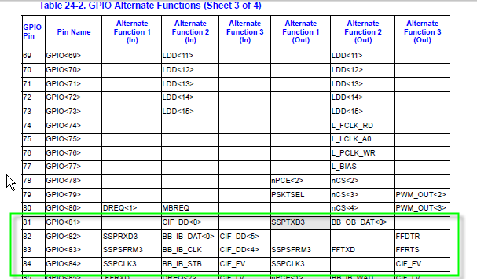

(From Matt Grenier):

You are correct, good sir.

I have collected a few snapshots from the BitsyXb Schematic confirming that GPIO81-84 maps to Header J3.35,37,39,43:

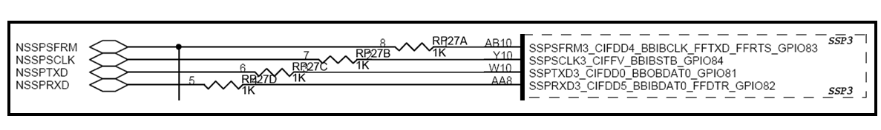

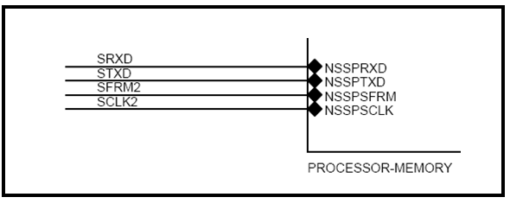

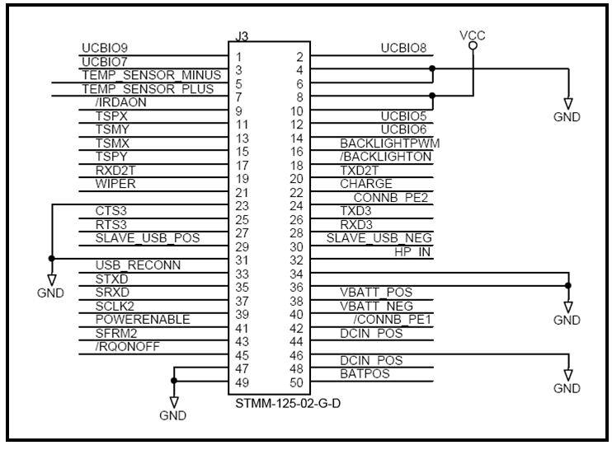

Matt Grenier | Support Engineer | Eurotech Inc | O:+1 301.490.4007 x185 | [matt.grenier@eurotech.com](mailto:matt.grenier@eurotech.com)

**From:** Stephen Rogers [mailto:sarogers@leanpath.com]   
**Sent:** Friday, December 04, 2009 3:39 PM  
**To:** Grenier, Matt  
**Cc:** Bill Leppo; Andrew Shakman  
**Subject:** GPIO Mapping - NSSP to SSP

Matt,

Digging into specs and comparing old/new drivers, it would be helpful if you can confirm that the analogous GPIO pins are still connected to the SSP that is used for SPI.  As I read it, the PXA255 used GP81-84 for NSSP:

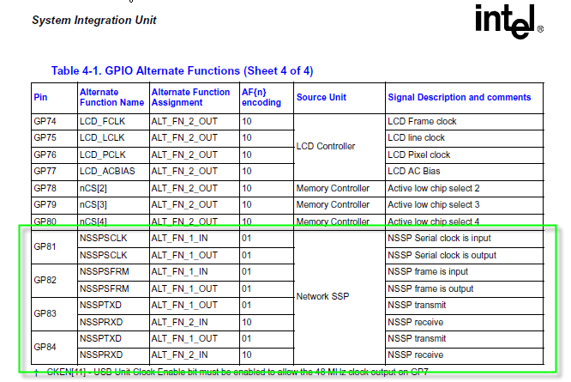

It looks as if the PXA270 does also, and it is still Alternate Function 1:

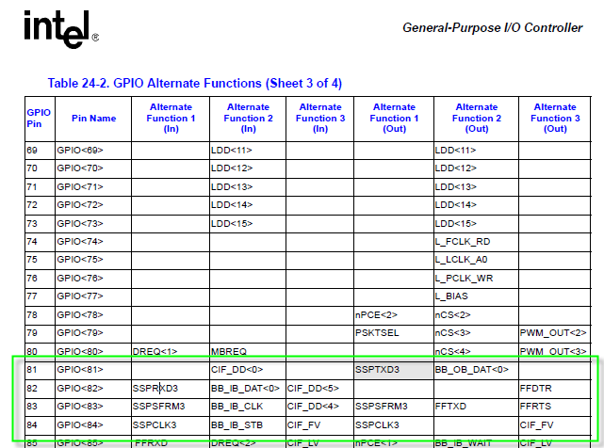

Can you confirm that the BitsyXb hooks the J3 SPI pins (see below) to the above processor pins?  It looks like the bit/pin mappings are different for 81-84, though.  Those differences should be accounted for in the BitsyXb design and in the software that accesses the registers.

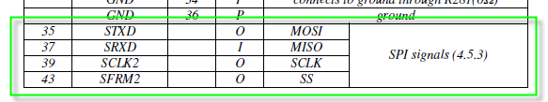

What this should confirm is that the GPIO signals SSPTXD3, SSPRXD3, SSPSFRM3, and SSPCLK3 are the processor signals that drive the SPI.  This seems logical given that you said the SSP driver is hooked to “SSP3:” in the WinCE stream I/O system.  It also looks consistent with the NSSPTest.cpp sample, but since it isn’t clear really what NSSPTest does, I wanted to double check.

Thanks.  Other than this it would appear that the SPI driver initialization is similar between BitsyXb and BitsyX.

Stephen

# Volume-based Entry for Recurring Transactions

## Overview

On 9/25/09 Dave and Stephen met with Andrew to go over the issue of needing a way to enter recurring transactions using fractional amounts rather than just integers. This documents what we came up with to solve that issue – it goes on the list of items to prioritize appropriately for development.

Over the next week or two the concept was updated in discussions and email. This document reflects the updated version.

## Recurring Transactions by Volume

The primary breakthrough idea is to allow recurring transactions to have the same ability to enter by volume that the user currently has on the standard waste loop. It is undetermined at the moment whether this will create a new identifiable waste item transaction type. It is expected that there will be a new identifiable combination, i.e. both volume and recurring coexisting in a way that at least allows auditing level ability to determine transaction origin. But we agreed that it is a requirement not to disturb the waste protocol or import code.

So key features include:

* Paper Entry will include new ability to enter by Volume.
* Any item-type recurring transaction can be entered by volume if the food type and container type volume/weight info is filled in properly.
* The choice about whether to enter an item-type recurring transaction by volume is made after an item-type recurring transaction with full volume/weight info available is clicked. At that time, a dialog is presented that offers the choice of whether to enter by volume or unit count.
  + If the user clicks on Unit Count, then the same thing occurs as now, i.e. the second screen of the current Paper UI is shown.
  + If the user clicks on Volume, then a screen similar to the current Volume entry screen on the main loop is shown.
* ~~User chooses whether they want to enter by Item, Volume or weight, using buttons on the transaction selector screen. Based on this choice, the tree of available transactions immediately populates with those types of transactions. The default choice would remain by Item, Volume would be second and the little-used (as of yet) enter by Weight type would be third. Weight type transactions would not show by default as they do now, only Item type.~~  
  ~~So in essence we add a filter to the transaction selector screen.~~
* When user selects a transaction, if it is weight or item the same thing occurs as now. If it is by Volume then the Volume screen comes up and the user enters number of containers, just like the current enter by Volume screen on the standard waste loop.
* If possible without disturbing data path, we will set both the recurring and volume flags so that the transaction type is unique and could be audited or reported on. Otherwise, we would fall back to characterizing it as a standard volume transaction (and it would be lost whether it originated from recurring or standard waste loop).

No changes are required to either VWA4.NET or VWA4.Delphi as a result of this addition to VWT4.

## Diagrams from Work Session

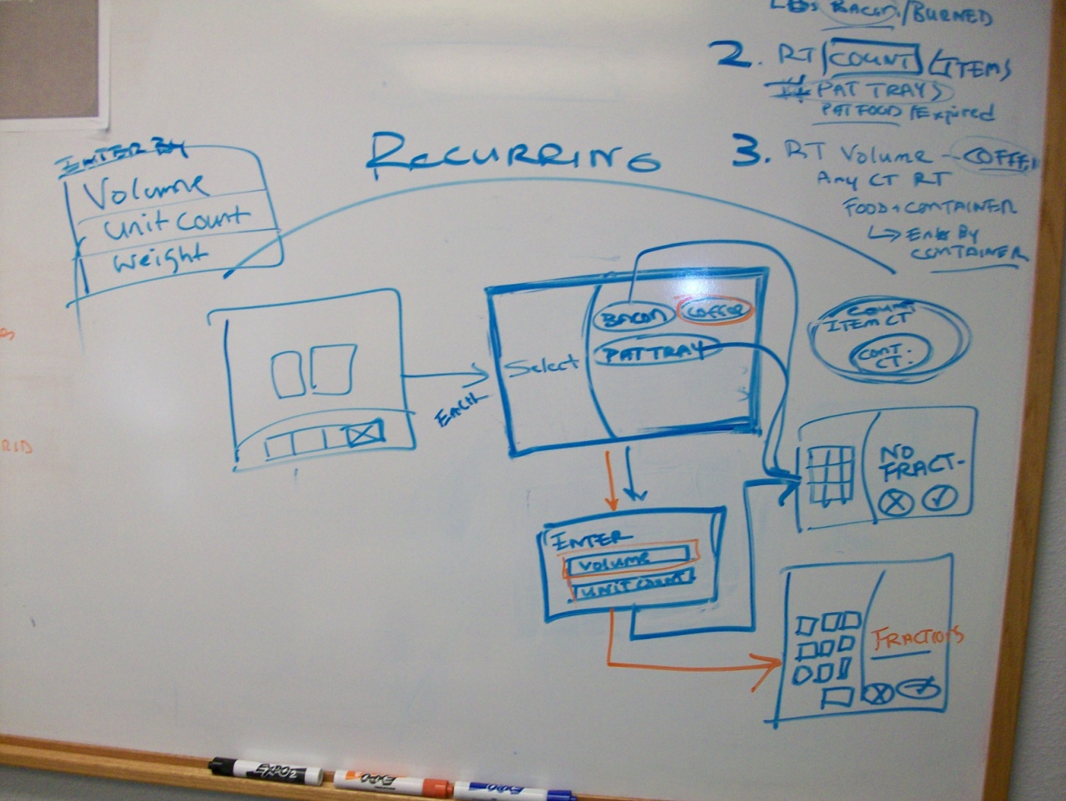

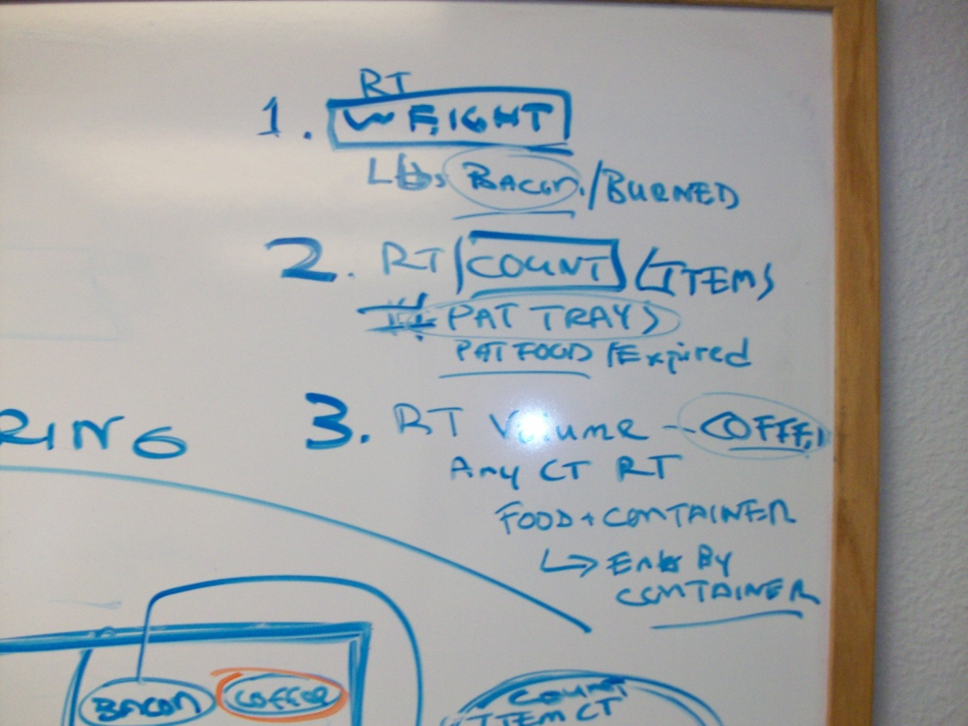

# Splash Screen

## Links to Articles

<http://www.codeproject.com/KB/cs/applicationcontextsplash.aspx>

#### Using Threads

<http://www.albahari.com/threading/part3.aspx>

# C# Techniques

## C# Animated GIFs

<http://www.vcskicks.com/csharp_animated_gif.php>

<http://bytes.com/topic/c-sharp/answers/510116-how-switch-animated-gifs>

Create them online from your pics:

<http://picasion.com/get-photo/>

## Menu Strips

<http://www.speakcomputers.com/windows-forms-programming/MenuStrip.aspx>

<http://en.csharp-online.net/Tool,_Menu,_and_Status_Strips%E2%80%94ToolStrip_Basics>

<http://msdn.microsoft.com/en-us/library/system.windows.forms.toolstripitem.tag.aspx>

## Resizing Controls at Runtime

<http://69.10.233.10/KB/dotnet/Resize_Control_at_Runtime.aspx>

<http://www.codeguru.com/cpp/controls/controls/resizing/article.php/c2151/>

<http://www.codeproject.com/KB/miscctrl/MovableControls.aspx>

## Resizing and Working with Images via GDI+

<http://www.codeproject.com/KB/GDI-plus/imageresize.aspx> (!!!!)

# Data File Protocol Changes

**1/22/10:**

**Added or modified fields are highlighted**

| **Configuration Data Record Structure** | | |
| --- | --- | --- |
| **Record type 0 – Transfer (one only per file)** | | |
|  | Record Type ID | * “TransferConfig” |
|  | Transfer File Written by VWA (Date + Time) | * The date + time that this file was written by VWA. |
|  | Transfer Written Locally by VWT (Date + Time) | * The date + time that this file was written to the Tracker by VWT, which represents the “update” date+time. * NOTE: this is only written by VWT as part of the Transfer Config process, and thus only is seen on the Tracker itself. |
|  | Product Version of VWA4.NET that wrote this config file.  (String) | * Provided by VWA4.NET in standard .exe version format. |
|  | Assembly Version of VWA4.NET that wrote this config file.  (String) | * Provided by VWA4.NET in standard .exe version format. |

| **Configuration Data Record Structure** | | |
| --- | --- | --- |
| **Record type 4 – Tracker Info (one only per Tracker section – must be first)** | | |
|  | Record Type ID | * “Tracker” |
|  | Tracker ID  (integer – in DB as text) | * The unique serial number of the target VWT station for this record. (TermID in the DB) |
|  | Tracker Name  (string / 20) | * Text string designating the assigned name of the Tracker associated with Tracker ID. (TermName in the DB) |
|  | Admin PIN  (string / 6 – numerics only) | * PIN for gaining Admin access (0-6 digits)   + 0 digits (null) => no PIN required |
|  | Waste Loop Timeout value  (integer) | * Number of seconds of inactivity, during a waste log reading, before the current user is logged out and the station is returned to the Stage 1 menu. |
|  | Admin Timeout value  (integer) | * Number of seconds of inactivity, during an Admin session, before the current user is logged out and the station is returned to the Stage 1 menu. |
|  | Attract Loop Timeout value  (integer) | * Number of seconds of inactivity, while at the Stage 1 menu, before the attract loop starts. |
|  | Delete Record Reachback Timeout value (see View/Change funct in VWT)  (integer) | * Number of seconds that can elapse before a waste record can no longer be edited or deleted on the Tracker. 0 means that records cannot be edited or deleted. |
|  | Default Waste Class  (integer) | * Standard Waste Class # that is used to configure the UI. Standard values --- thus far these include:   + -1 = All Waste Classes (most generic)   + 0 = Food_General – (standard, generic Food mode)   + 100000 = Non-food_General (standard, generic Non-food mode) |

#### Record Type 1 - Transfer

| **Waste Log Record Data Structures** | | |
| --- | --- | --- |
| **Record type 1 – Transfer (one only per section)** | | |
|  | Record Type ID | “TransferWaste” |
|  | Tracker ID | The unique serial number of the Tracker that generated this record. |
|  | Tracker Name | Text string designating the assigned name of the station associated with Tracker ID. |
|  | Transfer Date + Time | The date + time that this file section was written by the originating VWT. |
|  | Transfer Type | “New” or “Prior”  See earlier specs for explanation of these transfer types. |
|  | Tracker Software Version | String with Tracker software version #, standard Microsoft format (e.g. 4.0.1.1)  Used for reporting whether people have done their upgrades.  For ValuWaste 4, the Tracker version must be 4.x.x.x. |
|  | Site ID | ID (Primary key) of the Site that this Tracker is associated with. |
|  | Site Name | Name of the Site that this Tracker is associated with. |
|  | Type Catalog ID | ID (Primary key) of this Type Catalog in the database (Integer). 0 => Master Type Catalog |
|  | Type Catalog Name | Text name of this Type Catalog |
|  | VWA Product Version | String with VWA4 Product Version #, standard Microsoft format (e.g. 4.0.1.130)  Used for reporting whether people have done their upgrades; debugging problems.  For ValuWaste 4, the Tracker version must be 4.x.x.x. |
|  | VWA Assembly Version | String with VWA4 Assembly Version #, standard Microsoft format (e.g. 4.0.3674.24640)  Used for reporting whether people have done their upgrades; debugging problems.  For ValuWaste 4, the Tracker version must be 4.x.x.x. |
|  | Notes: | * Site data is used for consistency check (database already has a Site linkage via the Tracker ID). * Type Catalog association is derived from the |

# Database Updates

**1/22/10:**

**ADDED:**

* **Weights.StartTimestamp**
* **WeightsProduced.StartTimestamp**
* **ErrorWeights.StartTimestamp**
* **ErrorWeightsProduced.StartTimestamp**

**1/20/2010:**

Mila/Dave,

Just to make sure we’re in sync, TaskItems table has been expanded for persisting new Task Bar functionality.  This is necessary to run the newest QA version of VWA4.NET.

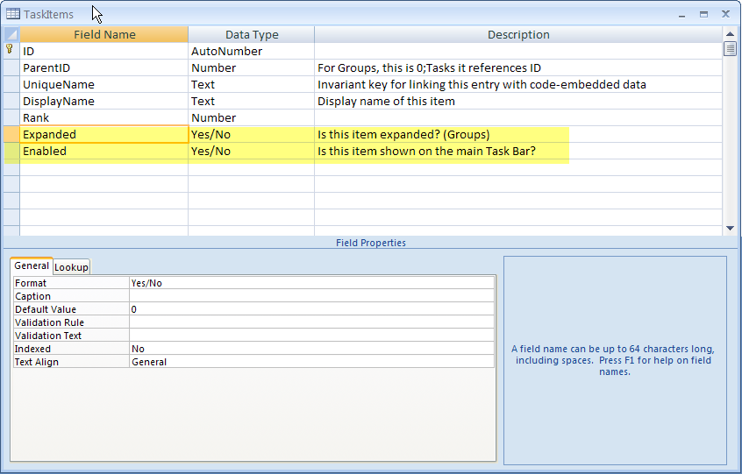

Stephen

**1/17/2010:**

Mila,

Yes I am going to add a new WasteClass field to FoodType table now.  I am going to use a unique text field like the types and units tables use, as an invariant key, so the general concept will be similar to how UnitsWeight is done - a separate table called WasteClass will have information relating to the specifics of Waste Classes.

This will be FoodType:

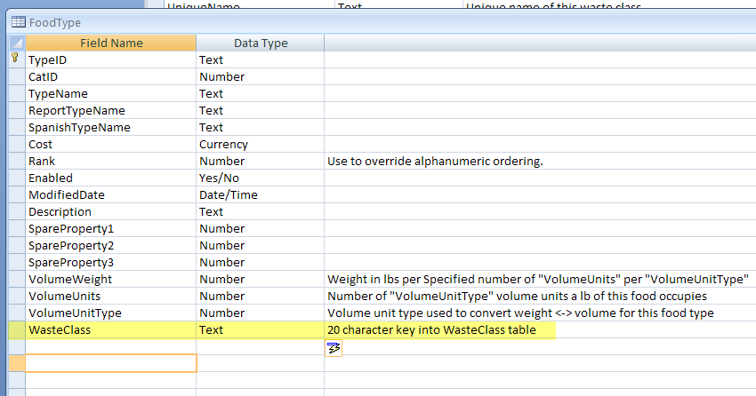

In the WasteClass table, it will be like this:

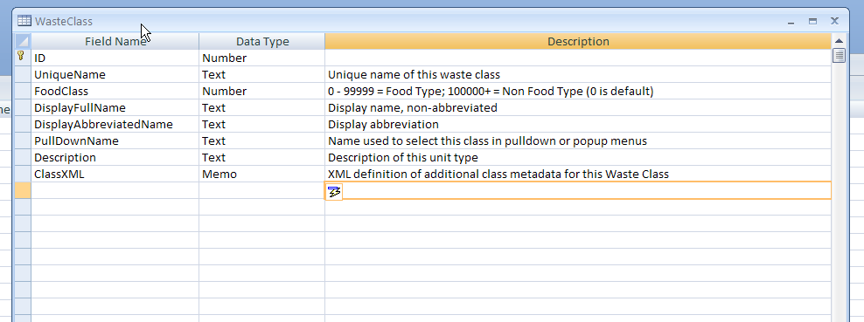

The reason I use WasteClass.FoodClass is to have a quick/easy way to determine if a Type is food or non-food.  The actual specifics of a particular class will be available (as necessary depending on the class) in a separate table made specifically for that class.  It is also possible that the WasteClass.ClassXML field may be adequate to store class information – if so that would be great, and reduce the need to update tables based on new waste class requirements.

It is possible that I may need to add something else but right now this is what I’m planning.

On your side, you can determine the best way to expand the reports so they handle non-food vs. food as a filter.  You will join WasteClass table to FoodType table on UniqueName key field, and then test the value of FoodClass – if FoodClass is 0 to 99999, then it is a food type ; if FoodClass is 100000 or greater, then it is a non-food class.  Later we will want to report by specific waste classes – so if you are modifying the report queries you should allow that as a filter also.  But for now, it is adequate to simply use WasteClass.FoodClass as filter.  For the short term, you can decide if you want to map this field into Pre/Post/Intermediate or modify the report filtering – just remember this needs to be done quickly.  We can’t take weeks to implement this one feature.

I also am going to add an additional field to Weights, and the waste file protocol, just to store a time interval (the amount of time it took a user to do the transaction).  All you need to do with it is simply store the value into each record.  I will send you details on this next week when I add it.  At some point we will want a simple report showing things like average time or total time taken to use the product in the kitchens.

I am not planning on coming into LeanPath office next week, but am working out in Hood River.  VPN works great for me, and the source control is up to date with a lot of changes so you should get new changes.  I don’t have all the database changes yet but will shortly.

Thanks, Stephen

**From:** Ludmila Klimkina [mailto:klimkina@gmail.com]   
**Sent:** Sunday, January 17, 2010 1:13 PM  
**To:** Stephen Rogers  
**Subject:** Re: where are you?

Hi!  
  
I think we should add new field for food/non-food to FoodType table now. Because it is hard to change DB after release. So please add this field. I.e. for FoodTypes from 0 to 9999 it'l be 0 and for FoodTypes after 9999 it'll be 1. Let me know how you do it.  
  
-Mila

On Thu, Jan 14, 2010 at 5:13 PM, Stephen Rogers <[sarogers@leanpath.com](mailto:sarogers@leanpath.com)> wrote:

In an earlier email, you said the query changes would make adding a new food type field (as a filter for Food/Non-Food) a lot of work.   We don’t have much time, so we need to conserve time on this if it’s a big difference.  We need to have everything done for QA in just a week and a half.

This made sense to me as a quick way to proceed since your reporting queries don’t need to be changed, only the UI to add a few more choices.  The initial choices for

Pre/post consumer flag would be:

1.       Food Pre-consumer = 1

2.       Food Post-consumer = 2

3.       Food Intermediate = 0

4.       Non-Food Pre-consumer = 10001

5.       Non-Food Post-consumer = 10002

6.       Non-Food Intermediate = 10000

If we add an additional flag value, we add 4 and 1004 as the new values.

This isn’t beautiful, but it works fine and should be very easy to implement.  Your existing queries will pick up the value and should filter by it correctly.  Should save a lot of time and reduce errors that we don’t have time for right now.

The Food Types (which will be labeled “Waste Types” in the UI for people who use it for Non-Food Waste in addition to Food Waste) will have a property that specifies whether it is Food or non-Food.  Food = 0 to 9999; anything above 9999, starting with 10000, would be different varieties of Non-Food.  This allows for more granularity in defining waste types.

For the short term, all you have to do is look at Food Type property when importing.  If it is < 10000, then set the transaction to 0, 1 or 2 since it is Food.  If it is 10000 or greater, set to the number (i.e. 10000) + 0, 1, or 2 .  You get the integer from Pre/post consumer flag.

Later, when we have more time, we can consider whether we really need to change the reporting to use the food property, and discard the Pre/post consumer flag.  This will only matter if Andrew and Dave want to add more complexity.  Otherwise, this approach will not matter to users, and even when if we change in the future, it will be forward compatible.

This is a last minute change that we need but can’t afford time to do if it takes more than a couple of days.  If you think you can change all the queries in a couple of days then we can go that route.  It doesn’t matter to me from a coding perspective.  I’m just making sure we don’t end up in a big mess because of the complexity and scope involved in changing your filters.  It seems like a big impact, and you said so during your trip when I asked you about it.

Let me know.  I’m starting on these changes tomorrow.

Thanks, Stephen

**From:** Ludmila Klimkina [mailto:[klimkina@gmail.com](mailto:klimkina@gmail.com)]   
**Sent:** Thursday, January 14, 2010 4:49 PM  
**To:** Stephen Rogers  
**Subject:** Re: where are you?

Hi!  
  
Sorry, I misunderstood. I thought you are going to send me more details.   
Everything is Ok. I think you want to add some Food Types that are Non-Food and have an additional field for it. Also you want user to be able to do report's filtering on food/non-food. Am I right? So far this is Ok.   
  
I can't understand why do you want to use Pre/Post/Intermediate? To do a quick fix and not to damage existing reports? It is not a good idea. If we can calculate it from Food Type then so be it. As I can see this is completely different so let's not mix those things.  
  
-Mila

On Thu, Jan 14, 2010 at 4:25 PM, Stephen Rogers <[sarogers@leanpath.com](mailto:sarogers@leanpath.com)> wrote:

Mila,

We’re looking for some feedback on the emails we’ve been sending…  is everything OK?

Thanks, Stephen

# Mac + Windows

<http://www.winsupersite.com/win7/win7_on_mac.asp>

# Installation and Upgrading

## Installer Programs

<http://www.tramontana.co.hu/wix/>

<http://www.installaware.com/landing/google.asp?kw=installation%20software&nw=search&cr=4730647377&pl=&gclid=CMqfjeme7Z8CFQkcawodeDvcfQ>

## Product Reviews & Comparisons

<http://www.installsite.org/pages/en/msi/comparison.htm>

<http://lextm.blogspot.com/2007/08/product-review-installaware.html>

<http://www.actualinstaller.com/>

## Accessing Database Schema

<http://aspalliance.com/542_CodeSnip_Access_Database_Schema_with_ASPNET_20>

<end of document>